

User guide for contact persons and work approvers

*User manual for the Customer Portal*

| **Version** | *1.0* | |
| --- | --- | --- |
| **Latest update** | *2023-10-26* | |
| **Created by** | *Marius Gravem* | |
| **Contributors** | *Gøran Sæland* | |
| **Confidentiality level** | *PUBLIC* | |

Content

**1 Introduction 2**

**2 Logging in 3**

2.1 Login issues and forgotten password 5

2.2 Change password 5

**3 Menu 7**

3.1 Logged work 7

3.2 Jobs 10

3.3 Invoice 11

3.4 Offers/agreements 12

3.5 Inquiries 13

# 1 Introduction

In this document you can read about the customer portal. For companies using RecMan, the customer portal is an additional feature they can give access to for their created customer contacts in the system. This is commonly used to view and approve logged hours, but can also be extended for features to view offers/agreements, invoices, job information and much more.

While various modules are available, we will discuss the core features here:

* View and approve logged work
* View jobs
* View sent invoices
* View sent offers/agreements

Note: This guide is made with the basic permissions enabled to view and approve registered work. Should your profile look different, this can mean that your permissions and functionality is limited or adjusted by the staffing company.

# 

# 2 Logging in

In order to log in to the customer portal, the company using RecMan will first have to create a login. When that is done, they can assign permissions depending on your needs before sending you the login credentials. So assuming a login has been created and sent, we will go through the process of logging into the system to access your customer profile. We will also show you how to reset your password, should you have forgotten it.

Note that you may have a profile in several RecMan systems, depending on the company, and these profiles are not shared between the companies. Because of this, it is essential that you use the correct site when logging in. A typical site for logging in should look like this:

[https://COMPANY_NAME.recman.no/customer/login](https://mariussupport.recman.no/customer/login)

Here we have written “Company Name”, this is where you will use the name of the company you are registered with. When visiting this link, you will see the following screen.

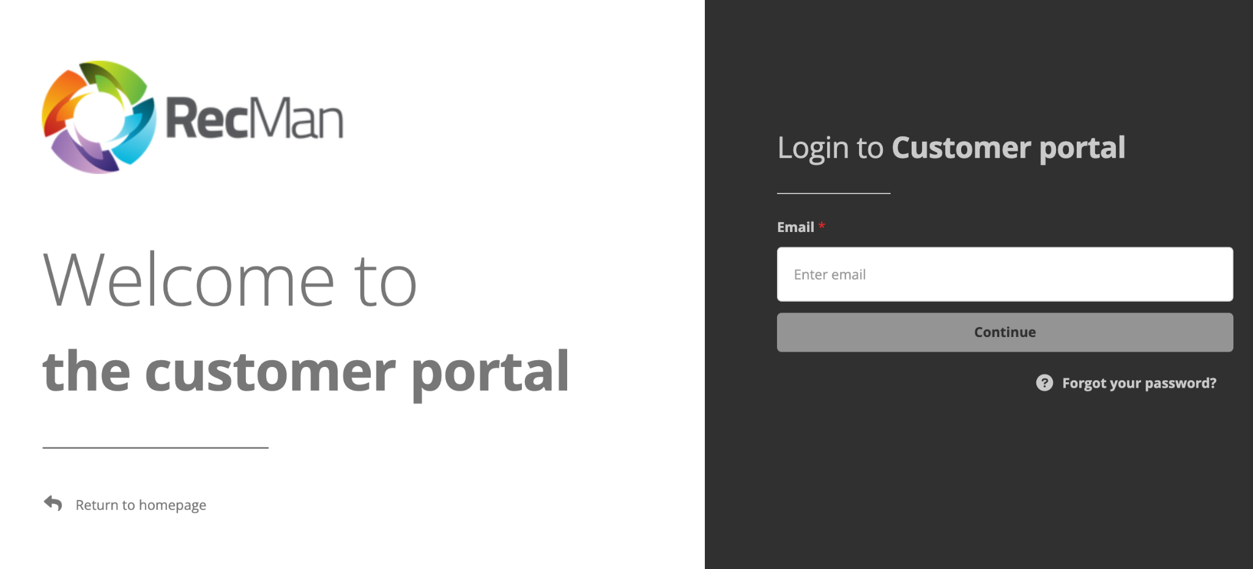

Here you input the email and password given to you by the company. Click “Log in” in order to log into your customer profile. When logging in for the first time, you are likely doing so using a temporary password, or a one-time login link. Therefore, it is recommended that you set a new and strong password for later use.

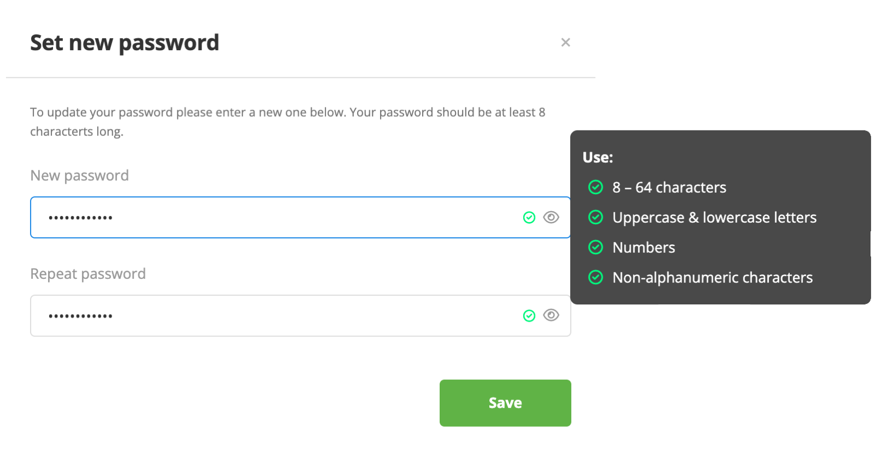

Clicking save, you should now be in the customer portal’s home dashboard:

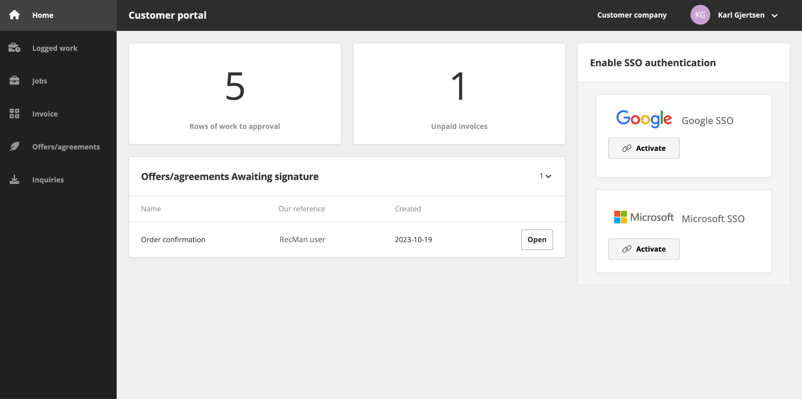

Here you should be able to view some basic information regarding the work “to approval”, unpaid invoices and offers awaiting signatures. You can also enable SSO authentication to make your profile more secure using a Google or Microsoft account.

## 2.1 Login issues and forgotten password

Should you have issues with your login, we recommend double checking that your email and password is written correctly. Should you be positive that both are correct, you can use the «Forgot your password?” button.

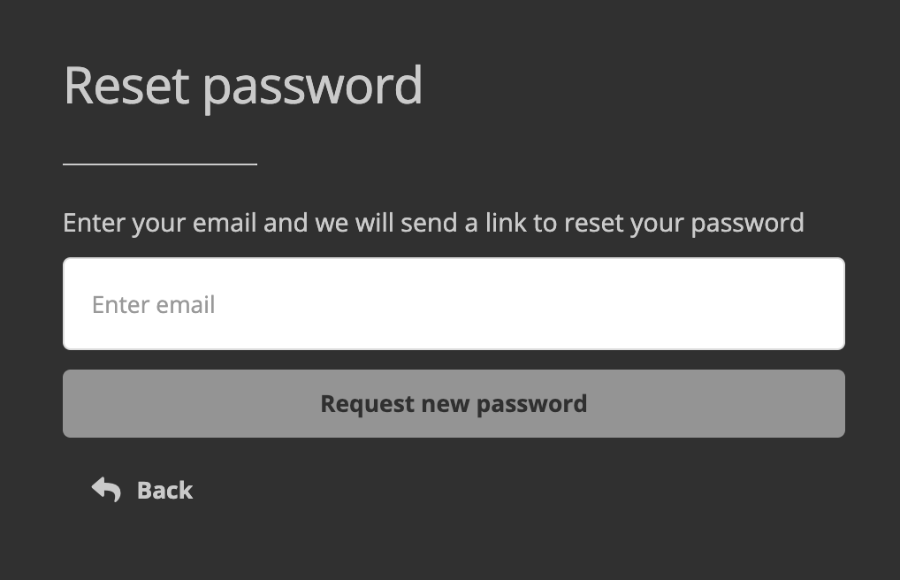

Once pressed, you will see a small box where you will be able to input your email once more, and press the «Request new password» button. Should your email have been input correctly, you will receive an email where you can click a link to be automatically logged in. You may also copy the link and paste it in the address field in your web browser if you are unable to click it.

When clicking the link, you will be logged into your profile, and you will see the same “Set new password” box as shown earlier.

Should you still have issues logging in, contact the company who has your profile in their system. On the same screen where you log in, you can click the “Return to homepage”. Here you should be able to find contact information, where the company should be able to provide you with a new password.

## 2.2 Change password

After you have logged into your profile, you can change your password, directly from your profile. As previously mentioned, you will be asked to define a new password the first time you log in / when you use the «Forgotten password» function, but should you wish to change it at a different time, you first click «Settings» as shown in the picture below.

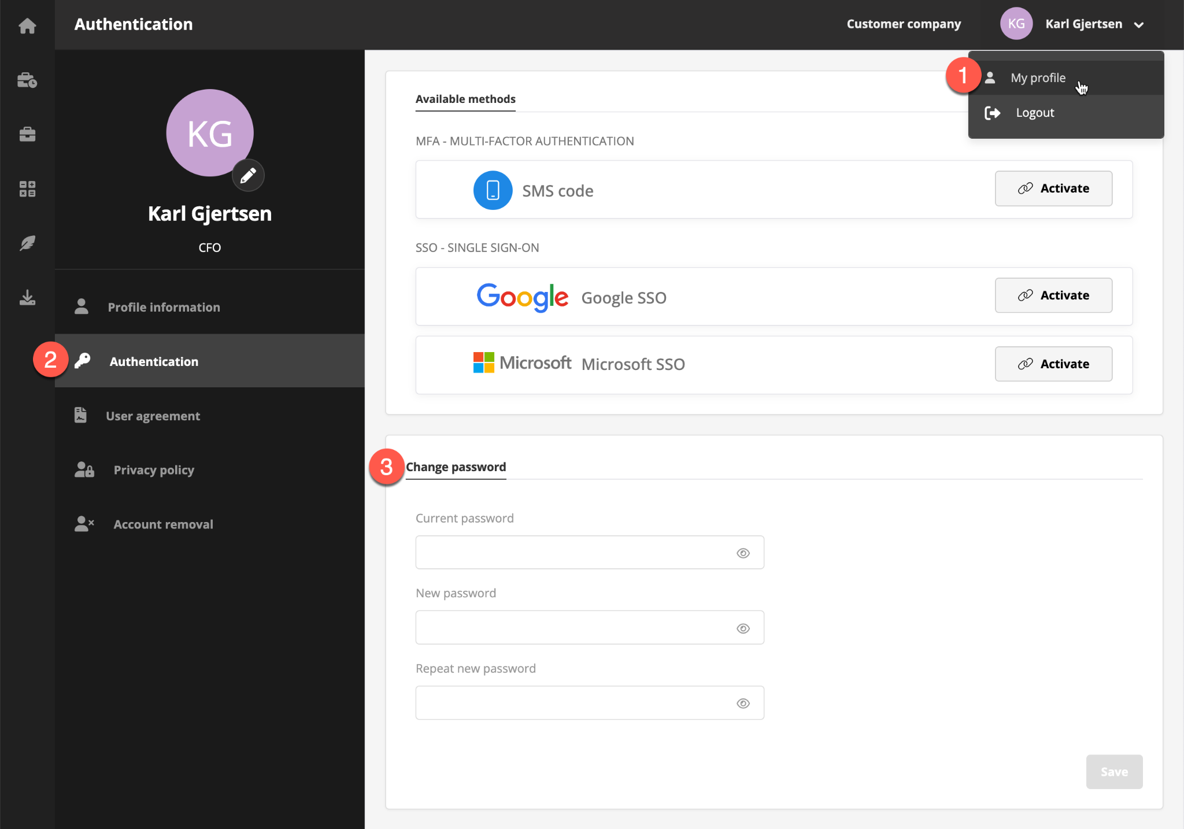

Here you have to enter your current password before inputting a new one twice to make sure it is entered correctly. Once done, click save to “change password”.

# 

# 3 Menu

For the customer portal, you have the navigation menu to the left showing the modules you have access to. Hovering the icons will expand and reveal the module names should you be in doubt.

As for the top right corner, you can find your own name and the companies. Clicking the company lets you view or update the company information, invoice preferences and company address. Clicking your name instead expands and lets you select “My profile” or the log out.

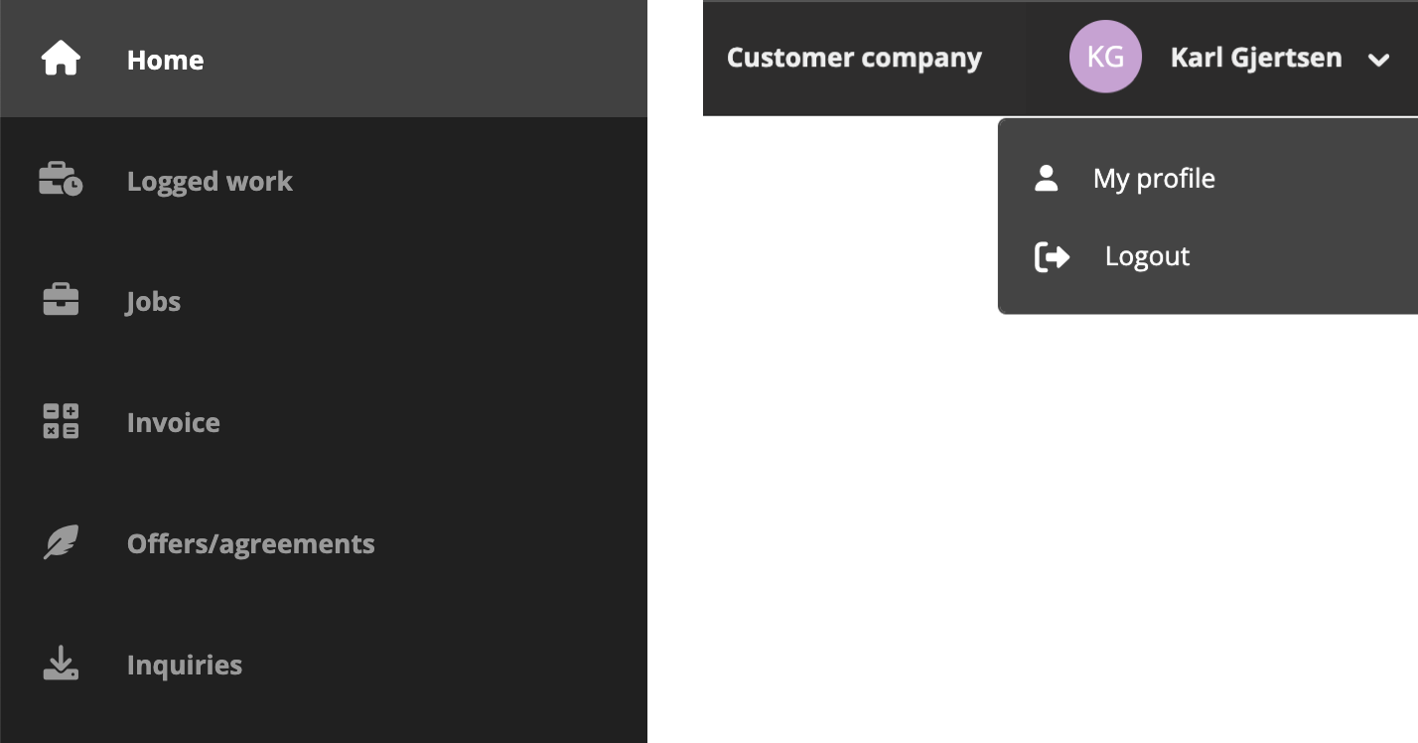

## 3.1 Logged work

In this module you can view and approve the logged work for the projects assigned to your profile.

By expanding the filters, here you can filter the logged work status, is “To approval”, “Approved”, or “Invoiced”. You can also navigate the months using the arrows, and change between a monthly or weekly view based on your preferences.

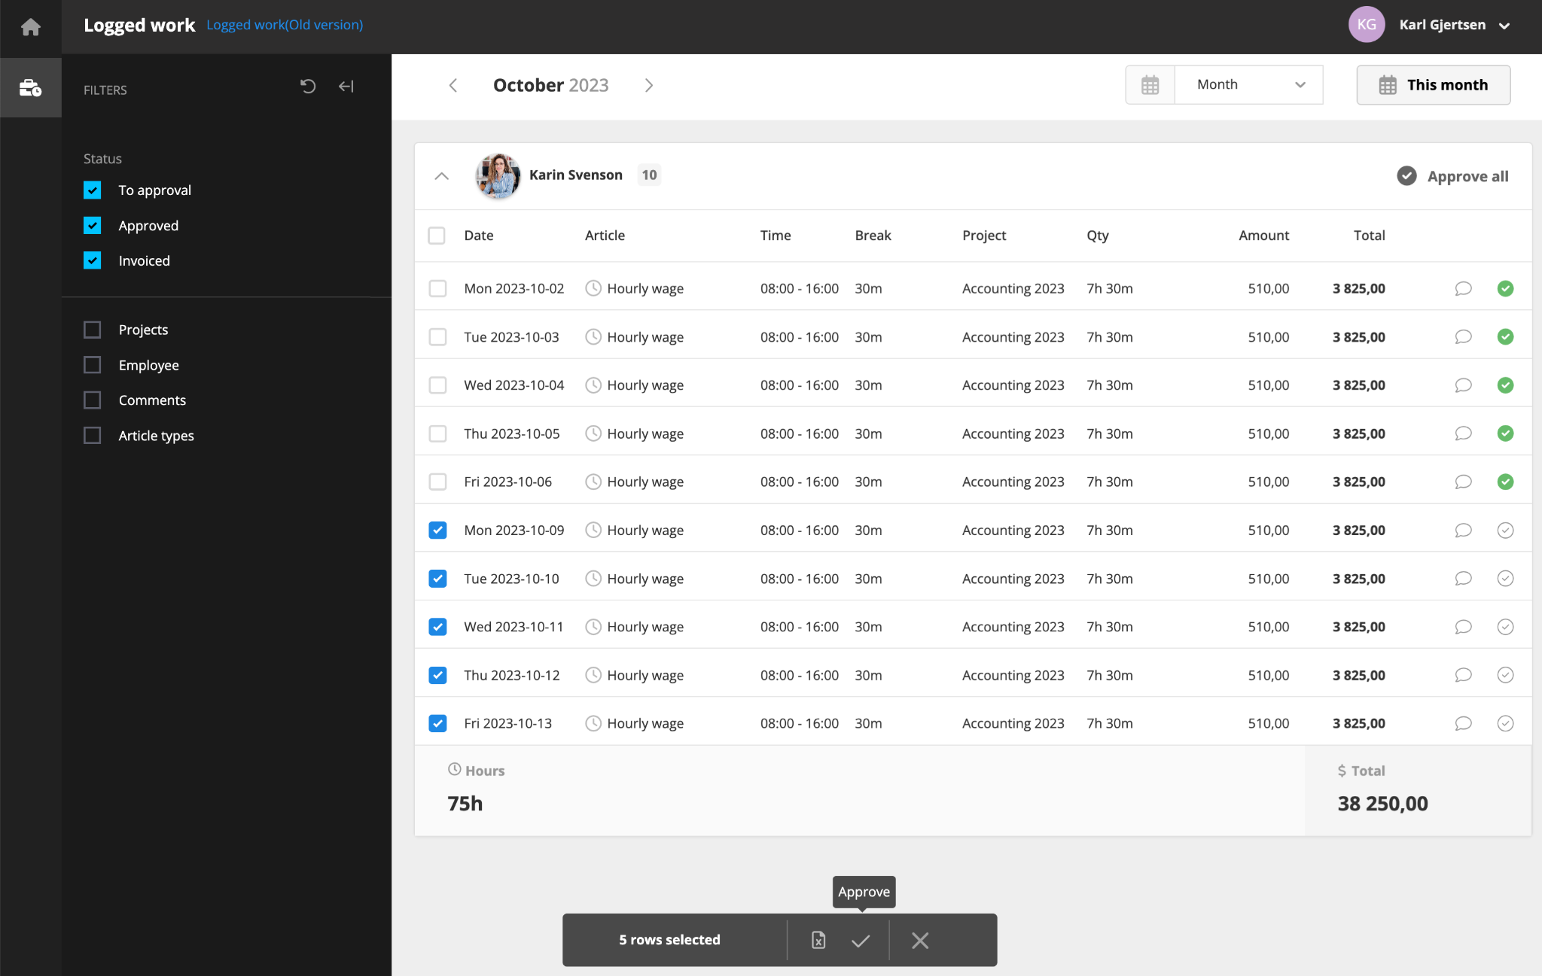

If everything looks to be in order, either click “Approve all”, check off one article at a time, or select one or multiple at a time. By using the select function, you can also download the list to an Excel spreadsheet should you like so.

In case you find an error, you can also click the article, or the chat bubble to write a comment. This will become visible to the users in the RecMan system reviewing the logged work, where they can take action to correct this.

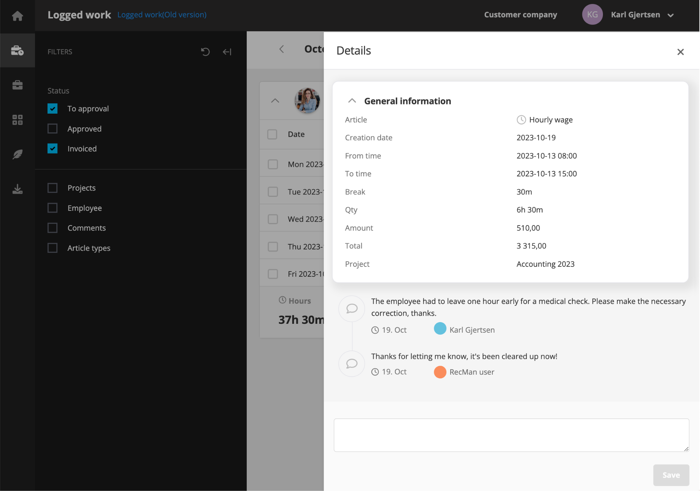

**NB!** The aforementioned step may deviate from the preferred procedure of the staffing agency. Please consult them for how to report and correct found errors.

## 3.2 Jobs

Here you can view the active jobs for your ongoing projects. Using the filters in the top lets you navigate the months for active jobs, but you can also switch between a monthly and weekly view. Click the “this month” shortcut to be taken back to the current month.

The filters available here let you search for employees, filter the status of their logged work and projects.

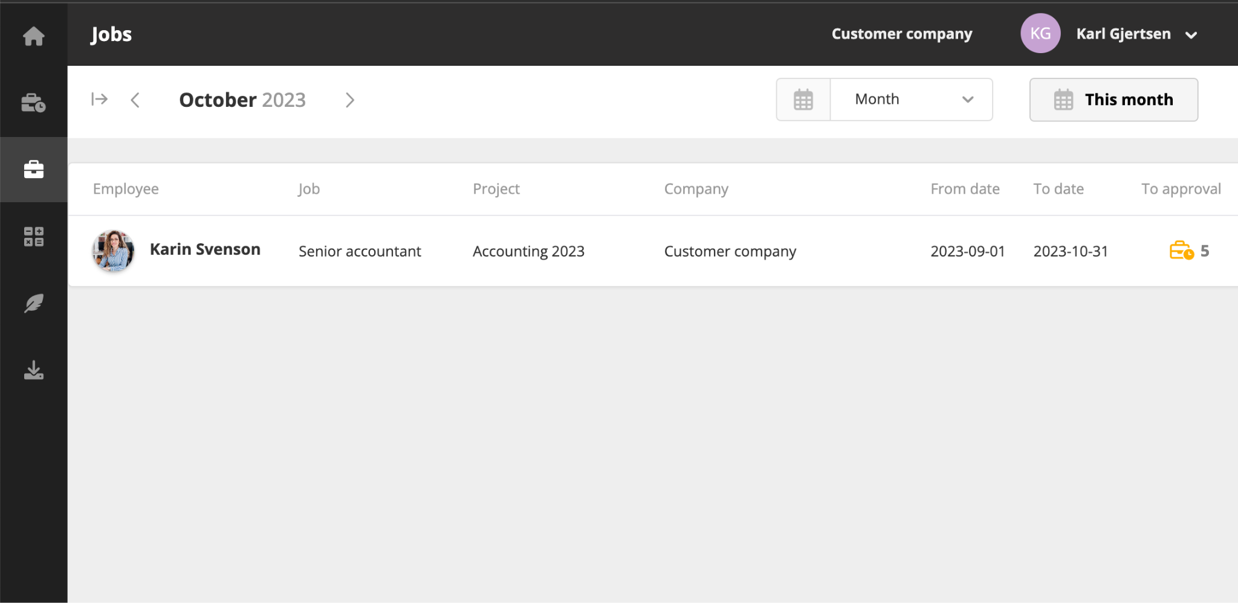

## 3.3 Invoice

In the invoice module, you can view all the invoices sent to you, your assigned projects or for the whole company.

Using the menu at the top, you can click the arrows to navigate the various months, change between a monthly or weekly view, and use the “This month” shortcut to take you to the current month.

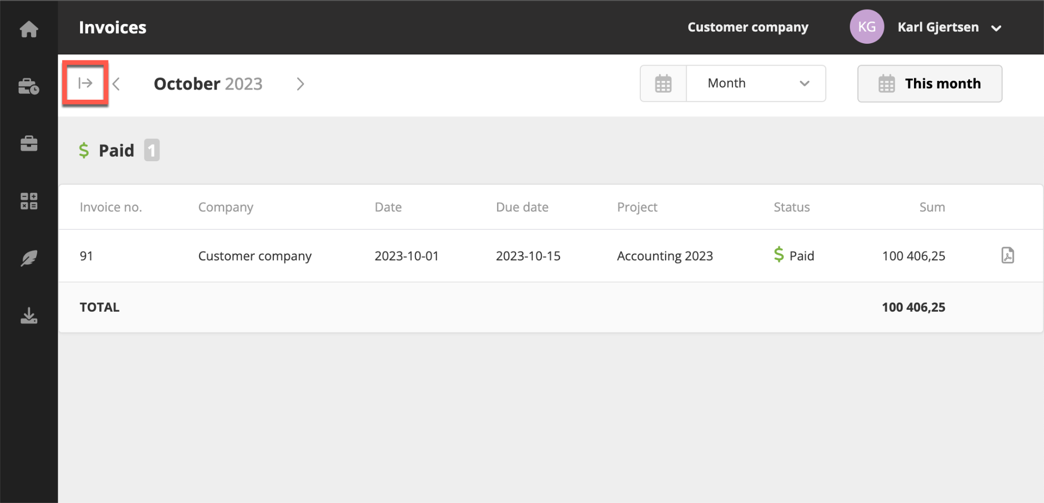

By expanding the filters (marked in the red box), you can filter for invoices that aren’t due, overdue, paid and not paid. You can also filter per company and project.

## 3.4 Offers/agreements

In the offers module, here you can view all the offers sent to you, the project or the entire company. This is typically order confirmations and other general offers. By clicking open, you can view the agreement and sign it electronically.

Expanding the filters lets you search the agreements, filter for “awaiting signature” and “signed”, as well as searching offers connected to specific projects.

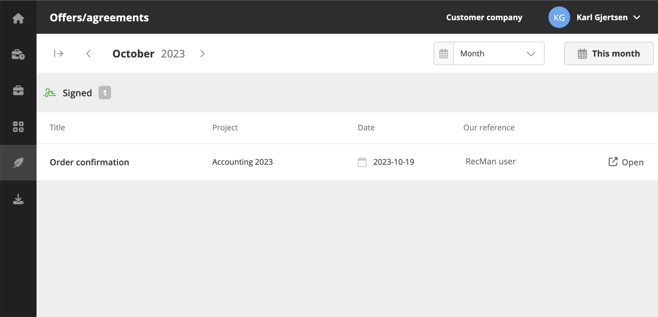

## 3.5 Inquiries

Using the inquiries module, you can send requests to the staffing agency for new business, or if there is something wrong with the newest invoice or offer.

If the inquiries module is not available, please contact <insert email>.

