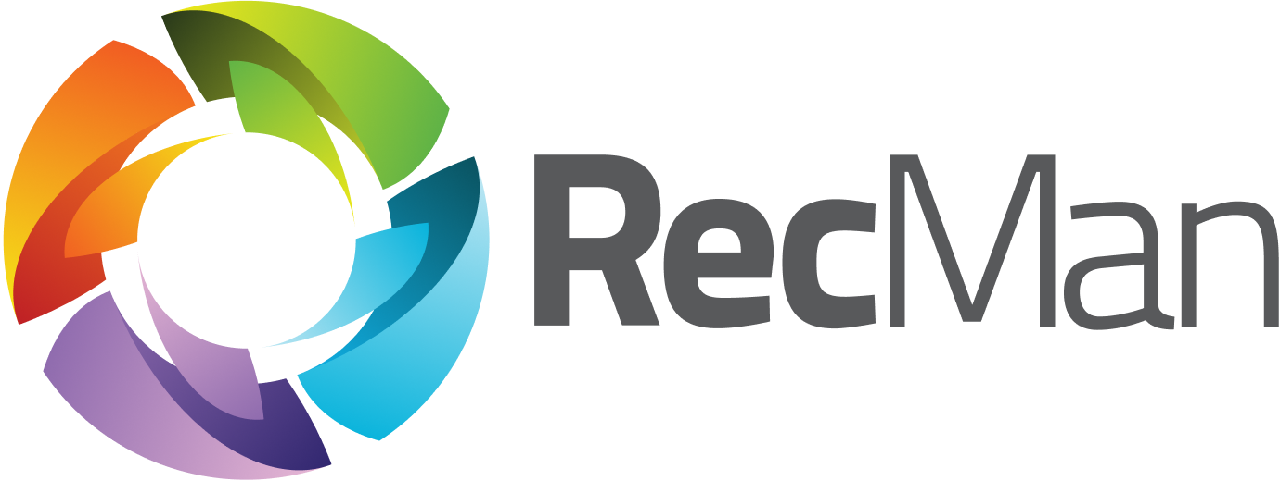

User guide for candidates and employees
User manual for the Career Page and Employee Portal

Version | 2
Latest update | 2026-06-04
Created by | Gøran Sæland
Contributors | Marius Gravem, Iryna Volynets
Confidentiality level | PUBLIC

Content
1 Introduction 2
2 Login 2
2.1 Login issues and forgotten password 3
2.2 Change password 3
3 Career page 4
3.1 All job posts 4
3.2 Applications 4
3.3 Agreements 5
3.4 Profile 5
3.5 Settings 6
3.6 Submit feedback 6
3.7 Logout 6
4 Employee Portal 7
4.1 Homescreen 7
4.2 Profile 8
Work 9
4.3 Log work 9
Break logging 11
Hours 11
Hour registration with child projects 11
Manually 11
Units (Piecework) 11
Time 12
Additions, deductions, and attachments 13
Dashboard tab 13
4.4 Absence 14
4.5 Logged work 16
4.6 Requests 17
4.7 Calendar 18
4.8 Salary 19

1 Introduction
This document describes the Career Page and Employee Portal and their features, both for candidates and employees. We will also discuss various functions, like mandatory CV fields, resetting your password, and work registration.
Note: This guide is made with every possible permission and function turned on. Should your profile look different, it could mean that your permissions and functionality are limited or adjusted by your employer.

2 Login
First, we will walk you through logging in to access your profile and showing you how to reset your password if you have forgotten it. Note: The login may behave differently depending on whether you are a candidate or an employee.
When you register a profile with the company using RecMan, you can log in as you please. You may have a profile in several RecMan accounts at different companies, where your profiles are not shared between the accounts. Because of this, you must use the correct site when logging in. A typical site for logging in should look like this:
https://company.recman.page/login
Here, we have written “company,” which you will use as the name of the company you are registered with. When visiting this link, you will see the following screen.
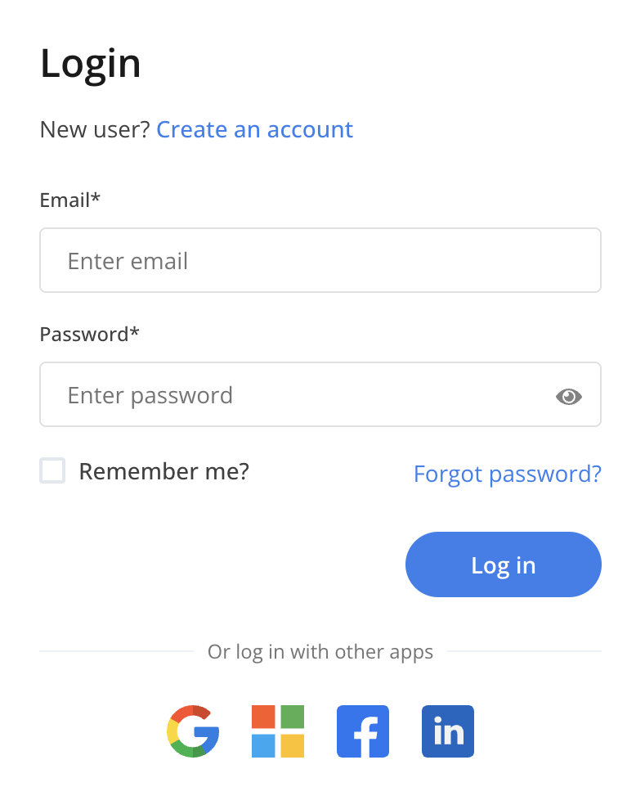

2.1 Login issues and forgotten password
If you have issues with your login, we recommend double-checking that your email and password are written correctly. If you are positive that both are correct, you can use the “Forgot password?” button.
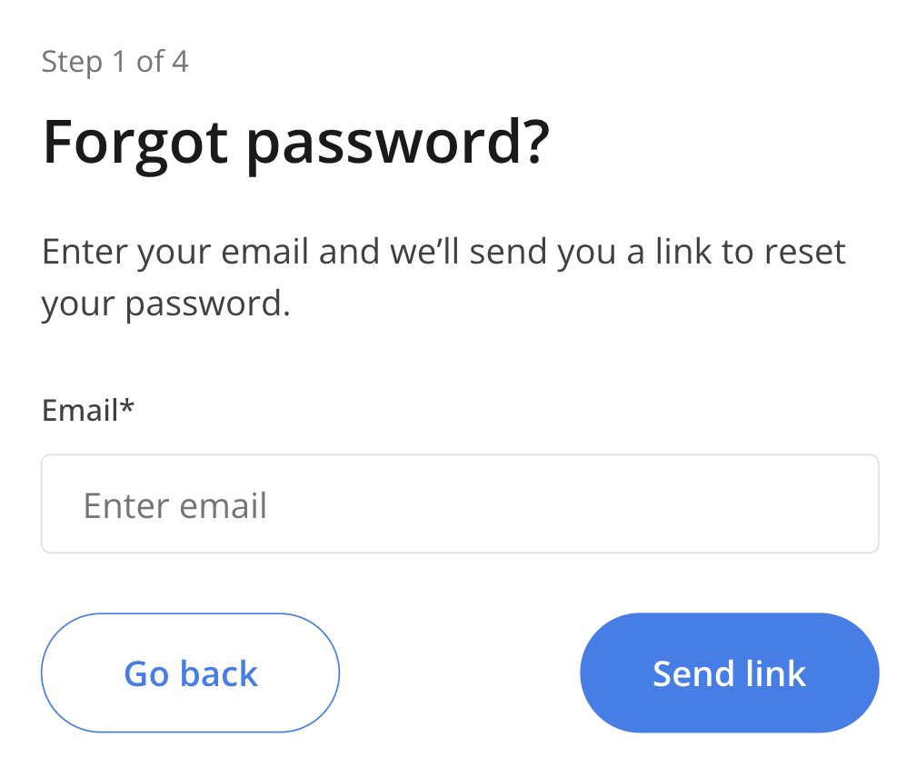

If you still have trouble logging in, contact the company you are trying to log into. On the same screen where you log in, you can see a link to their website.

2.2 Change password
After you have logged in to your profile, you can change your password directly from your profile. You will be asked to define a new password the first time you log in or use the «Forgotten password?» function, but should you wish to change it later, you first click «Settings,» as shown in the picture below.
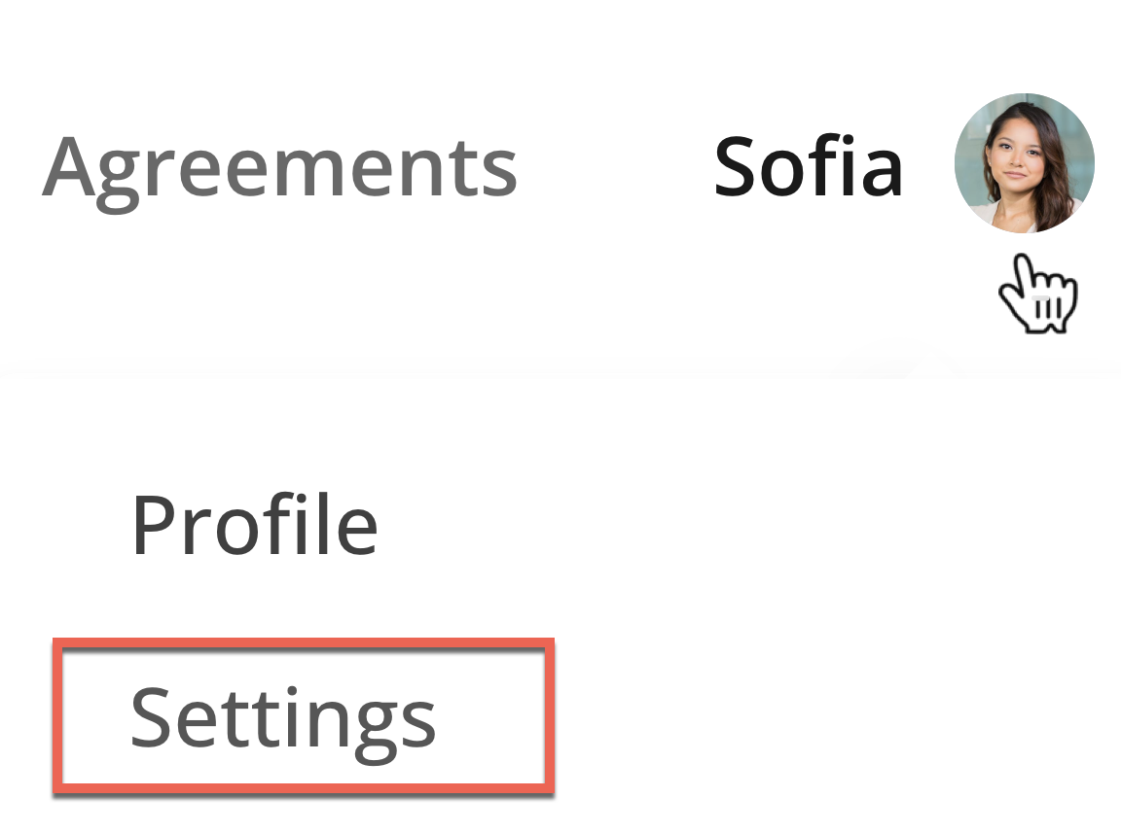

3 Career page
When logging in to your profile, you will have a selection of tabs to visit. These can vary depending on the company’s RecMan account settings and whether you are a candidate or an employee.
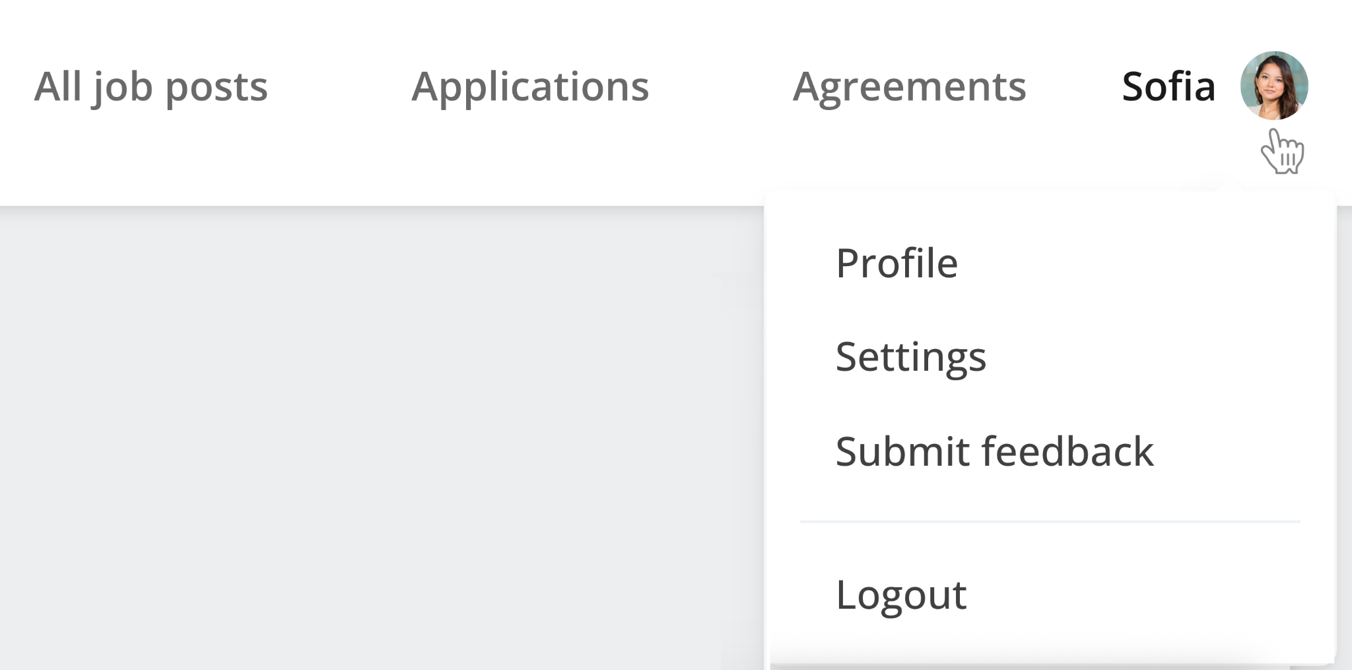

3.1 All job posts
Here you may see all available positions for which you can apply. As you have already created a profile, you will not be required to fill out information as you did when first registering.

3.2 Applications
You may see your active and prior applications for positions and their status here.

3.3 Agreements
Your employer can send you electronic agreements to sign. Usually, these agreements are offers, confidentiality agreements, employment contracts, and order confirmations. Note that this button is only visible once an agreement has been created for you.
You get these agreements sent to your email. However, you can also see all agreements sent to you directly in your candidate profile. Additionally, you can sign any unsigned document after opening it. This button is displayed in red if you have unsigned documents.

3.4 Profile
Your candidate profile page contains your personal information, files, and CV data.
CV information, such as education, work experience, skills, references, etc., can be inserted and edited, and files and profile pictures can be uploaded. All files in the Career page can be viewed in a separate preview modal, allowing you to stay on the same page and reducing the need for extra navigation. Reference contacts require only a single contact method — either email or phone, but adding both is recommended. You can verify your diploma by getting information from the diploma registry. Also, you may update or add your contact details or include more information if you are employed.
Sometimes, the company you have registered with may define some fields as mandatory. This means that they demand that you fill them in. If you don’t, your profile could potentially not be assessed. You will be notified which fields you are missing, as shown in the picture below.
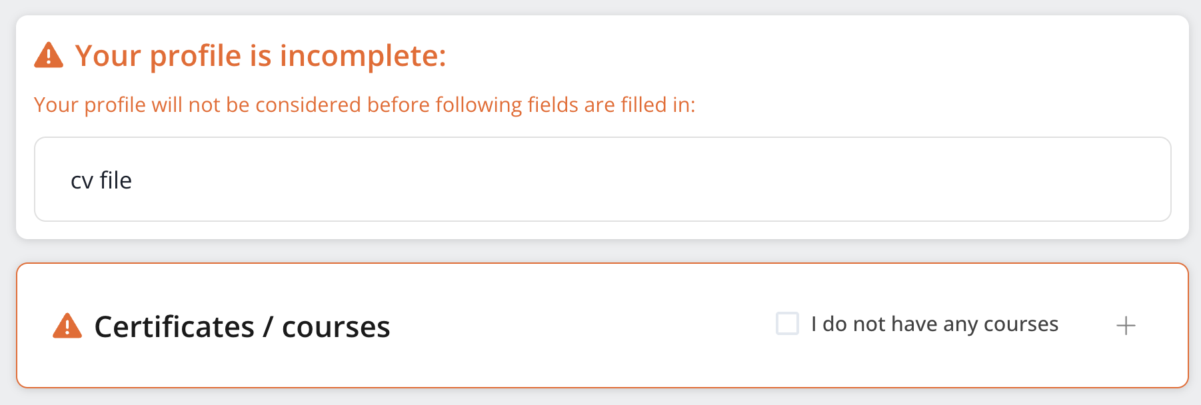
Note: Even though the company does not use mandatory fields, we highly recommend you fill out as many fields as possible in your CV. This will increase your chances of getting considered for a position. Incomplete profiles are often ignored or deleted outright.

3.5 Settings
Here, you may set a variety of settings for your profile. You can access and view the terms you accepted when registering and change the default period set for automatic deletion (if activated by the company). Depending on the permission set by the company, you may either delete or request deletion. If you are employed, you cannot delete your profile. Automatic deletion will also be put on hold if you are an employee. Note: The company will not be able to restore your profile should you regret your decision to delete it.

3.6 Submit feedback
If you have any feedback, submit it using this button, and it will be forwarded to the product managers and developers at RecMan.

3.7 Logout
Click this button to log out. If you don’t log out, you will be logged in when you return to the page later, provided you allow cookie storage in your web browser.

4 Employee Portal

4.1 Homescreen
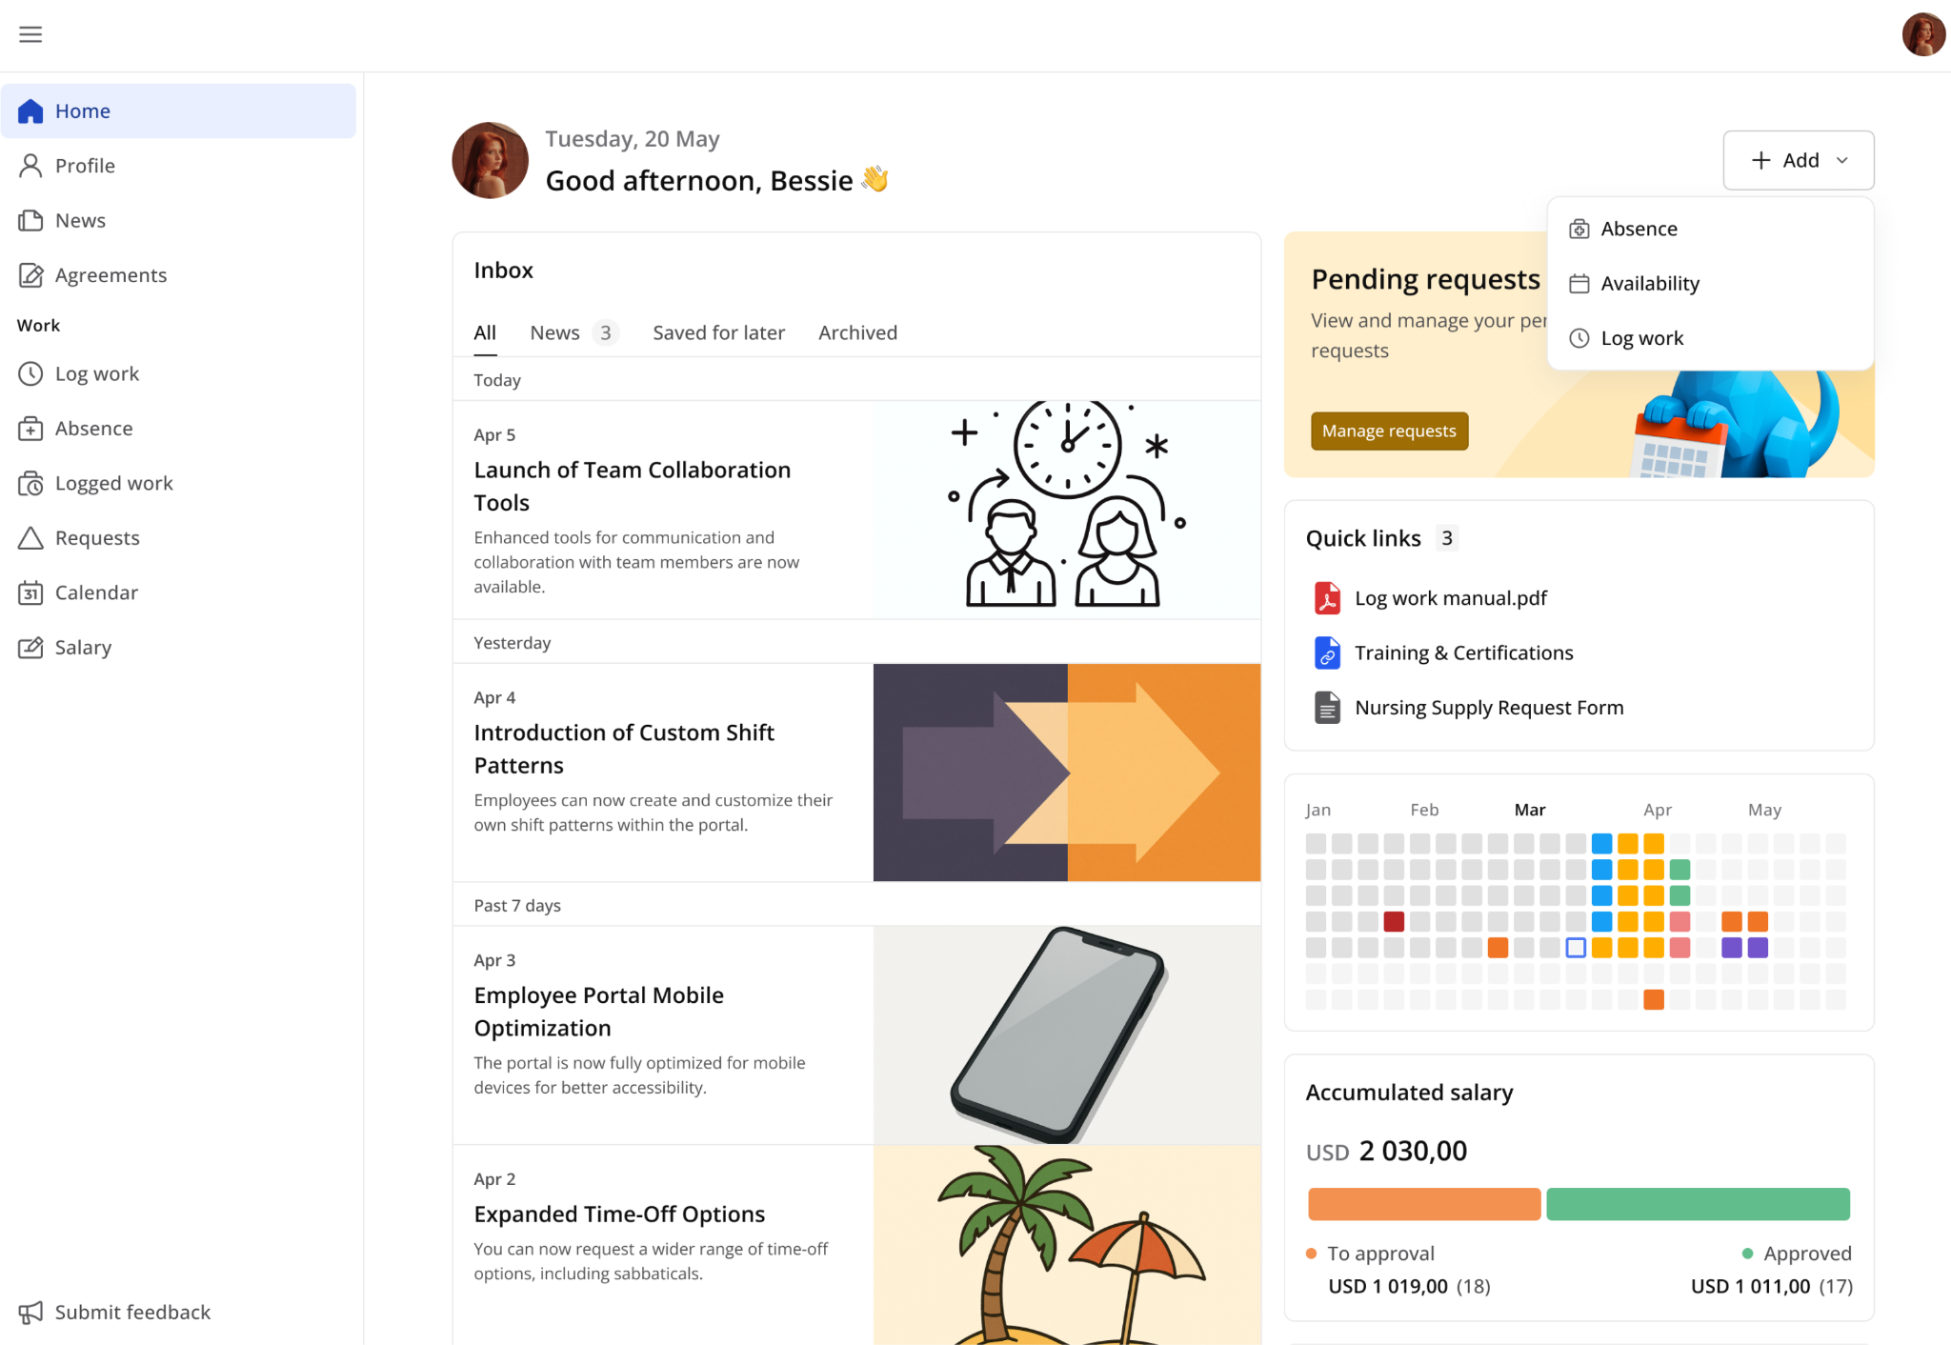
A homescreen provides a clear overview of important information and quick access to key actions. It includes several widgets designed to give quick insights and easy navigation:
- Inbox - displays corporation-level news and announcements so you can stay informed about updates and important messages.
- Notification banners - highlights important actions you may need to take, such as pending signature agreements or completing missing profile information (e.g., required attributes or fields).
- Quick links - provides access to shared files. All files in the Employee Portal can be viewed in a separate preview modal, allowing you to stay on the same page and reducing the need for extra navigation.
- Heatmap calendar - shows tracked activities on specific days, giving a visual overview of your activity history.
- Salary overview widget - displays approved and pending salary-related work items. Once payments are processed, they are removed from this list.
- Weekly work widget - shows work items locked during the current week, helping you quickly track your logged work.
You can also quickly perform key actions directly from the homescreen, such as logging work, adding absences, or updating availability, with shortcuts that redirect to the relevant sections.

4.2 Profile
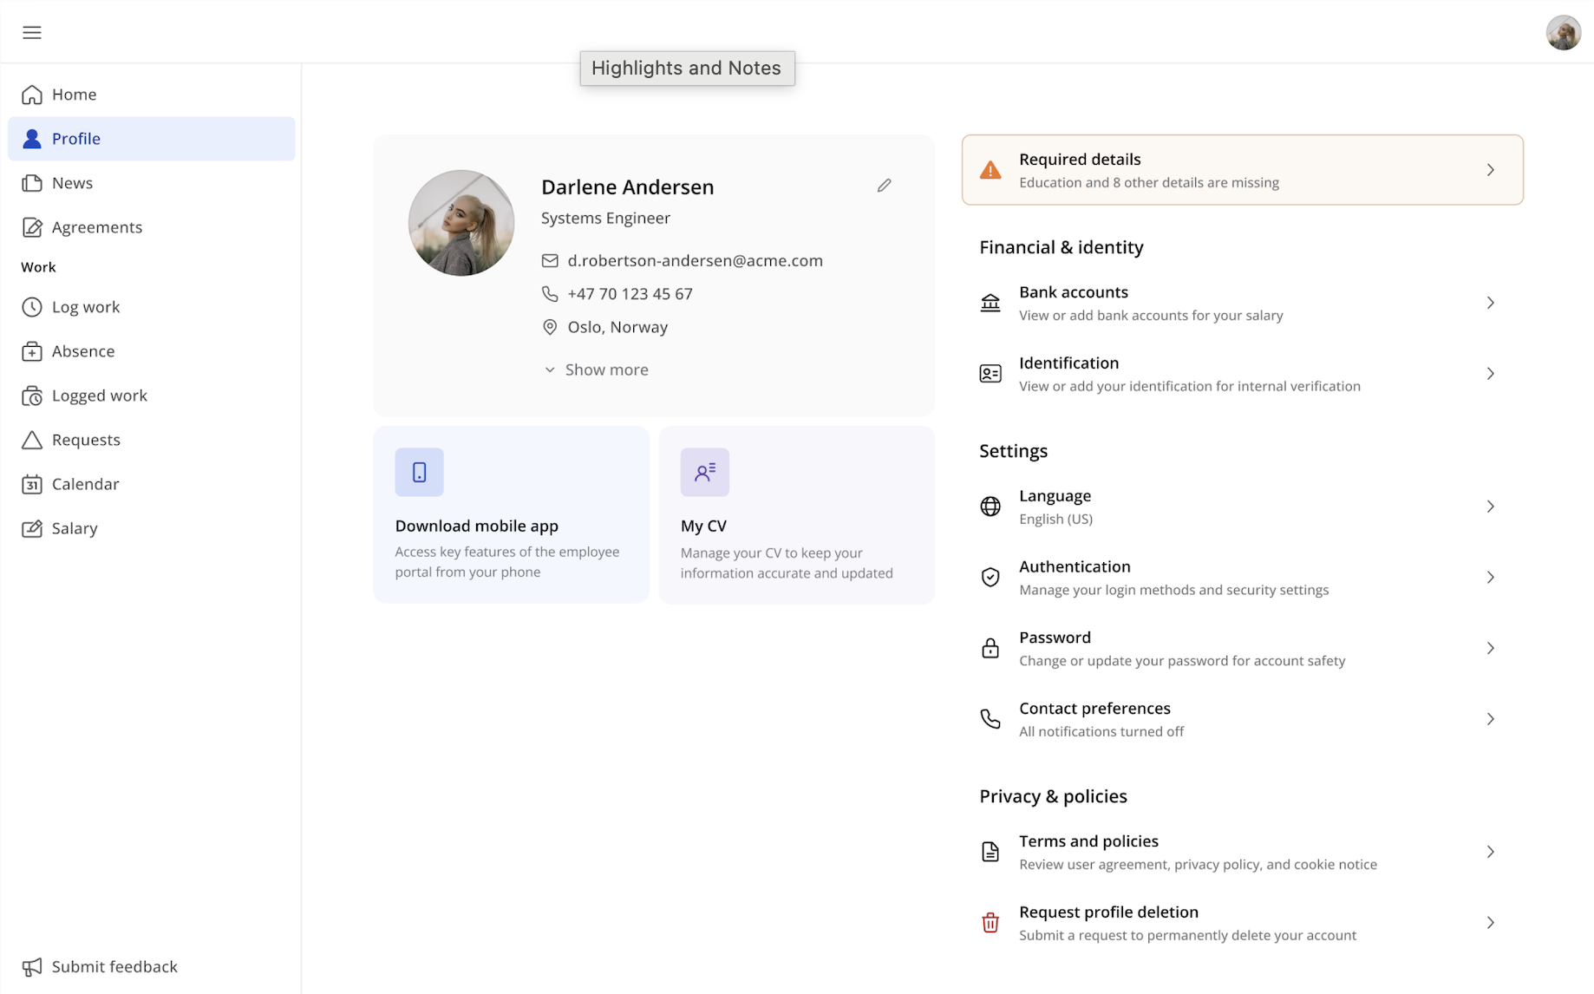
From this page, you can view and manage your general information, update contact details, and access personal settings such as changing the interface language and password.

Depending on permissions, you may also be able to download the mobile apps, review files, and access privacy-related information.

A key feature of the profile page is the My CV section, where you can review existing profile information, add new entries, and edit CV details as needed.

The profile page is dynamic and will adapt based on system settings and the information available in the profile. If required fields are missing, you will receive a notification prompting you to complete the necessary information.

Work

4.3 Log work
We will now go through the logging work process. To find the screen for work registration, click «Log work».
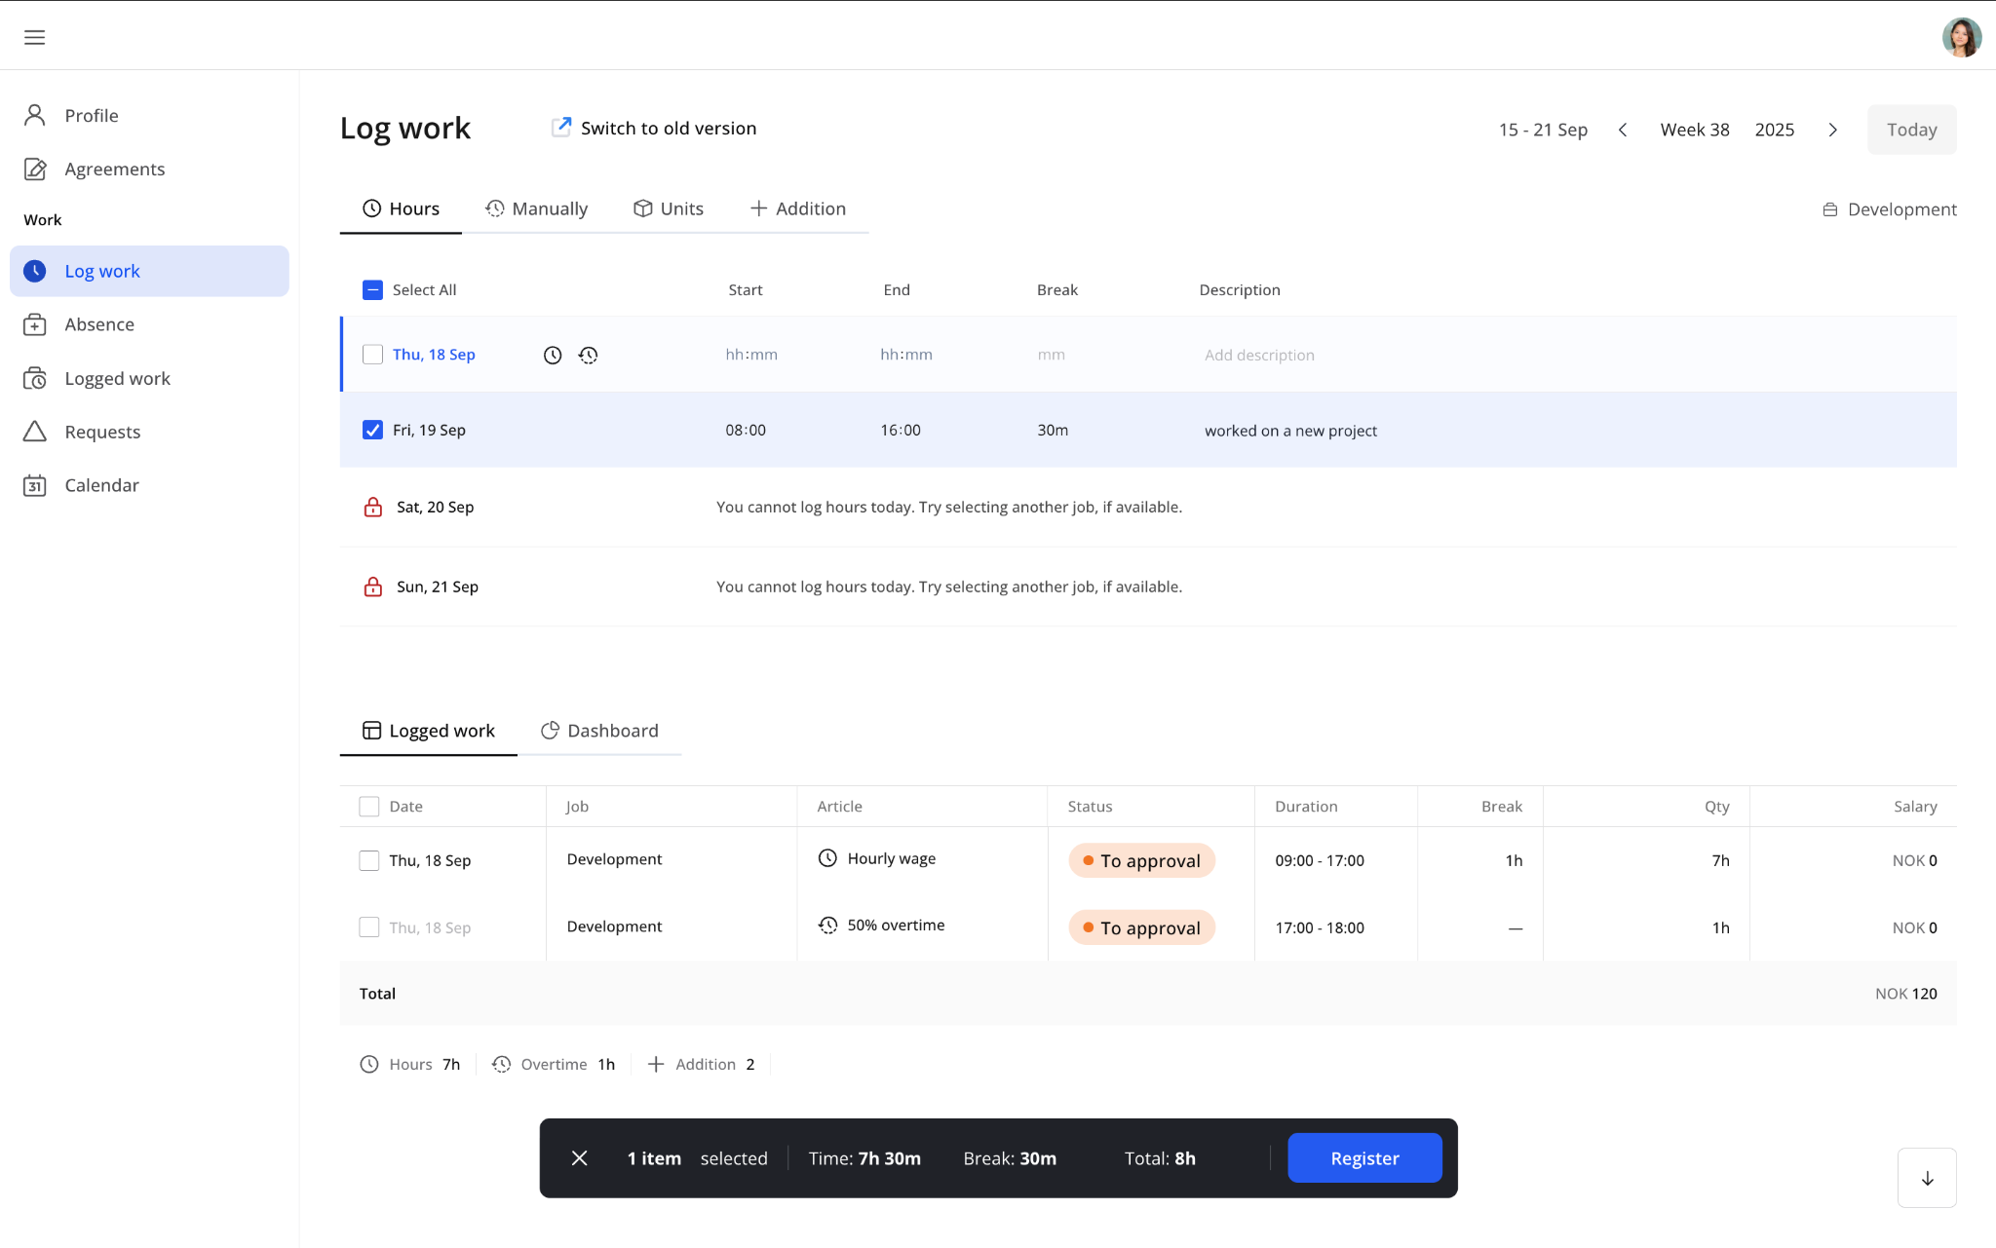
Once clicked, you will see a screen where you can log your work. In most cases, this screen will display the days of the current week, with the ability to register hours for various times on these days. Note that this screen may differ depending on your employer’s preferences and policies.
You can select one or more days before clicking «Register». Note that the «Register» button only appears when valid work is ready to be registered. The work will be recorded, and your employer or an external approver can approve it. Once work is logged, it appears below for quick reference.
If certain jobs are unavailable for logging during a selected period, they are shown but disabled, ensuring users can clearly see which options are valid. Logged items for the current day are also listed, helping users avoid duplicating entries.
Work can be registered for any available day, with the current date highlighted for visibility. Each entry can be reviewed in a drawer, edited directly, or deleted if needed. A status indicator makes it easy to track the state of logged work.
You can also change which week you want to log your work on by clicking the week and year buttons in the top right corner. Note that depending on policies set by your employer, the ability to log work on certain days, i.e., in the future, can be closed, and you will have to wait until tomorrow.
If your manager leaves a comment, you can answer it in the Comments section at the bottom of the right-side Details drawer.
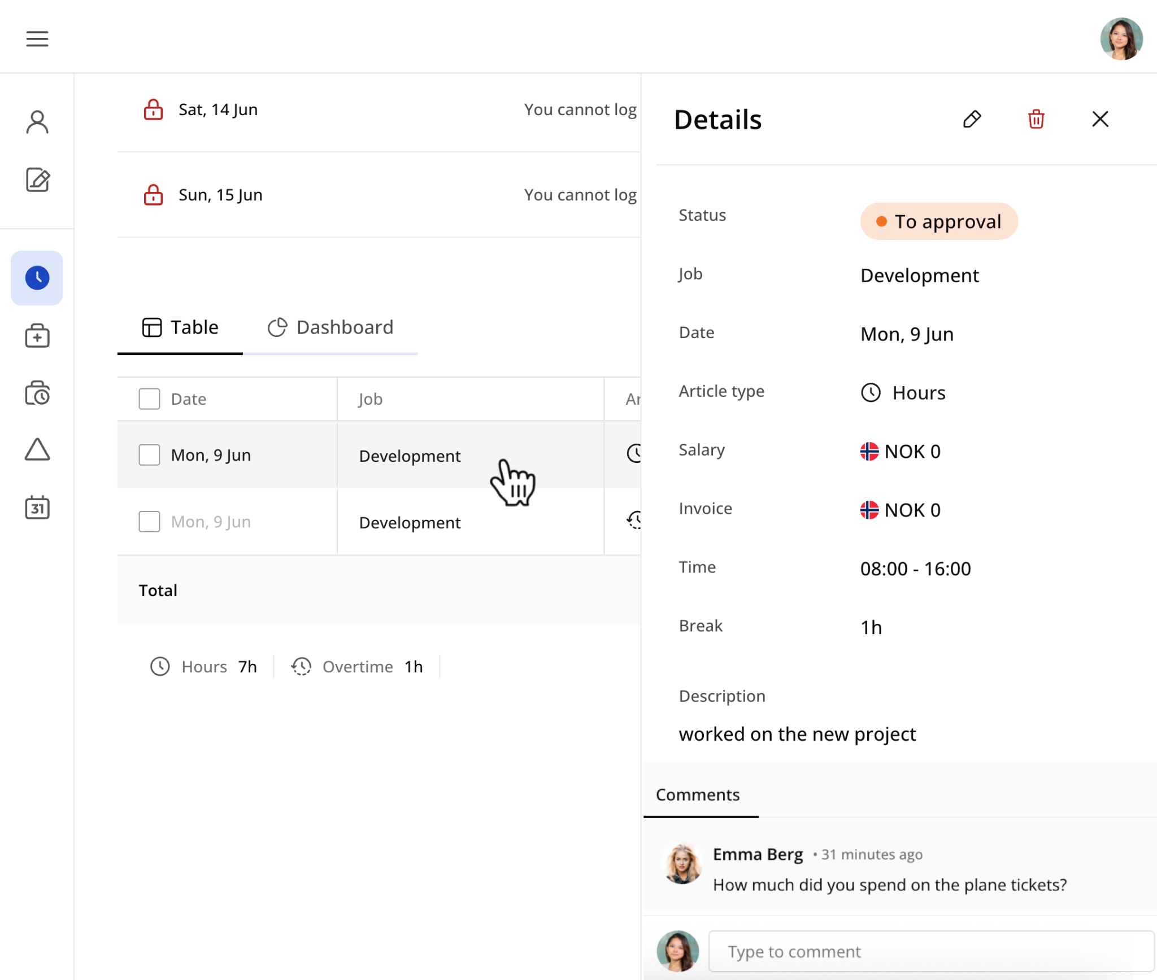
If you are to log piecework, addition/deduction, absence or for some reason two or more sets of hours on a given day, click the tabs for “Units”, “Addition” or “Hours”. In the “Addition” tab, the date is preselected. Here you can upload attachments or add more rows by hovering over the date.

Break logging
When accessing the work calendar, you can select your job and switch to break period view to log break time associated with your scheduled shifts. The system automatically displays available break periods based on the job schedule configuration.

Hours
In some cases, you are required to log work at different times on the same day. By clicking the “Hours” button, another row for logging work on the same day is added. This could also be used in combination with absence, where you, for instance, were at work for two hours, two hours at the doctor's, and then four hours at work again.

Hour registration with child projects
When you are to record regular work, but your work is to be separated during the day, your employer may use child projects. You can define this when you register your hours for your employer so that they can see where you worked and at what times. This is typically used in construction.

Manually
In rare cases, a function for logging work manually will be available. This means you define the salary article, work type (salary, addition, overtime), time and dates you have worked.

Units (Piecework)
Unit logging, or piecework, is common in sales, consulting, and construction positions. Piecework is often registered in addition to regular hours. Note that it could be in quantity or hours, so be aware if it should be 1 hour and 30 minutes or 1.5.
Piecework with period logging is very similar to regular piecework logging, with some changes. You record your work for the whole month, and once they have been sent to the employer, it may not be changed. Additionally, you must record work for the previous period before recording for the current month.
You can find specific jobs quickly by typing in articles. All job-related articles appear in a single dropdown under the article column. Grouped articles are marked, but any article can be selected with one click. The system manages group associations automatically.
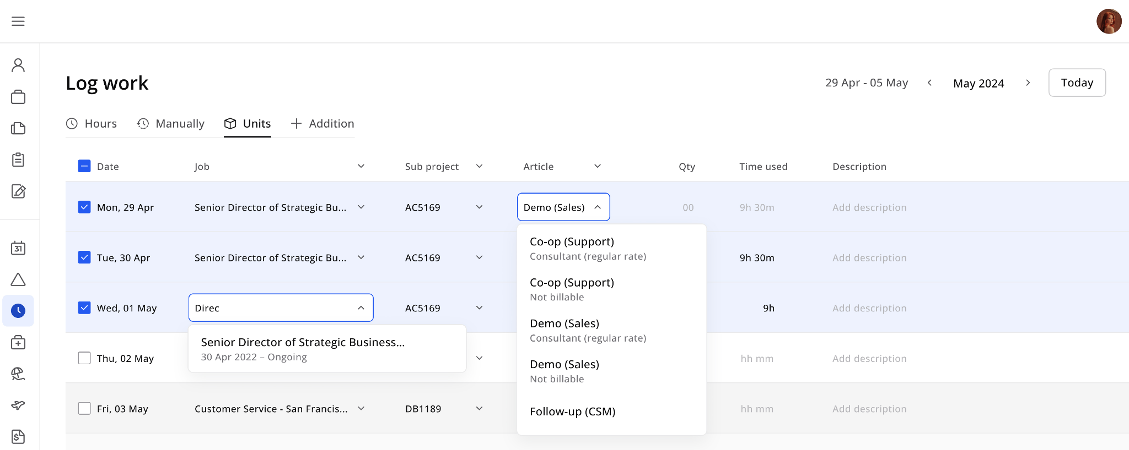

Time
"Time" tab offers an alternative way to log piecework units that's optimized for employees who need to enter multiple entries efficiently. The streamlined table layout organizes articles by job in a weekly timeline view, with each cell representing a single day, making it easy to log piecework week-by-week or article-by-article rather than entry-by-entry.

Data entry is quick and simple - just enter values in the cells and receive instant visual confirmation with a green indicator when data is saved, with the ability to add or remove rows as needed for each piecework type. The interface includes helpful tooltips that display daily summaries showing which salary and piecework articles were logged for each job, total numbers displayed at the bottom of the page, special UI highlighting for absences and holidays, and the ability to review, edit, or delete logged entries through a convenient drawer (permission-based).

Simplified units login is configured at the job level under permissions when selecting "log piecework" with four options: Yes (default) for both Units and Time tabs available, Flexible only for Units tab only, Simple only for Time tab only (simplified interface), or No to disable units logging.

This feature is ideal for employees who regularly log multiple piecework entries and need a more convenient alternative to the traditional hourly logging method.
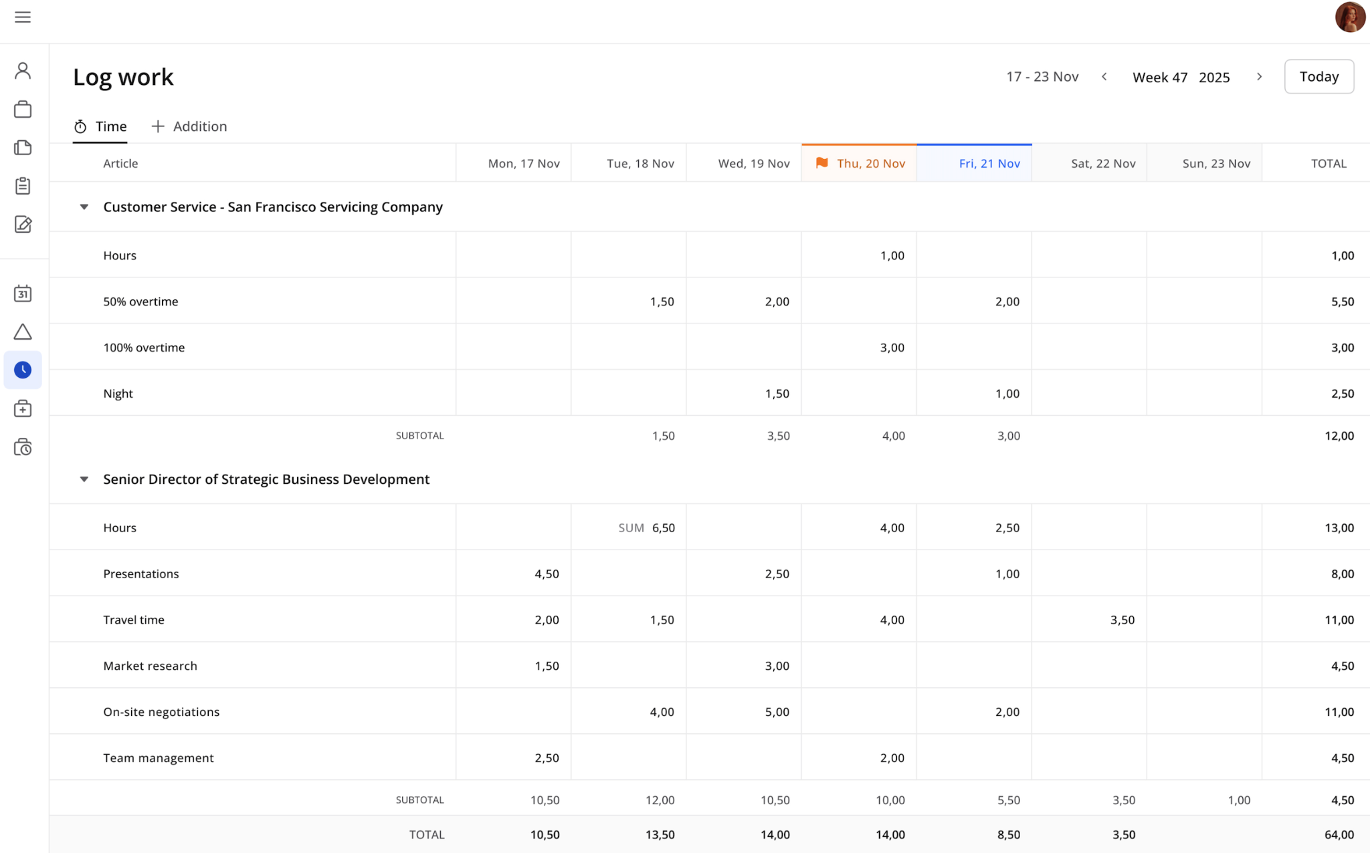

Additions, deductions, and attachments
Additions and deductions are loggings that you can make to adjust your salary. For instance, if you are to receive compensation for parking, driving to work, using your tools, etc., this can be logged as additions. You can upload attachments in this tab, and if you are using a phone, you may upload a picture directly from your mobile camera. Non-included lunch and rent are examples of deductions. You get additions in addition to your regular salary, while deductions are deducted from your salary.

Dashboard tab
A Dashboard tab will show a visual interface that displays key information in an easy-to-read format. It includes widgets like Total salary, Hours, Work week, etc.
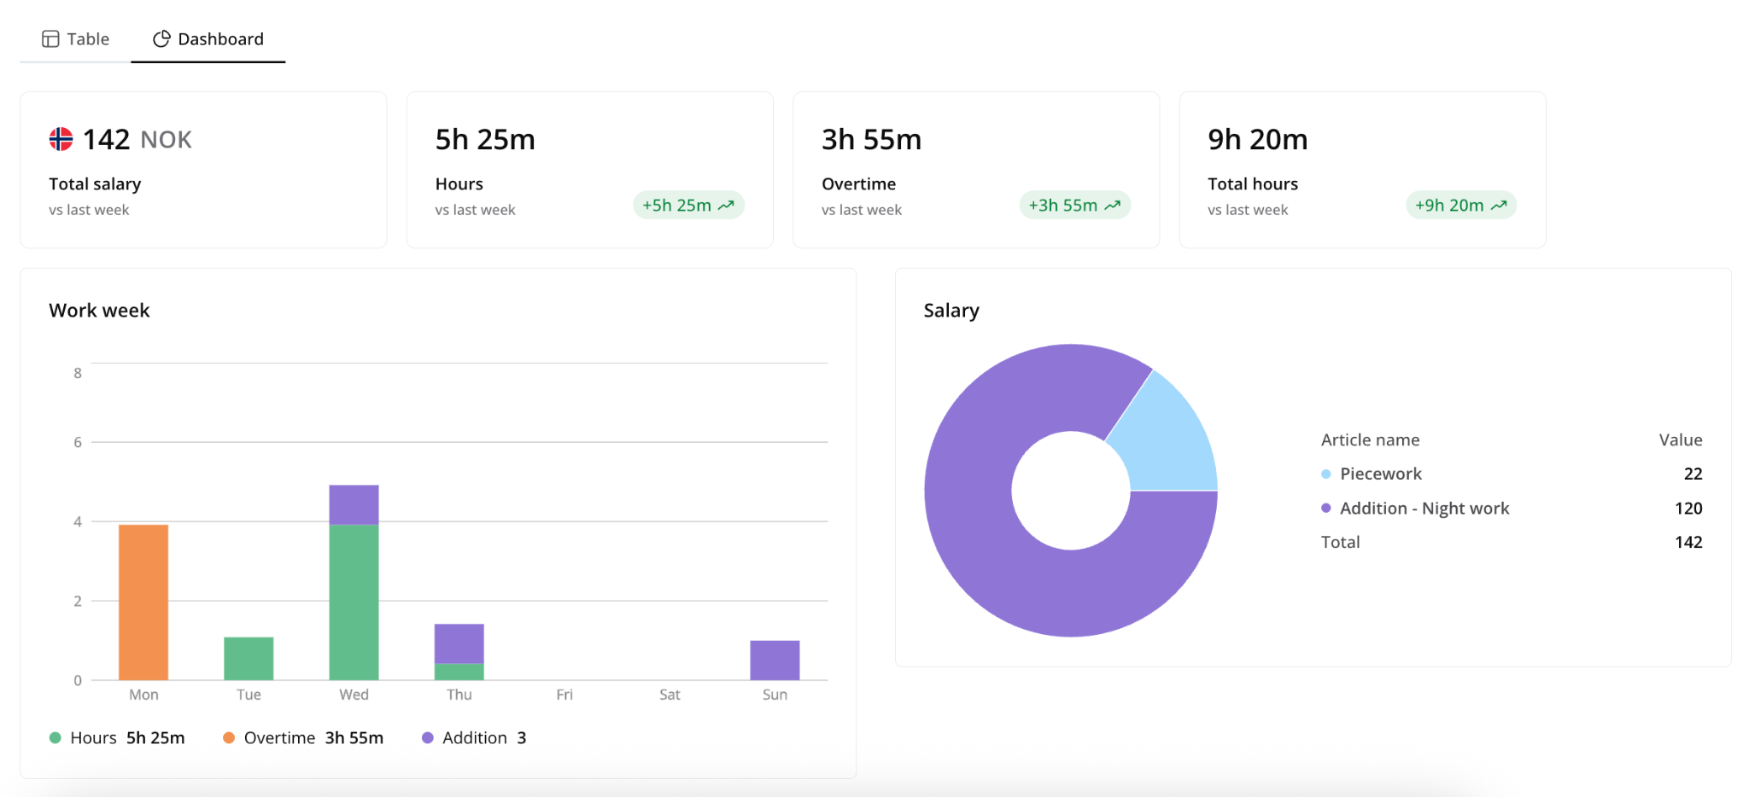

4.4 Absence
Absence is registered on days you haven’t worked, such as when you're sick.
The Absence module opens with an overview page. If no absences have been logged, only the Create absence button is visible. Once records exist, the page shows all absences for the year, split into To approval and Approved tabs. A dashboard on the right summarizes worked days and absences. A heat map at the bottom highlights absence days across the year. Any entry can be opened for details, edited, or deleted directly from this view.
Creating an absence is simple. By default, it records a single day, but you can extend this to a date range using the period toggle. Then select a job, enter the time, choose an article, add a description, and, if needed, upload files. After selecting a job, the break period time will display the relevant break periods from the assigned shifts. The calendar and preview update automatically to show how the absence will appear. When selecting longer periods, weekends can be included or excluded by choice (excluded by default).
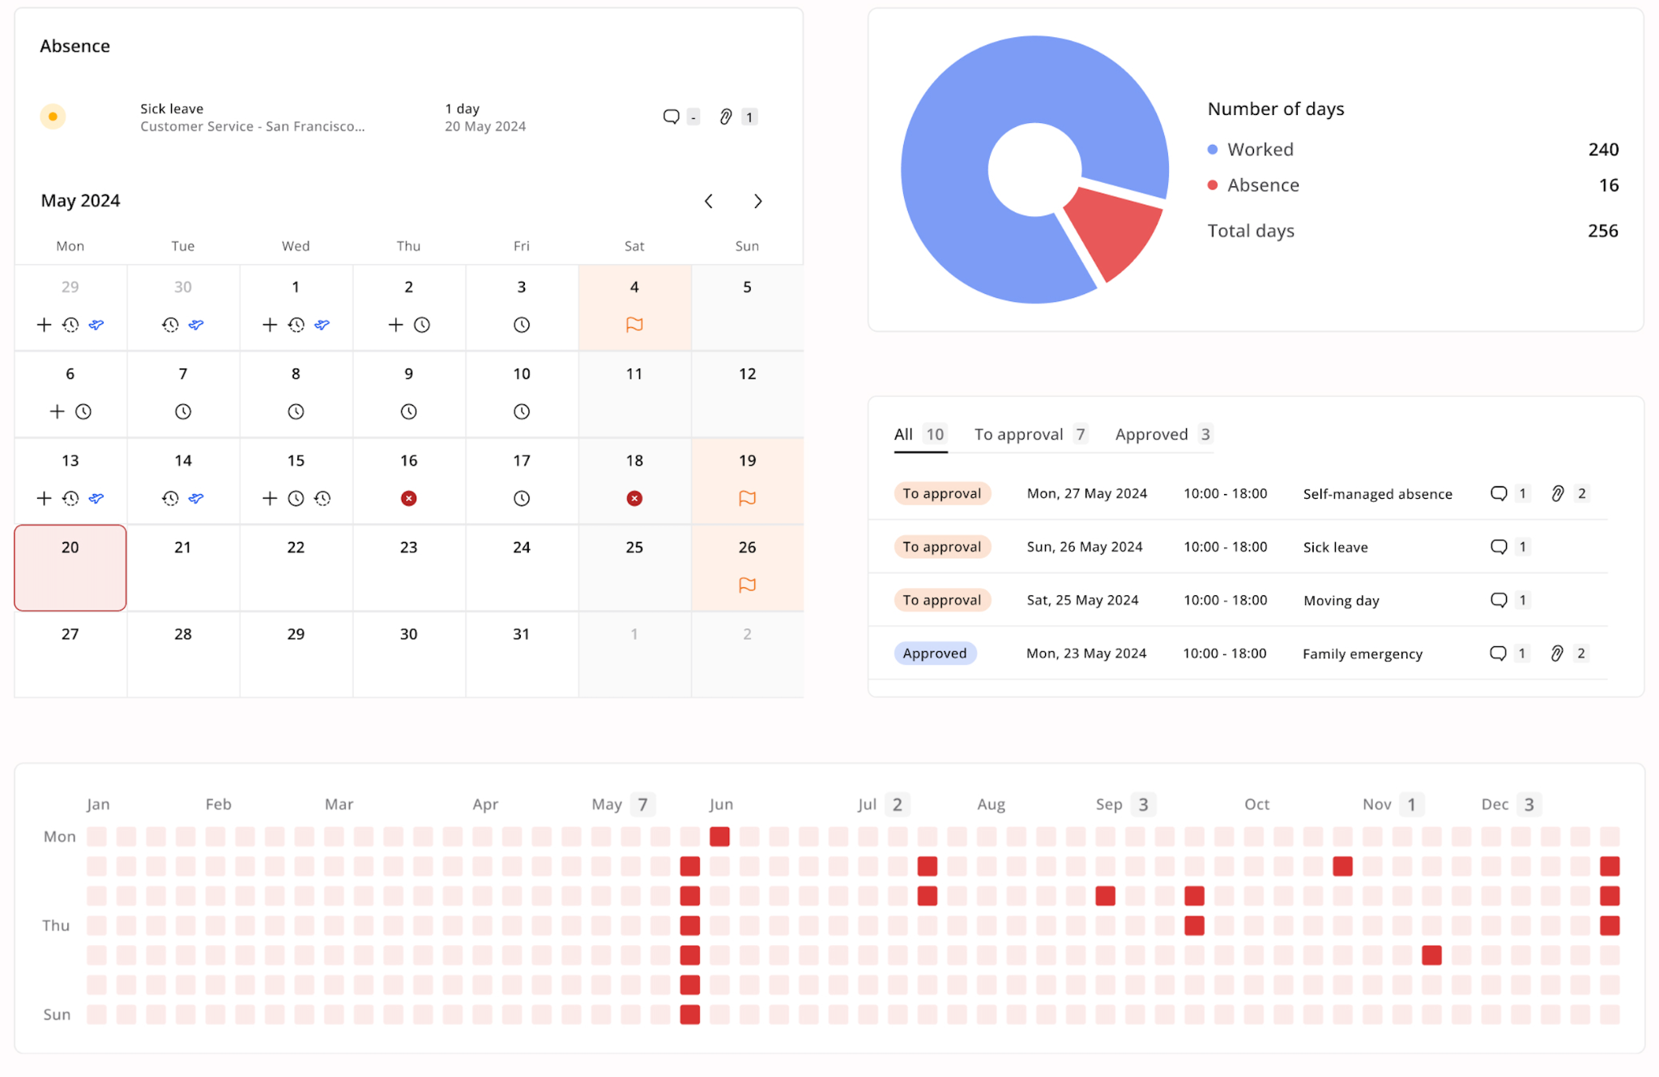

4.5 Logged work
“Logged work” allows you to review and manage all logged work items.
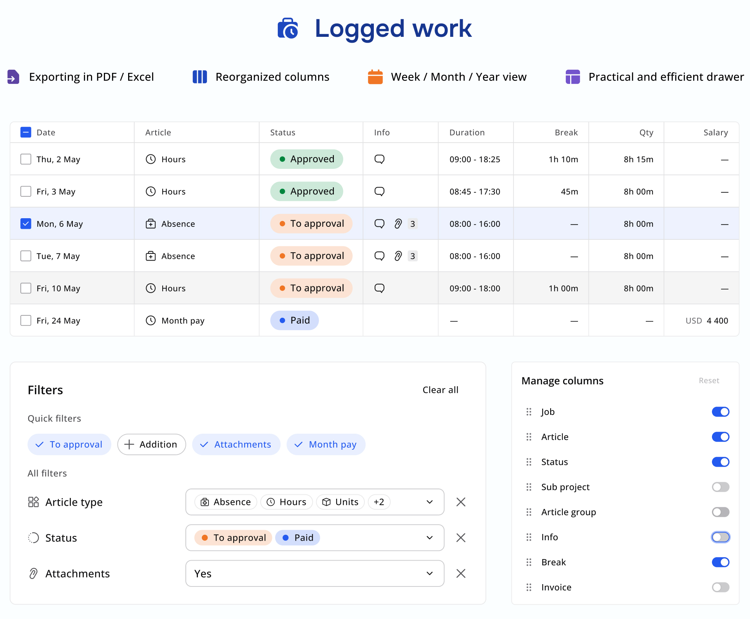
The summary view displays all articles logged within a selected month, including the quantity for each entry. It is designed to give you immediate insights and clarity about your work activities, making it easier to review and track what has been recorded over time.

4.6 Requests
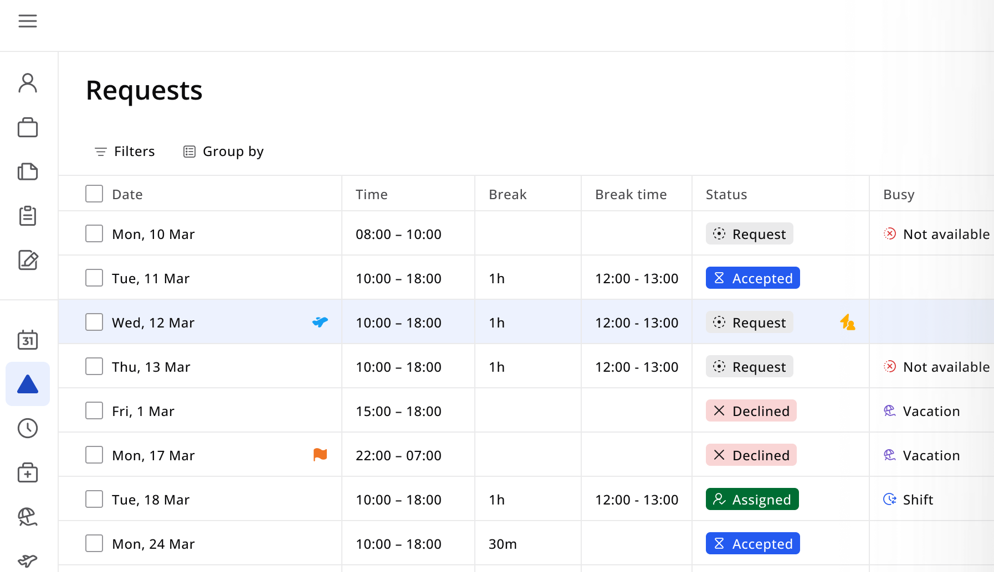
The Requests module in the Employee Portal allows employees to receive and respond to booking requests.
When a booking is created in the RecMan or Company Portal, and you have been added, you will receive a request in the Requests module. You can view project details, check availability, and decide whether to accept or decline the request. If accepted, the request is automatically converted into a shift.

4.7 Calendar
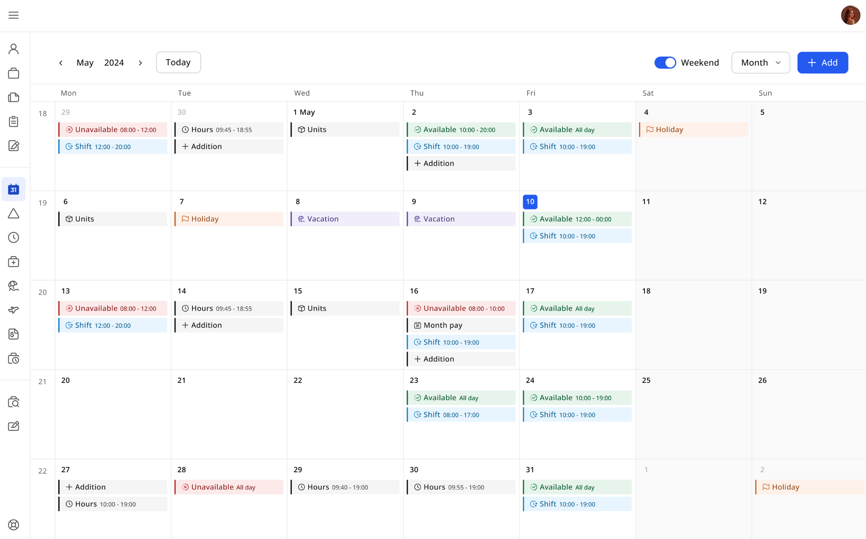
The work calendar module has a monthly view and includes flexible viewing options. Based on your preferences, you can display the calendar with or without weekends. By clicking the button of the current month, you can easily navigate through two dropdowns with months and years.
The calendar displays various events, including availability and unavailability events, vacations, logged work items, shifts, and holiday events. Depending on permissions, you can create, edit, and delete shifts directly from the calendar interface. The vacation logging process works similarly to adding availability shifts - you can specify start and end dates for your vacation request directly within the work calendar interface. A view-only modal displays detailed information about events for users without editing permissions.
You can view detailed information for availability, unavailability, and shift events. When creating new events, you can schedule single-day or multi-day events, with options to set them as all-day events or specify exact start and end times. The calendar supports complete event lifecycle management, allowing authorized users to view, edit, and delete events as needed.
Multi-day events created at the same time are visually grouped into event threads. When editing or deleting a threaded event, you can choose to apply changes to all events in the thread or only to selected days without the need to update or remove events one by one.

4.8 Salary
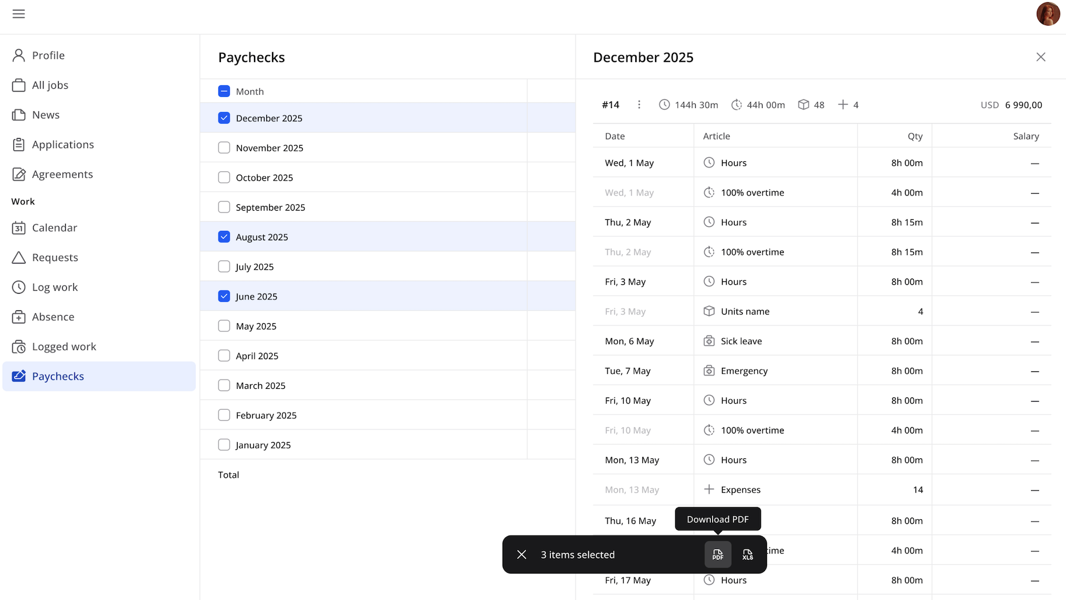
The Salary section provides an overview of salaries and payslips throughout the year. Salary data is displayed in a yearly view, showing only the months in which salary has been generated. The main table provides a monthly summary, including total hours, overtime, locked salary articles, and total salary amounts. All totals are shown using the currencies configured and locked on your profile. Each month can be opened in a detail drawer, where you can see a breakdown by article type with detailed totals and splits for full transparency. For record-keeping and sharing purposes, salary information can be exported to PDF or Excel, either for specific months or for all available months at once.

