

User guide for candidates and employees
User manual for the Candidate Portal

Version | 1.1
Latest update | 2023-10-26
Created by | Gøran Sæland
Contributors | Marius Gravem
Confidentiality level | PUBLIC

Content
1 Introduction 2
2 Logging in 3
2.1 Login issues and forgotten password 4
2.2 Change password 6
3 The different tabs 7
3.1 Positions 7
3.2 News 7
3.3 Work 7
3.4 Calendar 7
3.5 Agreements 7
3.6 Job applications 8
3.7 Contact us 8
3.8 Settings 8
3.9 Logout 8
3.10 Language 8
3.11 My profile 9
4 Mandatory fields 10
5 Log work 11
5.1 Piecework 13
5.2 Additions, deductions and attachments 13
5.3 Absence 13
5.4 Manual 13
5.5 Hours 13
5.6 Hour registration with child projects 14

1 Introduction
In this document you can read about the candidate portal and its features, both for candidates and employees. We will go through the most crucial functions, like work registration, mandatory CV fields and resetting your password.
Note: This guide is made with every possible permission and function turned on. Should your profile look different, this can mean that your permissions and functionality is limited or adjusted by your employer.
This document was published in January 2020, together with the release of RecMan’s improved view for logging work – optimised for mobile phones.

2 Logging in
First of all, we will go through the process of logging into the system to get access to your candidate profile. We will also show you how you reset your password, should you have forgotten it.
When you register a profile with the company using the system, you will be able to log in as you please. You may have a profile in several RecMan systems, depending on the company, and these profiles are not shared between the companies. Because of this, it is essential that you use the correct site when logging in. A typical site for logging in should look like this:
https://COMPANYNAME.recman.no/login.php
Here we have written “Company Name”, this is where you will use the name of the company you are registered with. When visiting this link, you will see the following screen.
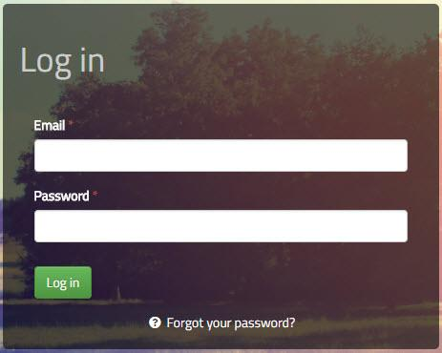

Here you input the email and password you used to register your profile with this company. Click “Log in” in order to log into your candidate/employee profile.

2.1 Login issues and forgotten password
Should you have issues with your login, we recommend double checking that your email and password is written correctly. Should you be positive that both are correct, you can use the «Forgot your password?” button.
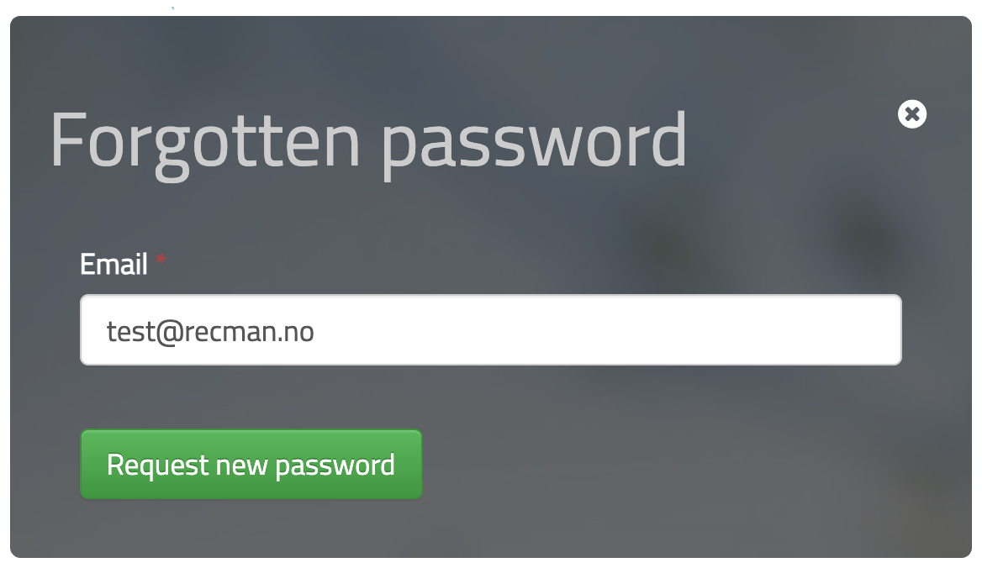
Once pressed, you will see a small box where you will be able to input your email once more, and press the «Request new password» button. Should your email have been input correctly, you will receive an email where you can click a link to be automatically logged in. You may also copy the link and paste it in the address field in your web browser if you are unable to click it.
When clicking the link, you will be logged into your profile, and you will see a red box where you can reset your password, enabling you to log in next time.
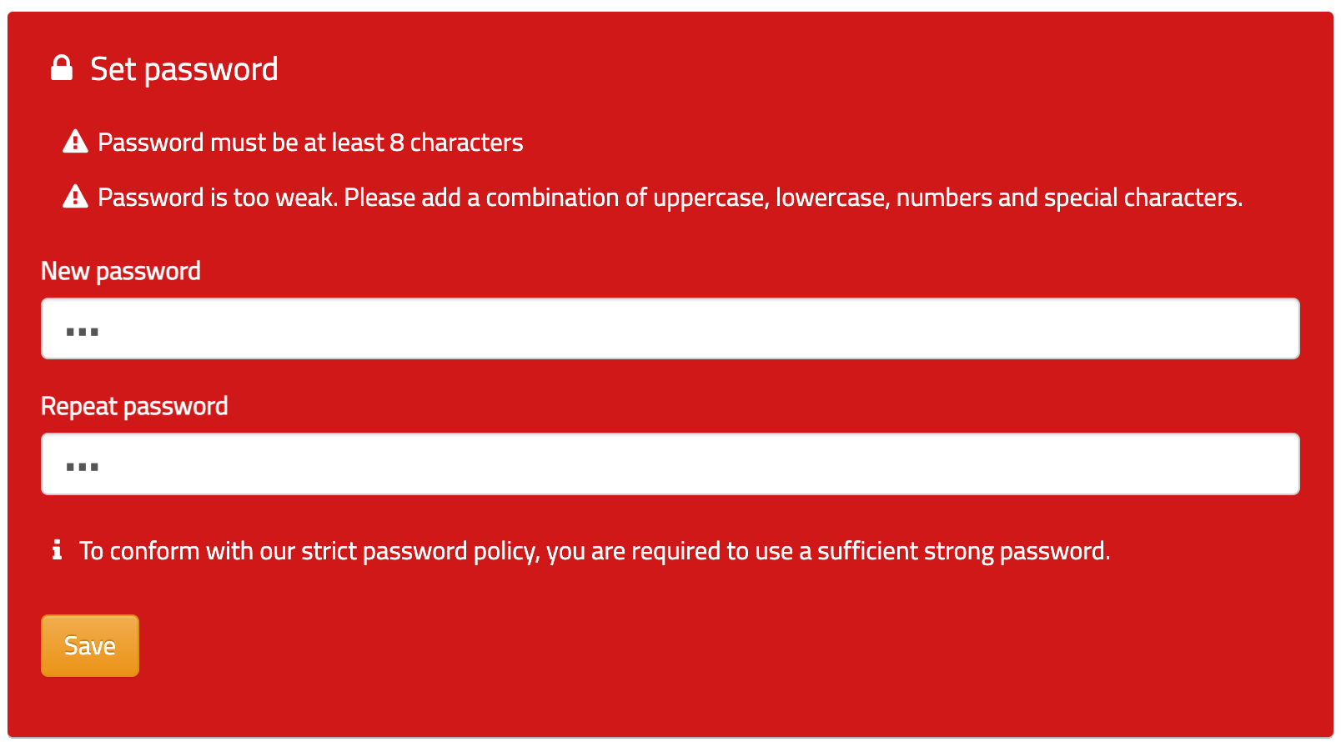
Should you still have issues logging in, contact the company who has your profile in their system. On the same screen where you log in, you can see a link to their website. They will be able to provide you with a new password.

2.2 Change password
After you have logged into your profile, you can change your password, directly from your profile. As previously mentioned, you will be asked to define a new password the first time you log in / when you use the «Forgotten password» function, but should you wish to change it at a different time, you first click «Settings» as shown in the picture below.
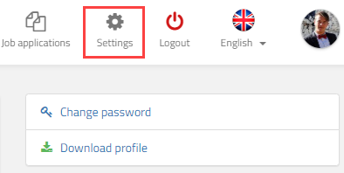
Here you can click «Change password». Once clicked, you see a box which looks like this.
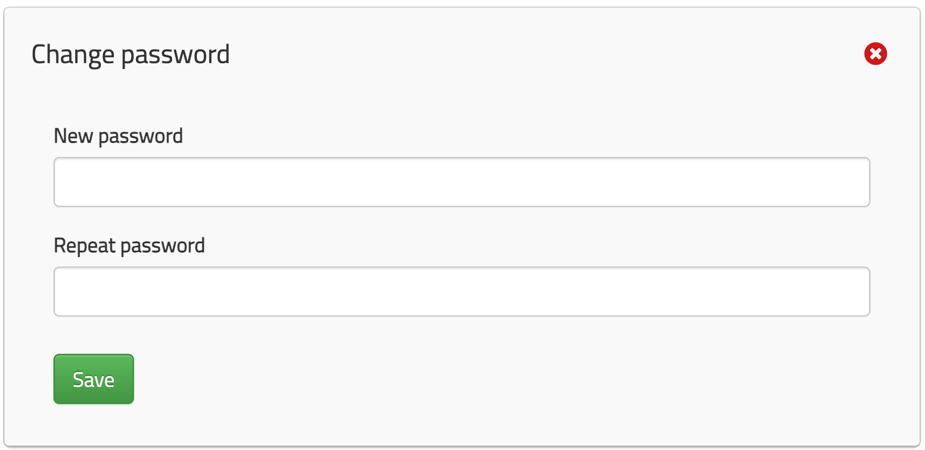
Here you can input a new password. You must input it twice to make sure that you write it correctly. Click «Save» to change your password.

3 The different tabs
When logging in to your profile, you will have a selection of tabs to enter. Depending on the settings in the company’s system, and if you are a candidate or an employee – these can vary.

3.1 Positions
Here you may see all available positions for jobs for you to apply on. As you have already created a profile, you will not require to fill out information as you did when first registering.

3.2 News
Here you can see news published by the company.

3.3 Work
As an employee, this is where you register work. See Log work for more information.

3.4 Calendar
As an employee, here you may set your status of availability, view vacation days and shifts you are to work in addition to accepting requested shifts.

3.5 Agreements
Your employer can send you electronic agreements for you to sign. Usually these agreements are employment contracts and order confirmations. Note that this button is only visible once an agreement has been created for you.
You get these agreements sent to your email from the employer, for you to sign. However, you can also see all agreements sent to you directly in your candidate profile. Additionally, you can sign any unsigned document after opening it. This button is displayed in red should you have unsigned documents.

3.6 Job applications
Here you may see your active and prior applications, and their status.

3.7 Contact us
Here you may find contact information at the company. If this button is not available to you, you could go to «Positions» and look for contact information on the bottom right corner of the page.

3.8 Settings
Here you may set a variety of settings for your profile. As a candidate, you will be able to access and view the terms that you accepted when registering, and you can change the default period set for automatic deletion. At any time, you can also delete your profile from the company’s system. All your information, including your CV and uploaded attachments, will be permanently deleted from the system. This also means that you will not be considered for any future positions.
Depending on the permission set by the company, you may either delete, or request deletion. If you are employed, you will not be able to delete your profile. Automatic deletion will also be put on hold if you are an employee. Note: The employer will not be able to restore your profile, should you regret your decision to delete it.

3.9 Logout
Click this button to log out. Note that if you don’t log out, you will be logged in when you come back to the page at a later time.

3.10 Language
Here you may select your designated language.

3.11 My profile
This is your candidate/employee profile page. Here, CV information such as education, work experience, skills, references etc., can be inserted, as well as uploading files and a profile picture. You may also add or update your contact information. If you are employed, you may also insert additional information regarding your employment.

4 Mandatory fields
In the profile, you can fill in several CV fields, among others work experience, courses, education, etc. Normally these fields are optional, meaning you can fill in this information as you wish.
However, in some cases the company you have registered with may define some fields to be mandatory. This means that they demand that you fill in those fields. If you don’t, your profile will not be visible to the company in their system, and your profile won’t be assessed. You will be notified of which fields you are missing as shown in the picture below.
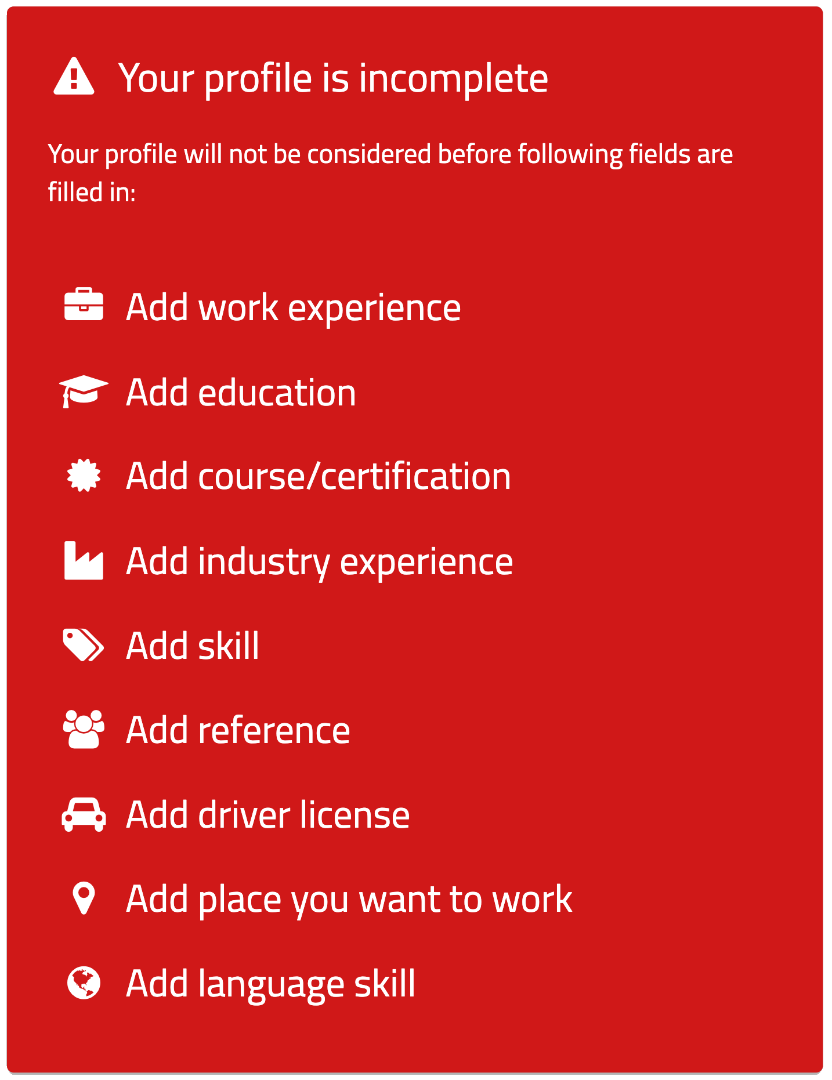

You can also see which fields are required by looking for the red star like: Work experience *.
Note: Even though the company does not use mandatory fields, we highly recommend you fill out as many fields as possible in your CV. This will increase your chances of getting considered for a position. Incomplete profiles are often ignored or deleted outright.

5 Log work
Once you have logged into your profile, you have several options. We will now go through the process of logging work. To find the screen for work registration, click «Work».
On the left-hand side, a set of windows can be selected. «Log work» is the window for logging work. «Logged work» is where you can see your logged work. «Create job» is a function for creating jobs, and «My jobs» will list all active and historical jobs.
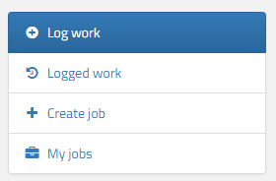
Once clicked, you will see a screen where you can log your work. In most cases this screen will display the days of the current week, with the ability to register hours to various times on these days. Note that this screen may look different depending on your employer’s preferences and policies. On the next page you can see an example of the screen where we can register regular work.
As you can see here, you are able to select one or more days before clicking «Register». Note that the «Register» button only appears when valid work is ready to be registered. The work will be recorded, and your employer will be able to approve it. You may also change times and break before registering, to match your actual hours in the case of a deviation.
You can also change which week you want to log your work on, or click the calendar icon in the top right corner of the “Log work” window. Note that depending on policies set by your employer, the ability to log work on certain days i.e. in the future can be closed – and you will have to wait for tomorrow.
If you are to log piecework, addition/deduction, absence or for some reason two or more sets of hours on a given day, click the buttons for «Piecework», «Addition», «Absence» or «Hours». The «Addition» button will forward you to the «Addition» tab where date is preselected. Here you can upload attachments.
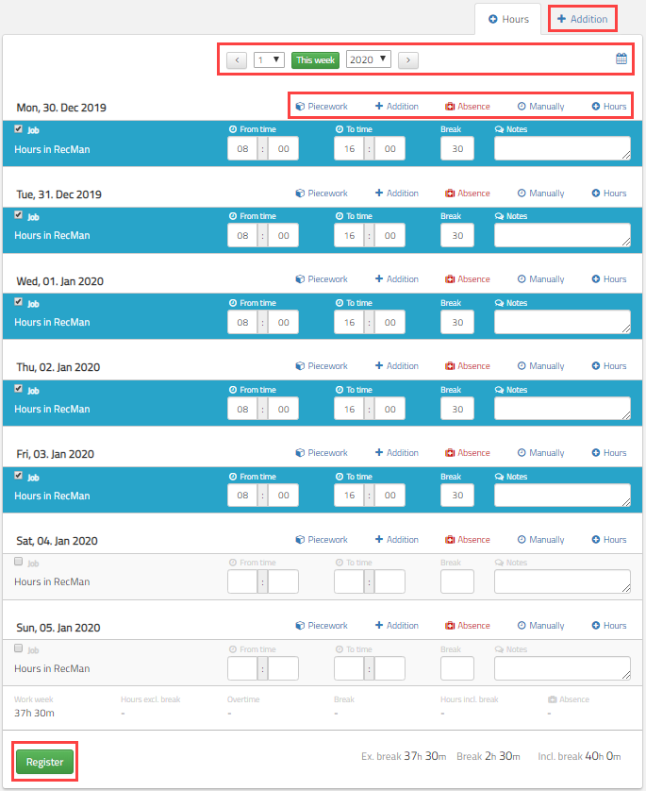

5.1 Piecework
Unit logging, also known as piecework, is common in for instance sales positions. Piecework is often registered in addition to regular hours. Note that piece means amount, and if hours are logged as piecework, 1 hour and 30 minutes should instead be logged as 1.5.
Piecework with period logging is very similar to regular piecework logging, with some changes. You record your work for the whole month, and once they have been sent to the employer, they may not be changed. Additionally, you must record work for the previous period before recording for the current month.

5.2 Additions, deductions and attachments
Additions and deductions are logging you can do to adjust your salary. For instance, if you are to receive compensation for parking, driving to work, using your own tools, etc., this can be logged as additions. You will be able to upload attachments in this tab, and if you are using a phone, you may upload a picture directly from your mobile camera. Non-included lunch and rent are examples of deductions. Obviously, additions are something you get in addition to your regular salary, while deductions are deducted from your salary.

5.3 Absence
Absence is registered like regular work, but with the option to change the article. Typical absence articles are vacation, sick leave, etc. Absence is registered on days you haven’t been to work.

5.4 Manual
In rare cases, a function for logging work manually will be available. This means that you yourself define what salary article, work type (salary, addition, overtime), time and dates you have worked.

5.5 Hours
In some cases, you are required to log work at different times in the same day. By clicking the «Hours» button, another row for logging work on the same day is added. This could also be used in combination with absence, where you for instance were at work for two hours, two hours at the doctors, and then 4 hours at work again.

5.6 Hour registration with child projects
In situations where you are to record regular work, but the work you do is to be separated during the day, your employer may be using child projects. This is something you can define when you register your hours for your employer so that they can see where you worked at what times. This is typically used in construction.

