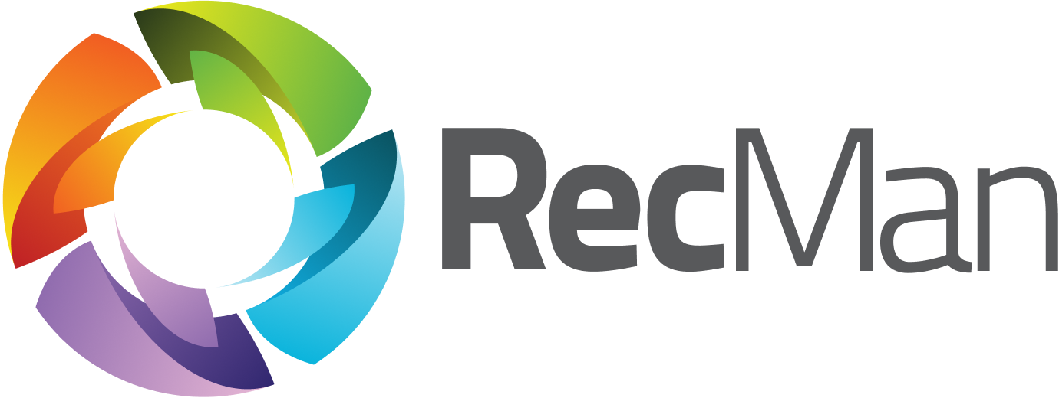

User guide for contact persons and work approvers
User manual for the Company Portal

Version | 3.0
Latest update | 2026-09-22
Created by | Marius Gravem
Contributors | Gøran Sæland, Iryna Volynets
Confidentiality level | PUBLIC

Content
1 Introduction 2
2 Logging in and Homescreen 2
2.1 Login issues and forgotten password 5
2.2 Change password 5
3 Menu 6
3.1 Contact persons 7
3.2 Booking 8
3.3 Logged work 9
3.4 Employees 12
3.5 Jobs 13
3.6 Invoices 13
3.7 Agreements 14
3.8 Job posts 15
3.9 Partner portal 15
3.10 Recruitment module 18
3.11 Presentations 19
3.12 Inquiries 20

1 Introduction
In this document, you can read about the Company Portal. For companies using RecMan, the Company Portal is an additional feature that can be provided to access their created customer contacts within the system. This is commonly used to view and approve logged hours, but can also be extended to include features such as viewing offers/agreements, invoices, job information, and more.
Note: This guide is made with the basic permissions enabled to view and approve registered work. Should your profile look different, this can mean that your permissions and functionality is limited or adjusted by the staffing company.

2 Logging in and Homescreen
To log in to the Company Portal, the company using RecMan must first create a login. When that is done, they can assign permissions depending on your needs before sending you the login credentials. So, assuming a login has been created and sent, we will go through the process of logging into the system to access your customer profile. We will also show you how to reset your password, should you have forgotten it.
Note that you may have profiles in several RecMan systems, depending on the company, and these profiles are not shared between companies. Because of this, it is essential that you use the correct site when logging in. A typical site for logging in should look like this:
https://COMPANY_NAME.recman.no/customer/login
Here we have written “Company Name”, this is where you will use the name of the company you are registered with. When visiting this link, you will see the following screen.
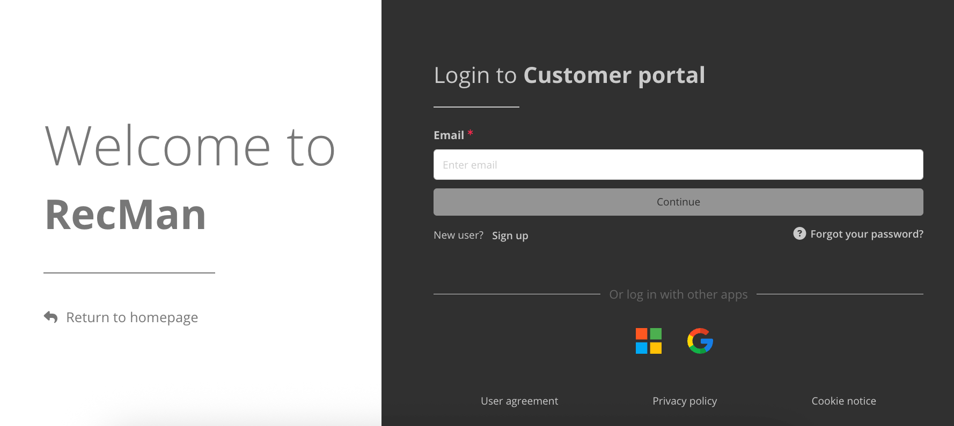
Here you input the email and password given to you by the company. Click “Log in” in order to log into your customer profile. When logging in for the first time, you are likely doing so using a temporary password or a one-time login link. Therefore, it is recommended that you set a new and strong password for later use.
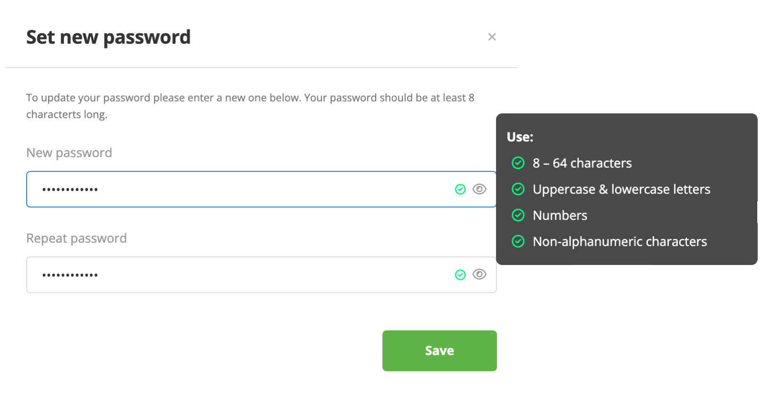
After clicking Save, you should now be in the Company Portal's Homescreen.
You can also enable SSO authentication to enhance the security of your profile using a Google or Microsoft account.
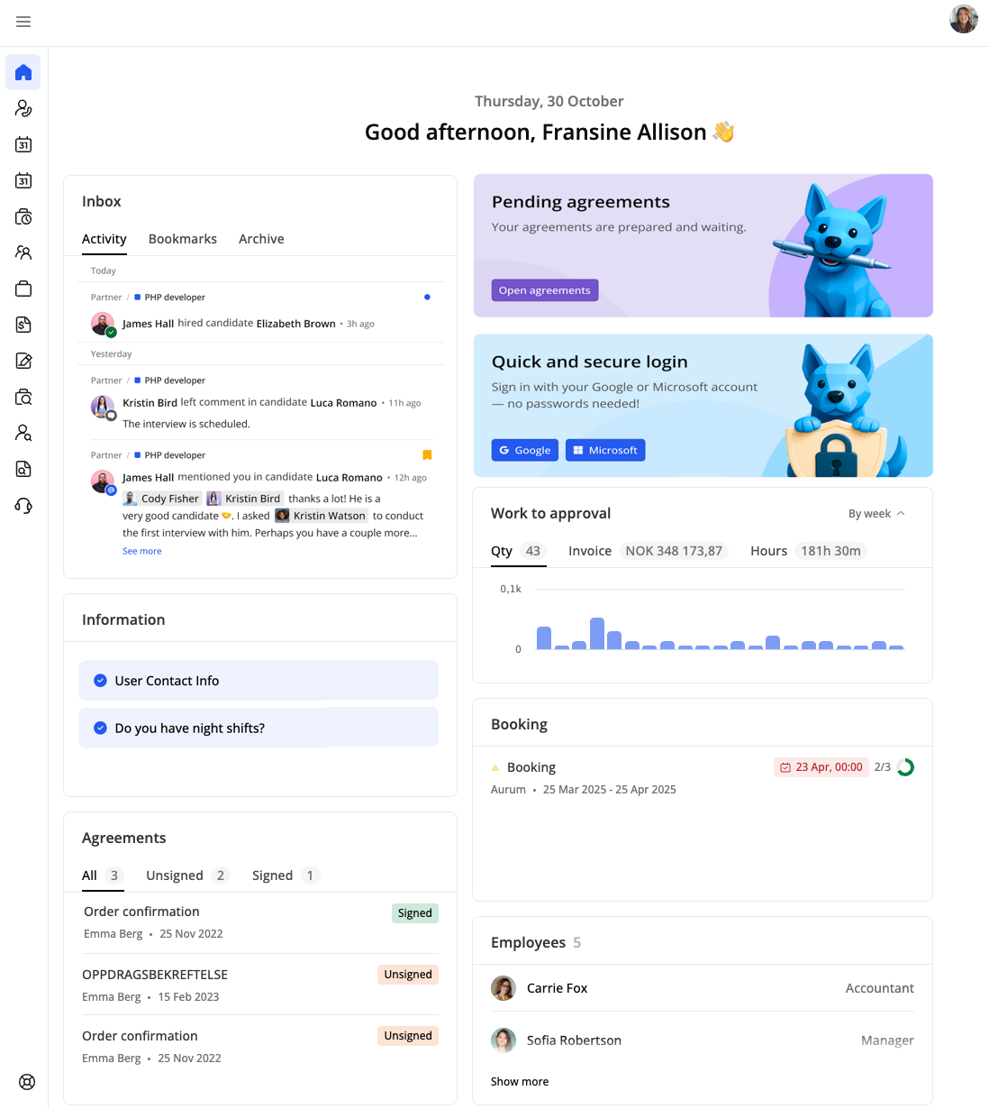
Here, on the Homescreen, you should be able to view various widgets related to notifications, bookings, employees, agreements, and more. Attribute management is accessible via the Information widget. The work approval widget displays the quantity of items pending approval, invoice amounts in multiple currencies, total work amounts, and hours separately, and you can switch between weekly and monthly views for better data analysis.
A Partner Portal Widget gives external partners (contact persons with Partner Portal permission) a quick overview of the projects they're involved in — highlighting new projects, the candidates they've submitted, and a status breakdown showing how many are hired, declined, or still in progress for each project.

2.1 Login issues and forgotten password
If you experience issues logging in, we recommend double-checking that your email address and password are entered correctly. Should you be positive that both are correct, you can use the «Forgot your password?” button.
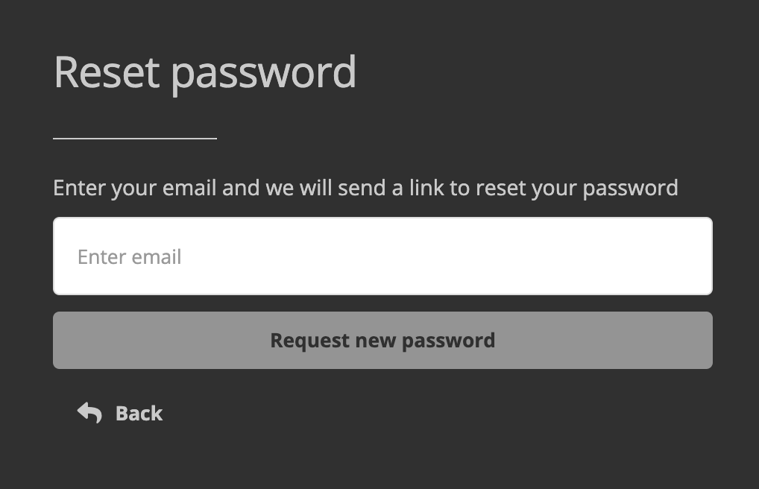
Once pressed, you will see a small box where you will be able to input your email once more and press the «Request new password» button. Should your email have been input correctly, you will receive an email where you can click a link to be automatically logged in. You may also copy the link and paste it in the address field in your web browser if you are unable to click it.
When clicking the link, you will be logged into your profile, and you will see the same “Set new password” box as shown earlier.
Should you still have issues logging in, contact the company that has your profile in their system. On the same screen where you log in, you can click the “Return to homepage”. Here, you should be able to find contact information, where the company should be able to provide you with a new password.

2.2 Change password
After you have logged in to your profile, you can change your password directly from your profile. As previously mentioned, you will be asked to define a new password the first time you log in / when you use the «Forgotten password» function, but should you wish to change it at a different time, you first click «Settings» as shown in the picture below.
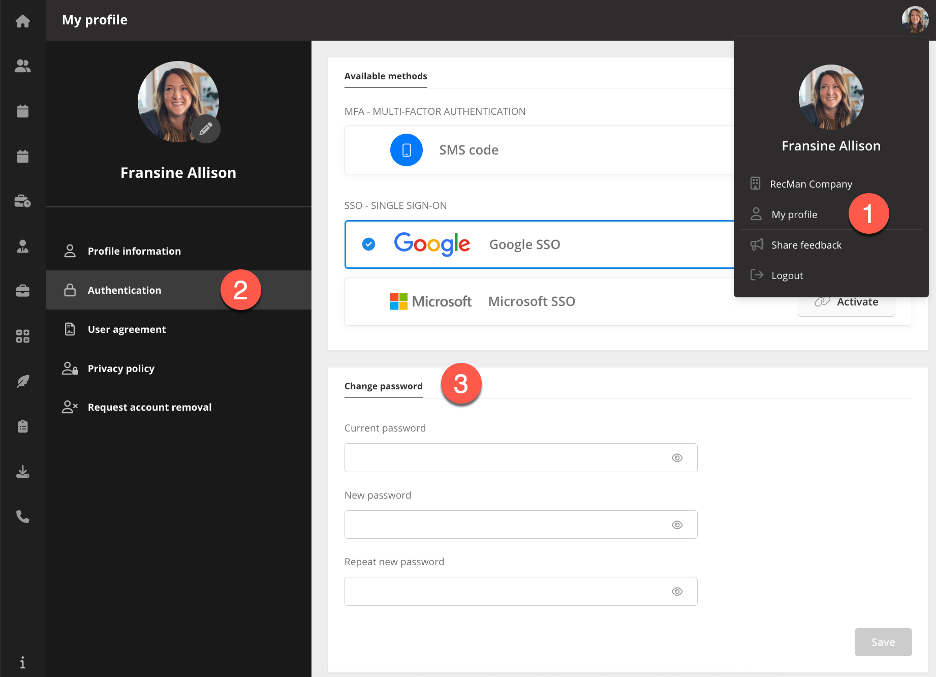
Here, you have to enter your current password before inputting a new one twice to make sure it is entered correctly. Once done, click Save to “change password”.

3 Menu
In the Company Portal, the navigation menu on the left shows the modules you have access to. Hovering over the icons will expand and reveal the module names, should you be in doubt.
In the top-right corner, you can find your own picture. Clicking on it lets you view or update the company information, "My profile", share feedback or log out. In the Company Portal, you can open files in a preview modal, allowing you to view content without leaving your current page. This preview offers a focused view of the file while maintaining your position in the workflow. You can easily close the modal to return to the previous context, enhancing efficiency and minimizing unnecessary navigation.
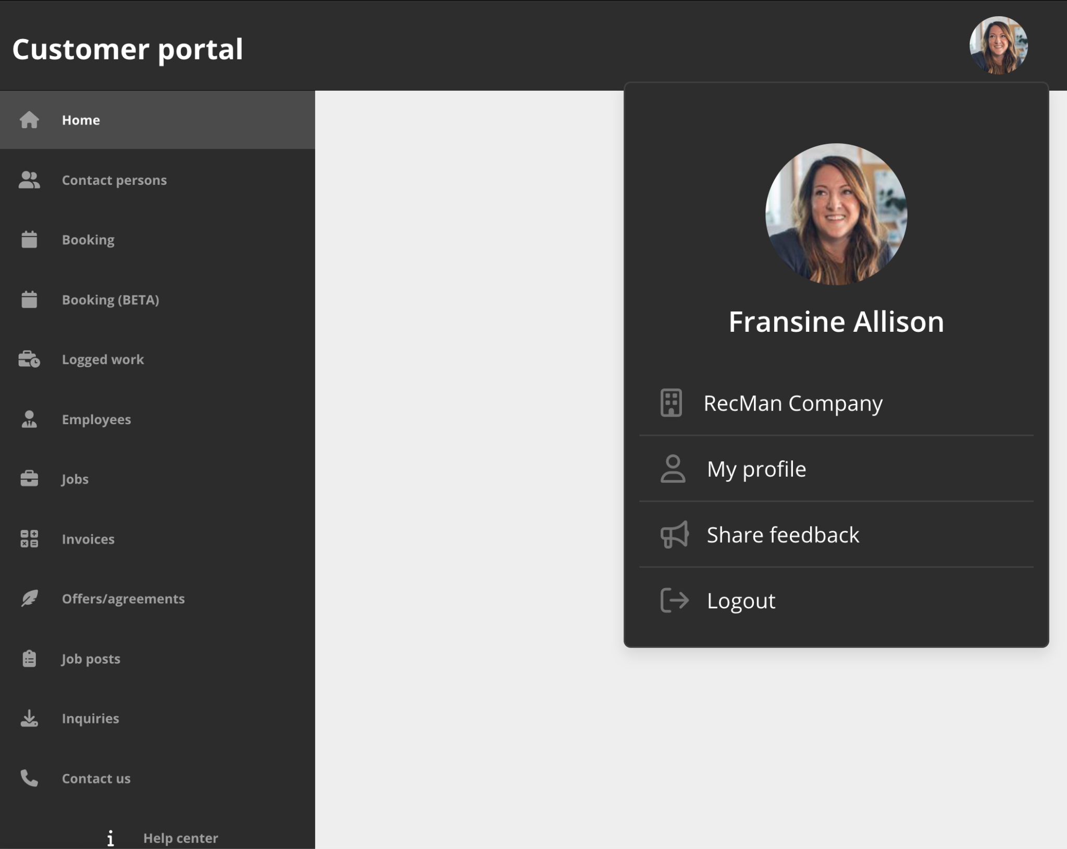

3.1 Contact persons
This module shows existing contact persons and lets you create new ones.
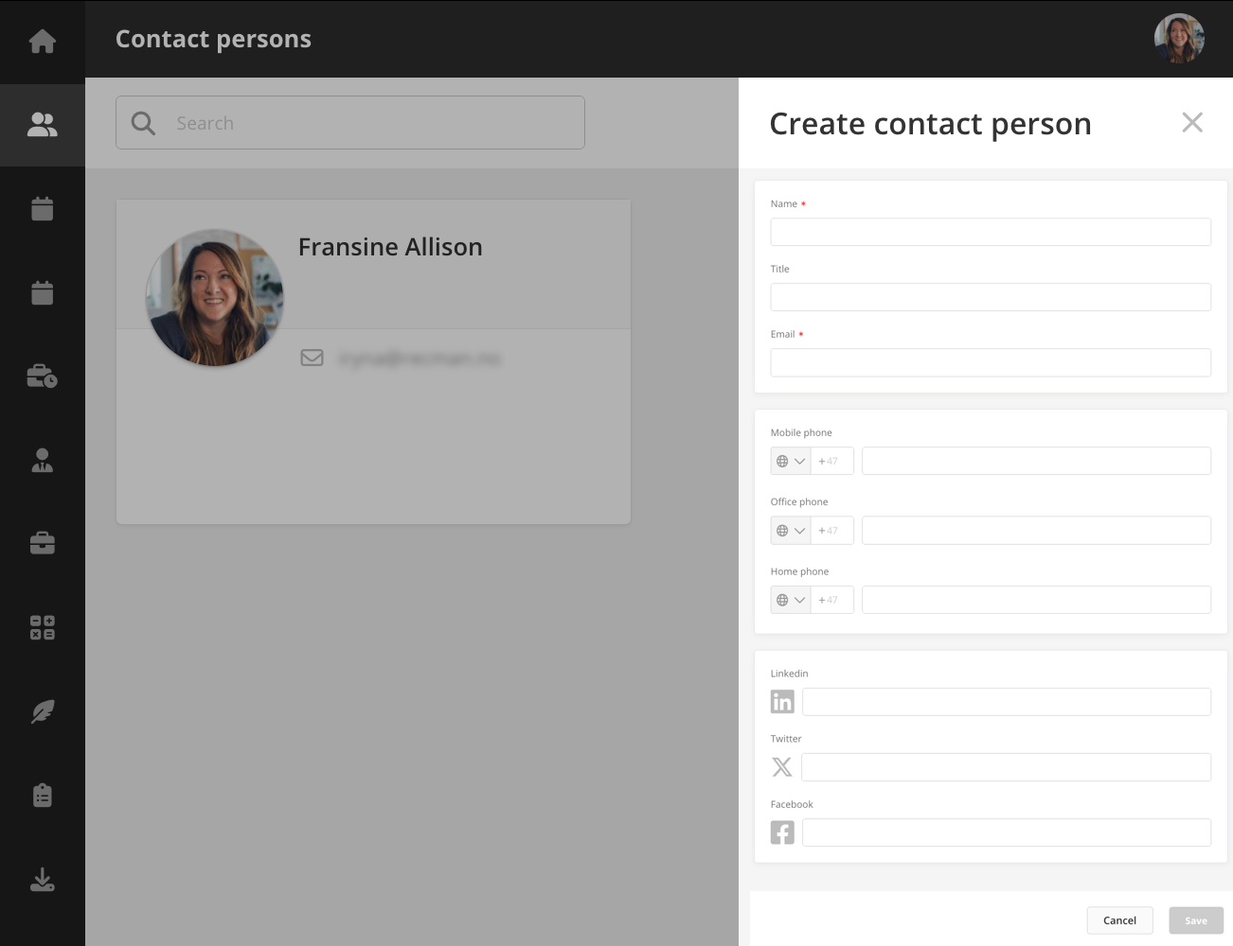

3.2 Booking
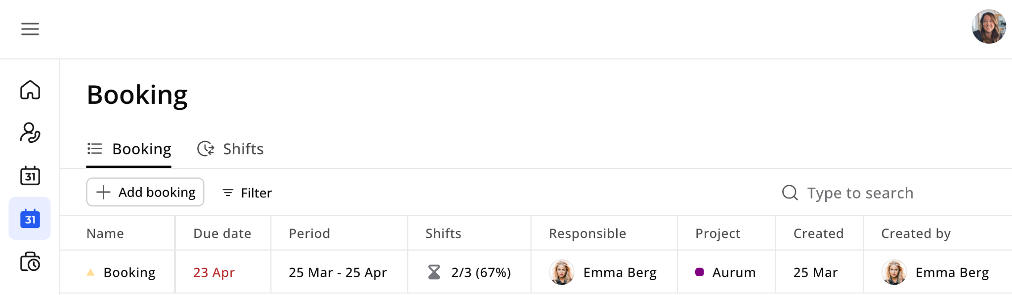
The booking module beta is fully connected with the core application, the employee portal, and the employee app, offering a more streamlined way to create and manage bookings.
You can create bookings, select projects, add collaborators, set dates, and attach files. Shifts can also be created within a booking, with employees assigned by co-workers. All bookings and shifts are visible across platforms, ensuring better coordination.
Access and editing rights depend on user roles and project associations.
The Shifts tab offers a centralized overview of all shifts originating from the staffing calendar, employee calendar, and booking modules. Detailed shift information is accessible via an informative drawer interface. Contact persons can see shifts linked to projects they have access to, as well as shifts within bookings they've created. You can filter shifts by status, project, and bookings with an intuitive date picker navigation. Shift data can be exported in PDF and Excel formats for reporting and analysis. Multiple shifts can be created at once and linked to existing bookings. You can perform various actions on shifts, such as exporting or selectively deleting shifts you created. You can also assign employees to projects and create shifts within a booking, including selecting dates, defining break options, and assigning one or multiple employees in bulk.
Read more about bookings in our dedicated help center article on the Booking module.

3.3 Logged work
In this module, you can view, edit and approve the logged work for the projects assigned to your profile.
Multiple filter options allow you to quickly find the data you're looking for.
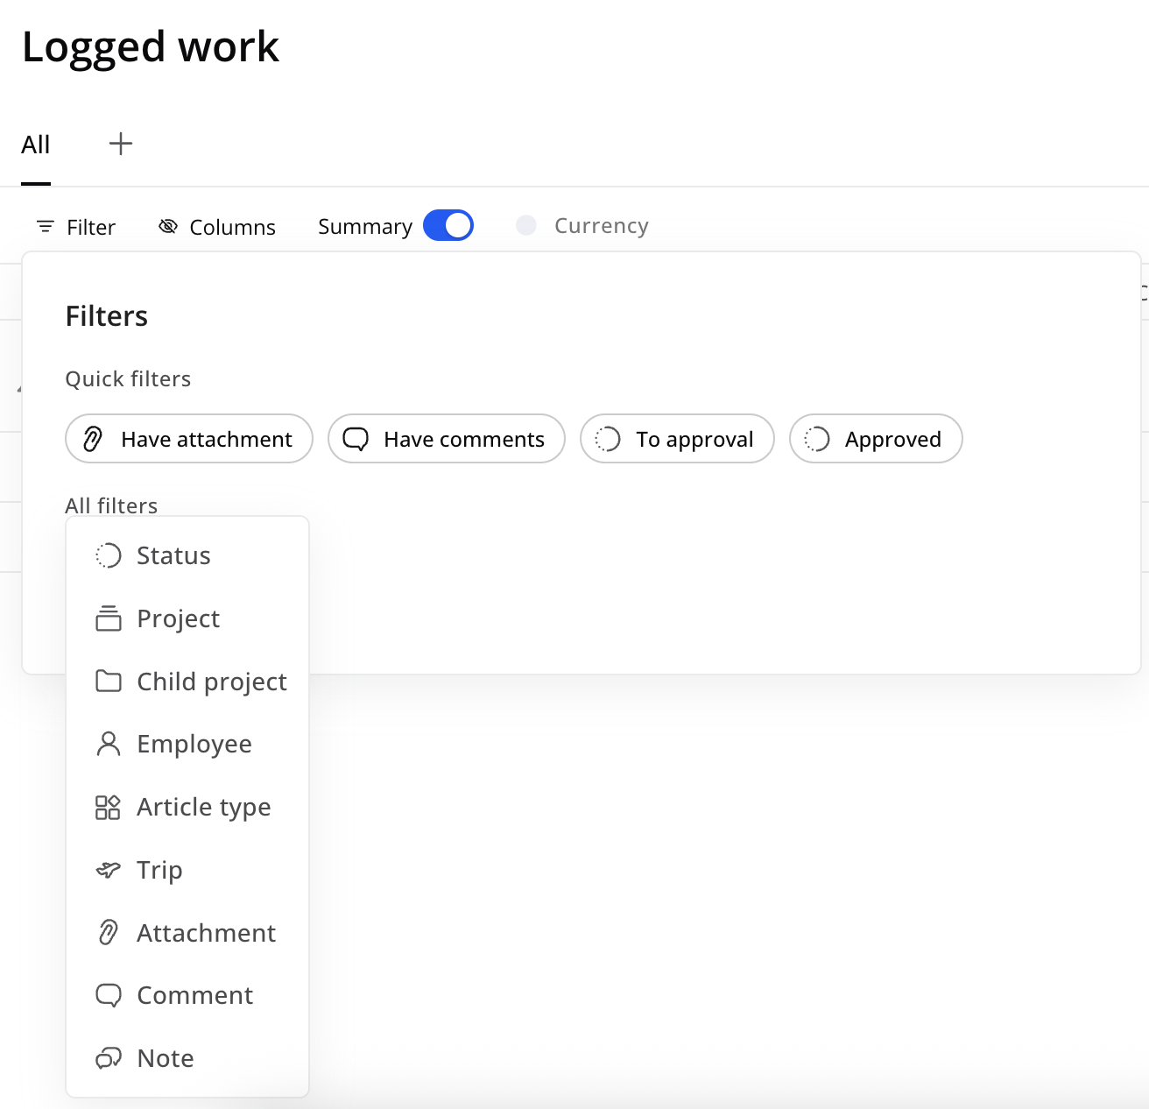
You can also navigate the period using the arrows and change between a monthly, weekly or custom view based on your preferences. For quicker navigation, you can create personalized tabs with specific filters by clicking the “+” button next to All.
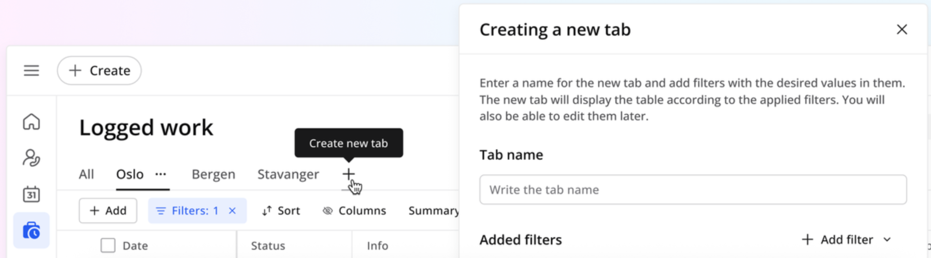
The To approval tab shows all unapproved, accessible work items for the entire period, with no filtering required. Clicking an approval link or a "work to approve" notification immediately takes you to this tab to review and approve all pending items.
If everything looks in order, click "Approve" for all, check off one article at a time, or select multiple at a time. Using the select function, you can also download the list to an Excel spreadsheet, if you like.
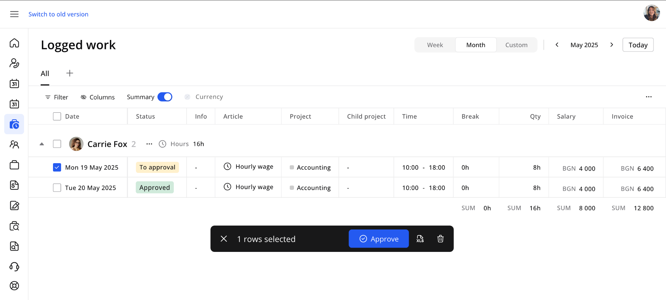
If you find an error, you can also click the article and write a comment in the drawer. This will become visible to users in the core application, who will review the logged work and take action to correct it.
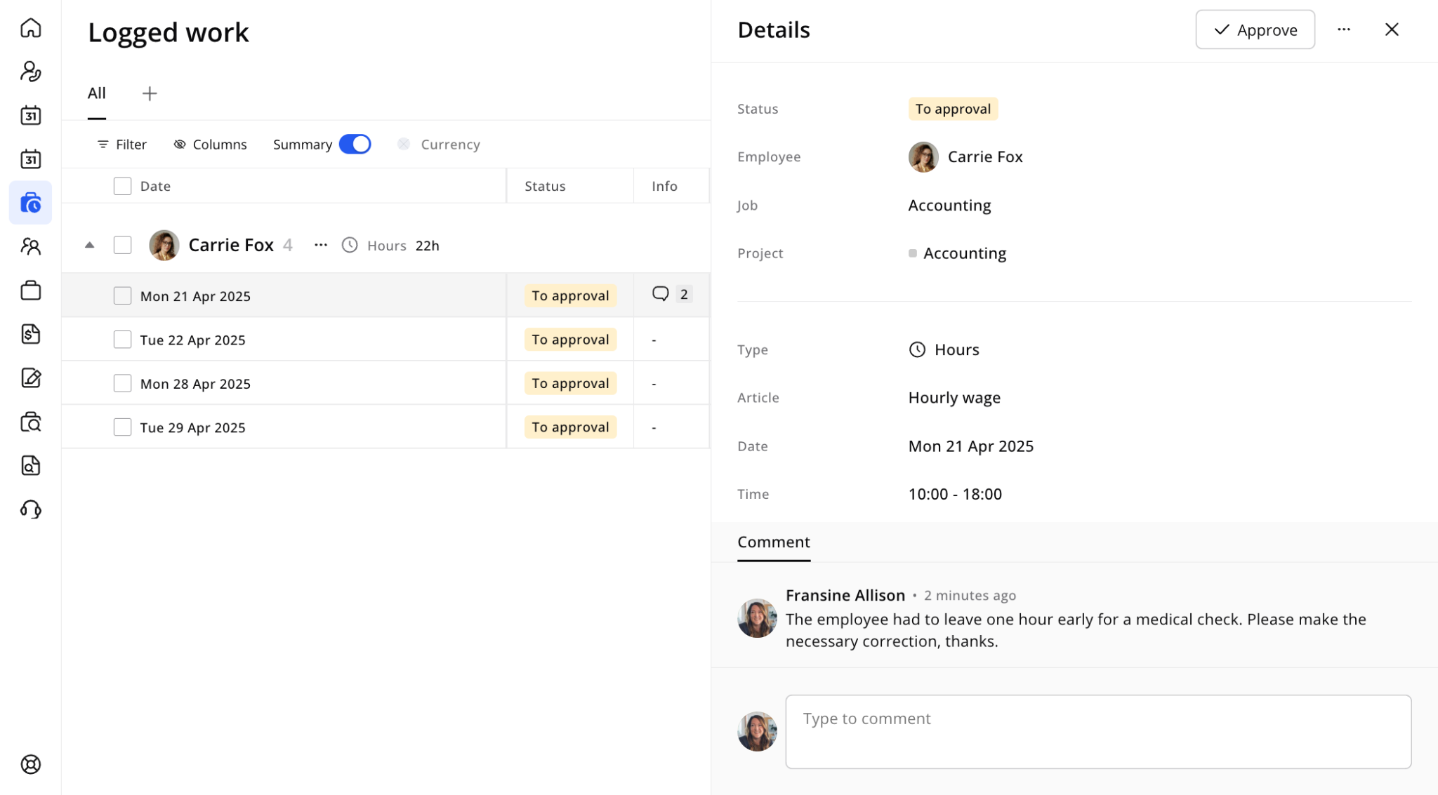
The Company Portal allows users to edit and delete logged work entries. Users (contact persons) with the "Work - Edit" permission on the core site can easily modify details such as the date, hours worked, and break duration.
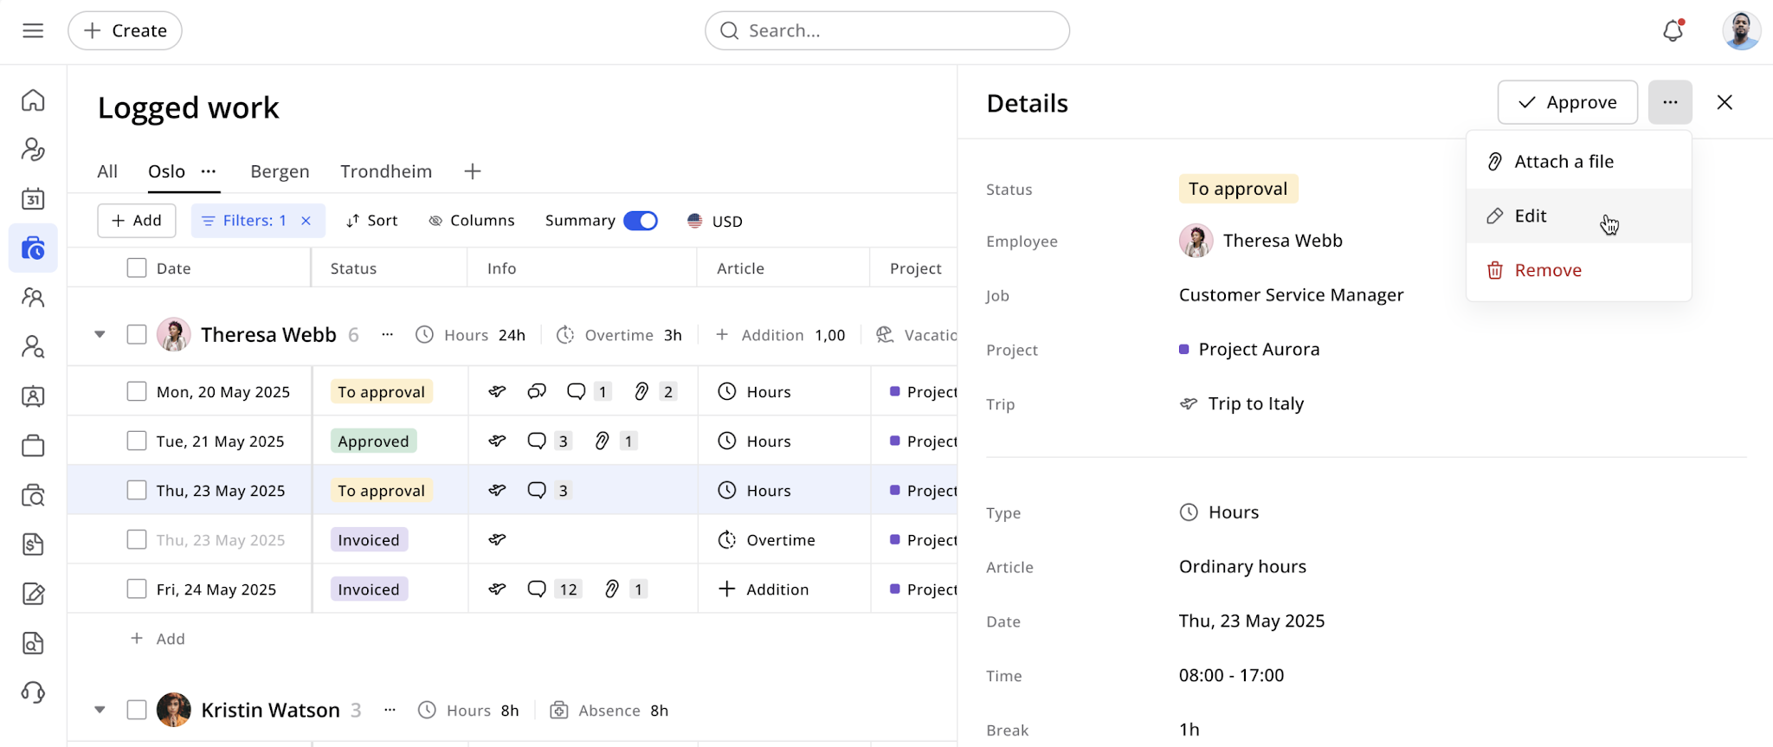
A summary bar at the bottom provides an instant overview of totals for all displayed entries, showing the total number of articles, time, and costs across employees. It updates automatically with filters or time changes and is permission-based.
The Hours / Days toggle switches display between hours and days. When enabled, all work info, summaries per employee, and total summaries are shown in days. It also affects data exports, formatting them in days or hours based on the toggle.

3.4 Employees
Here you will find a list of employees in your company, with the option to create new ones, upload their CVs, and perform additional profile actions.
This module displays a structured table of employees accessible to each contact person, including the jobs they are assigned to and, where applicable, their current pipeline stages within projects. Each job and pipeline step includes detailed tooltips for quick context and clarity. You can open an employee drawer to view and manage key details, including name, contact information, and custom attributes. Employee profiles clearly separate CVs from other uploaded files, making it easier to manage documents.
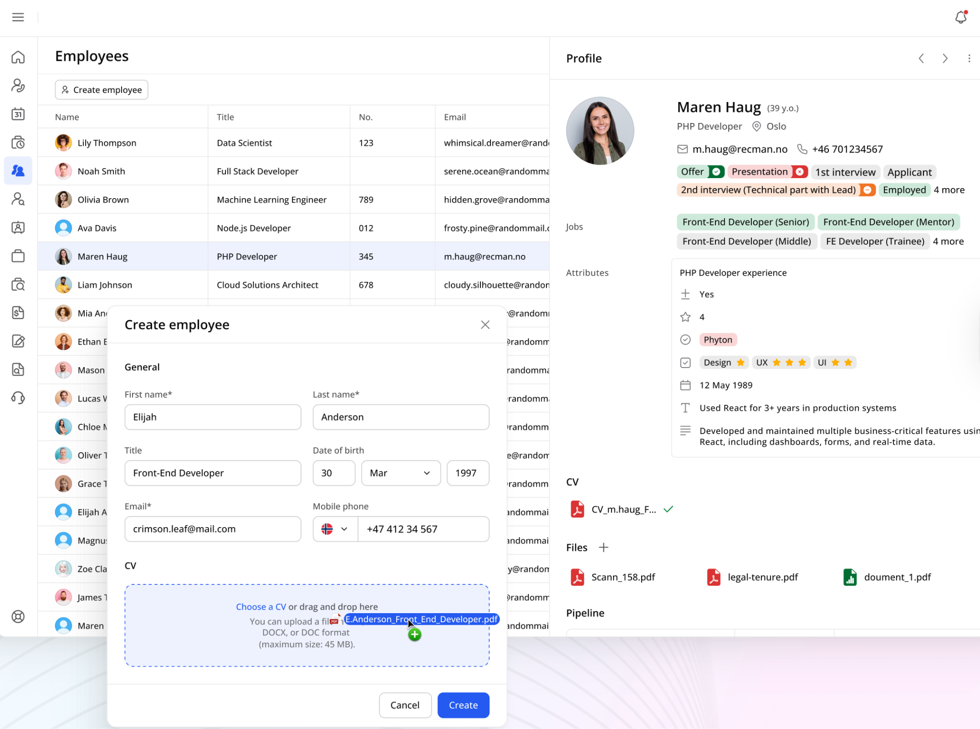

3.5 Jobs
Here you can view all jobs for your ongoing projects. Use Quick filters for one-click access to common views: Active, Due this week, Due next week, or Pending approval. For more advanced searches, click Filters to combine criteria such as Status, Employee, Company, Project, Start date, End date, and Work to approval — with support for multi-select fields and custom date ranges. Click Clear all to reset your filters.
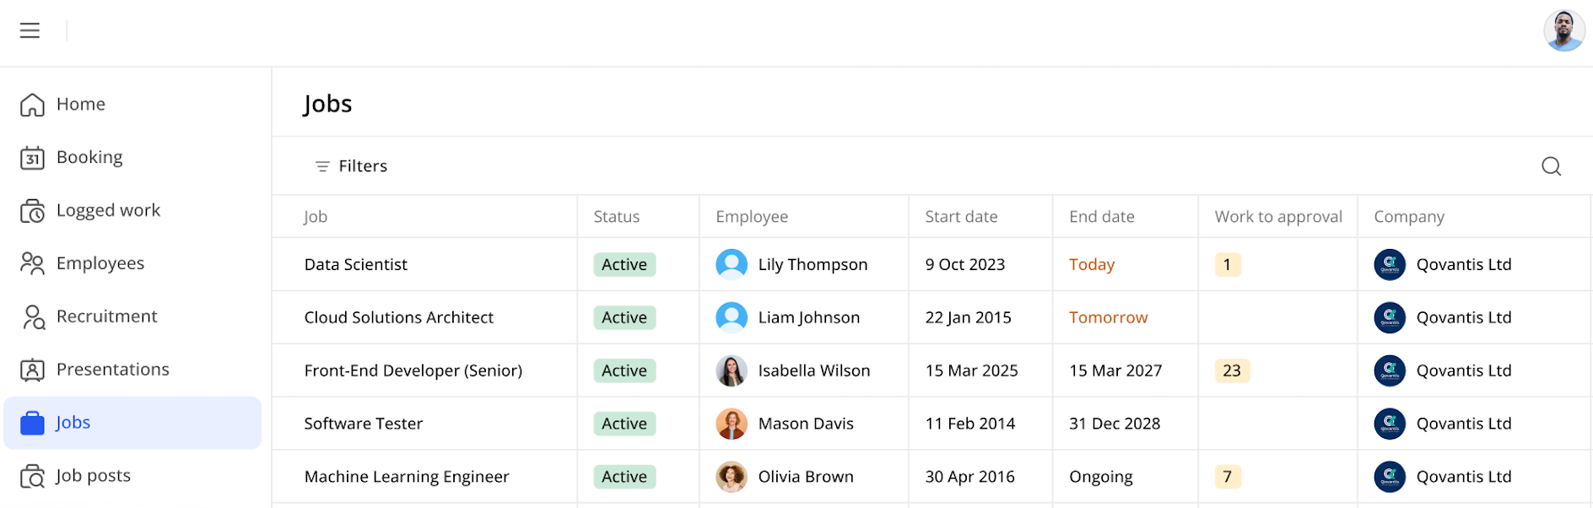

3.6 Invoices
In the Invoices module, you can see all invoices sent to you, assigned to your projects, or for the whole company, with clear status indicators to help you track and manage them.
Multiple filtering options are available in the invoice overview – by date range, billing category, payment status, and other relevant criteria.
You can export invoice data to support reporting, audits, and accounting workflows. Select the invoices you want to export and click Download in the selection action bar.
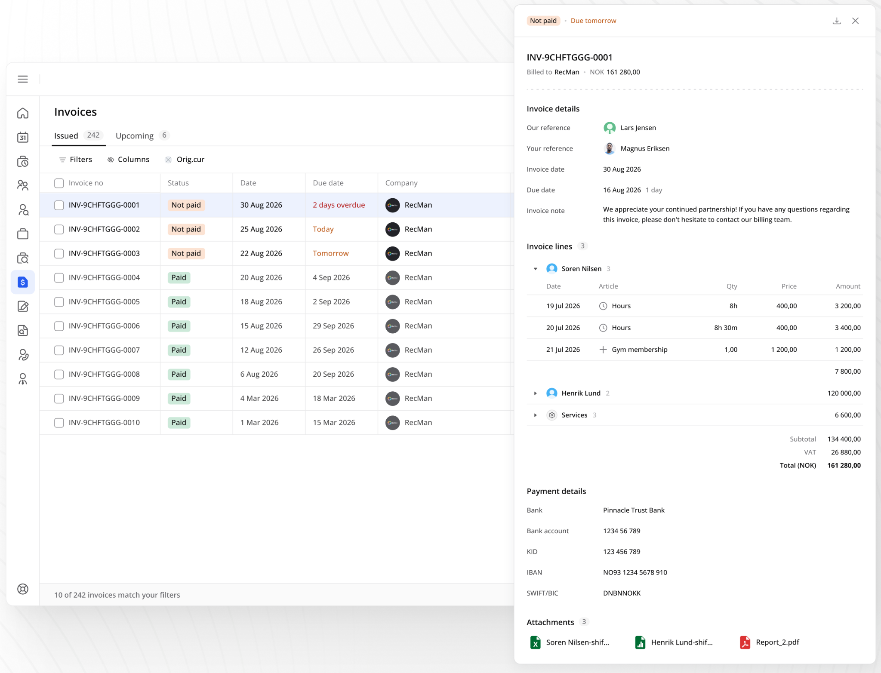

3.7 Agreements
In the Agreements module, you can view all agreements sent to you, to the project or to the entire company. These are typically order confirmations and other general offers. By clicking the Open button, you can view the agreement and sign it electronically.
Various filters let you search the agreements. Use the quick filters "To sign" (awaiting signature) and "My agreements," and search by associated project, status, signer, responsible person, creation date or title.
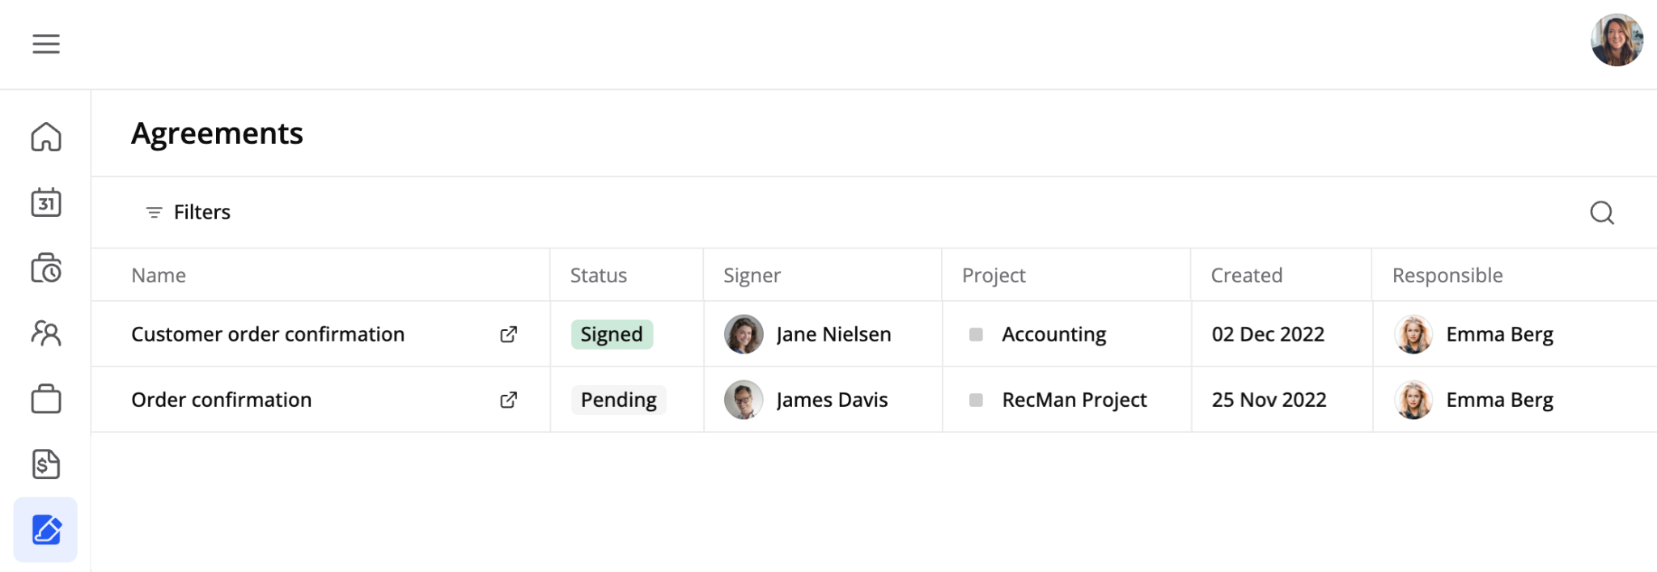

3.8 Job posts
Here you can view job posts.
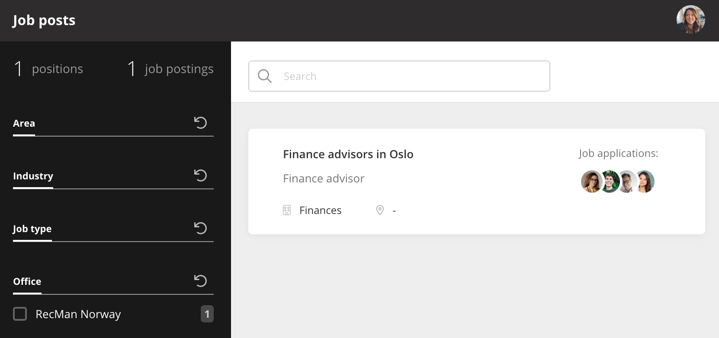

3.9 Partner portal
The recruitment module in the Company Portal is designed specifically for recruitment partners.
For this module to appear and work, the contact person's profile must have the "Partner portal" permission activated, and the job posts must be published on the Intranet (this job post portal must first be activated in System settings → Job postings).
Partners have access to a centralized dashboard displaying all job posts posted to the intranet.
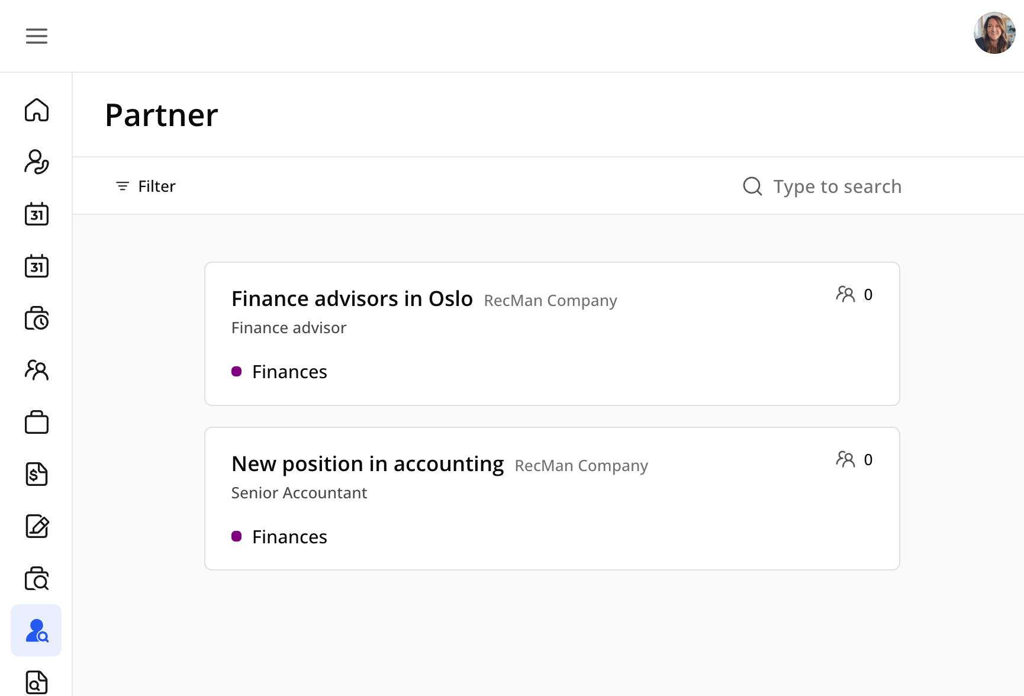
The interface includes robust filtering options by application status, company, and project, along with quick search functionality for efficient navigation through available positions.
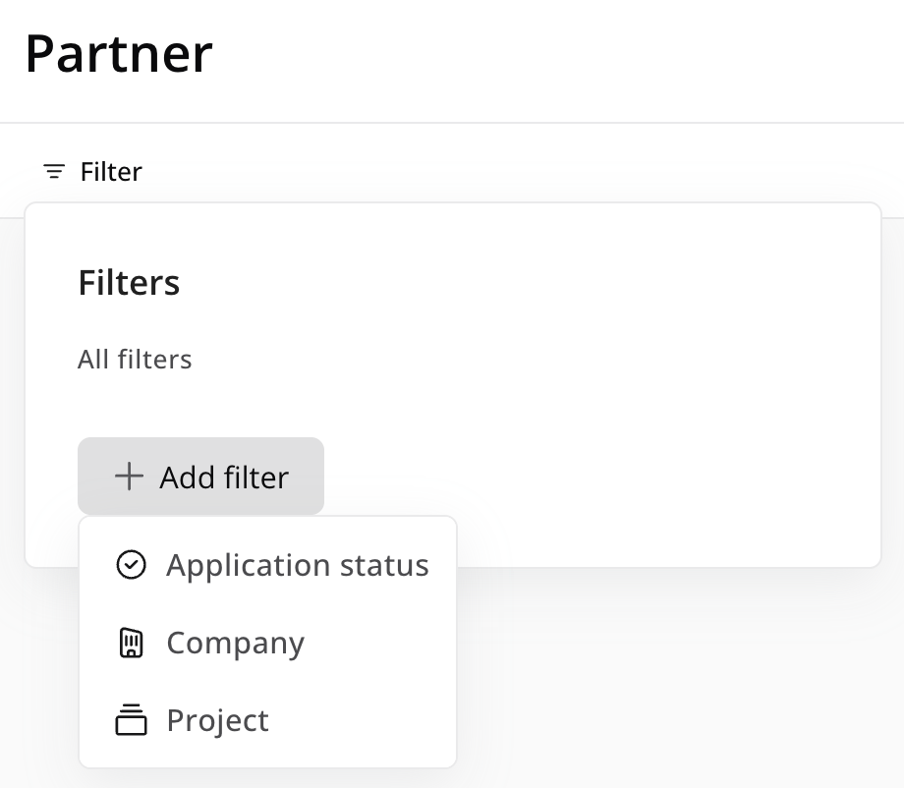
Each job post provides partners with a detailed project overview, including candidate metrics and essential project information.
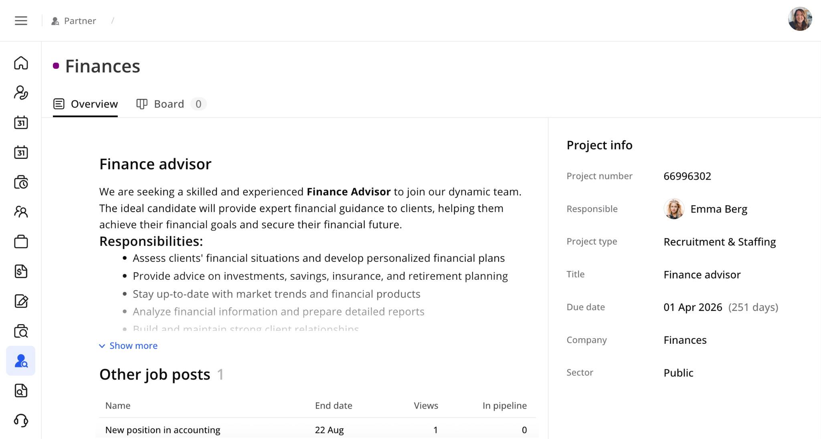
The core feature is an integrated recruitment board that displays the complete pipeline steps from the core recruitment process. Here, partners can attach files to candidates directly in the candidate drawer using a simple drag-and-drop, along with the Plus button.
Partners can filter candidates by status and have full capability to add new candidates either from their existing database or by creating entirely new candidate profiles.
Once candidates are added to the system, partners can comprehensively review candidate information and maintain ongoing communication with core team members through an integrated commenting system. The module supports project-specific custom fields, allowing partners to provide tailored information relevant to each recruitment project.
It's possible to use CV parsing when creating candidates. Upload a CV directly in the creation flow — the system automatically parses it and populates the candidate profile with the extracted data. All parsed information is instantly synchronized with the main Candidate database, giving immediate access to the new profile.

3.10 Recruitment module
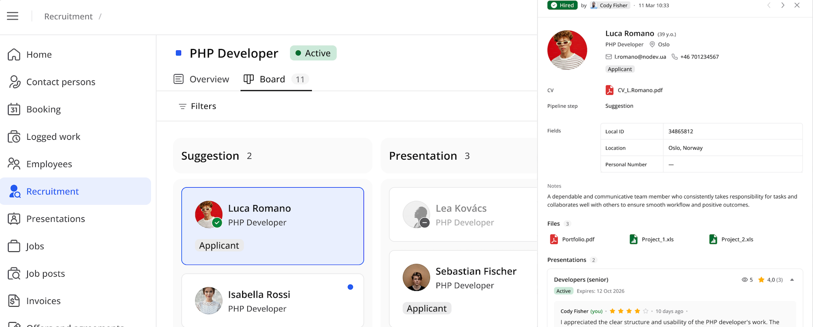
The Recruitment module in the Company portal provides visibility into recruitment projects and candidate pipelines. Access to the module is controlled through a new "Recruitment module" permission on the contact person profile. Once enabled, a Recruitment menu item becomes available in the Company portal.
Within the module, you first see an overview of the recruitment projects you are connected to.
- The project table displays key information such as the project name, the responsible coworker, the project status, and statistics showing the number of candidates currently in different pipeline stages.
- Opening a project provides a project overview, including: basic project details, candidates currently in the recruitment pipeline, job posts associated with the project, and the pipeline board with candidate stages.
- The pipeline board visually displays candidates across the different recruitment stages. In this first version, you have view-only access, meaning you cannot move candidates between stages or add new candidates.
- Each candidate includes a detail drawer where you can view contact information, relevant custom fields, and internal comments. The interface also lets you navigate easily between candidates to review additional information.

3.11 Presentations
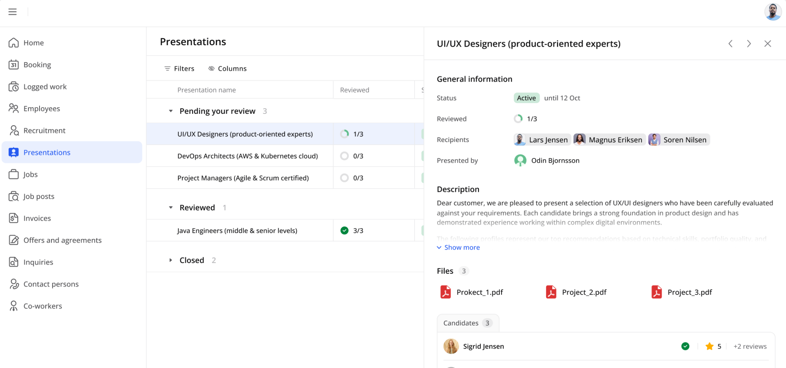
The Presentations module provides a centralized overview of candidate presentations shared with you throughout the recruitment process.
The Presentations module displays a structured table of key details, including the presentation name, associated candidates, presentation status, start and due dates, recipients, and the person who shared the presentation. It also highlights review progress, making it easy to see how many candidate profiles have been reviewed. To quickly find relevant presentations, filtering options make navigation easier.
Each presentation includes a detail drawer where you can view additional information, such as candidate ratings and comments left during the review process. From this overview, users can easily identify which candidates have already been reviewed, which still require feedback, the average rating, and how many times candidate profiles have been viewed.
You can also click a candidate within a presentation to open a full-screen candidate view, where you can review the candidate and submit a rating and feedback directly.
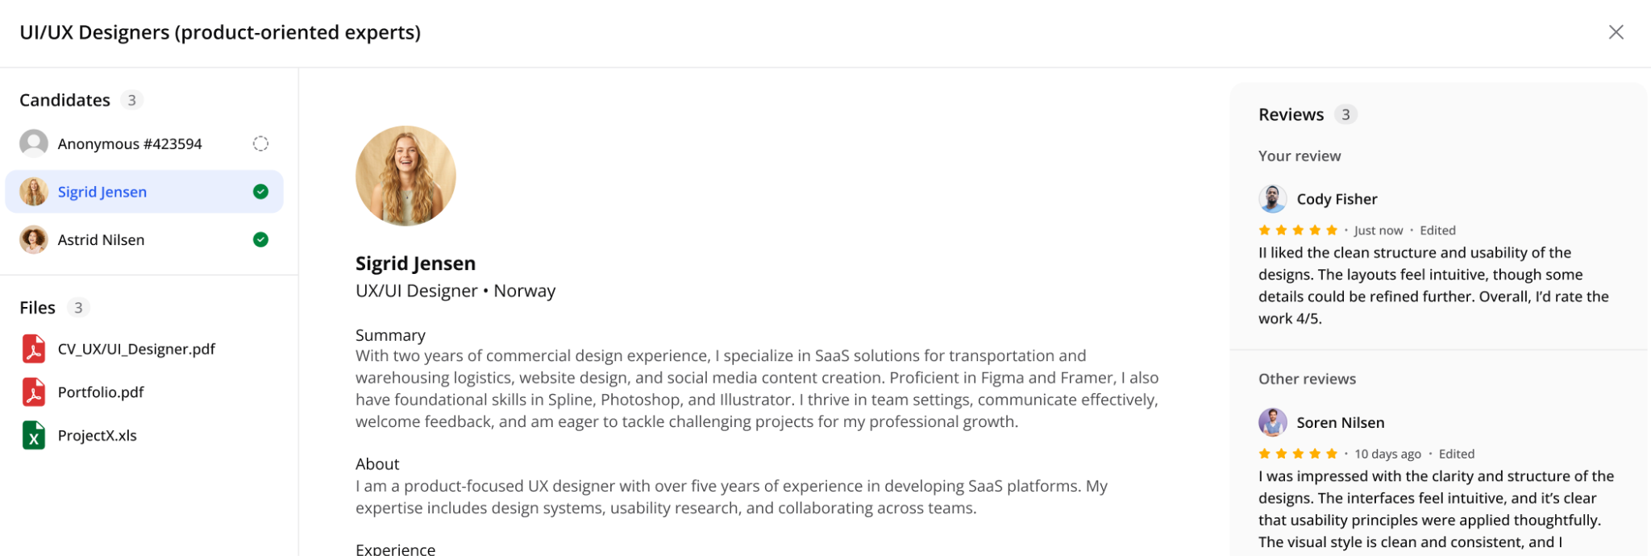
Even when a presentation has expired, it will still appear in the list for reference. While editing and reviewing may be closed, the presentation link and its key information remain accessible for transparency and record-keeping.

3.12 Inquiries
Using the inquiries module, you can send requests to the staffing agency for new business or if something is wrong with the newest invoice or offer.
