

User guide for contact persons and work approvers

*User manual for the Customer Portal*

| **Version** | *3.0* | |
| --- | --- | --- |
| **Latest update** | *2025-07-25* | |
| **Created by** | *Marius Gravem* | |
| **Contributors** | *Gøran Sæland, Iryna Volynets* | |
| **Confidentiality level** | *PUBLIC* | |

Content

**1 Introduction 2**

**2 Logging in 2**

2.1 Login issues and forgotten password 4

2.2 Change password 5

**3 Menu 6**

3.1 Contact persons 7

3.2 Booking 8

3.3 Booking (Beta) 9

3.4 Logged work 10

3.5 Employees 13

3.6 Jobs 13

3.7 Invoices 14

3.8 Offers/agreements 14

3.9 Job posts 15

3.10 Partner’s recruitment module 15

3.11 Inquiries 17

# 1 Introduction

In this document, you can read about the customer portal. For companies using RecMan, the customer portal is an additional feature they can give access to for their created customer contacts in the system. This is commonly used to view and approve logged hours, but can also be extended for features to view offers/agreements, invoices, job information and much more.

Note: This guide is made with the basic permissions enabled to view and approve registered work. Should your profile look different, this can mean that your permissions and functionality is limited or adjusted by the staffing company.

# 2 Logging in

In order to log in to the customer portal, the company using RecMan will first have to create a login. When that is done, they can assign permissions depending on your needs before sending you the login credentials. So assuming a login has been created and sent, we will go through the process of logging into the system to access your customer profile. We will also show you how to reset your password, should you have forgotten it.

Note that you may have a profile in several RecMan systems, depending on the company, and these profiles are not shared between the companies. Because of this, it is essential that you use the correct site when logging in. A typical site for logging in should look like this:

[https://COMPANY_NAME.recman.no/customer/login](https://mariussupport.recman.no/customer/login)

Here we have written “Company Name”, this is where you will use the name of the company you are registered with. When visiting this link, you will see the following screen.

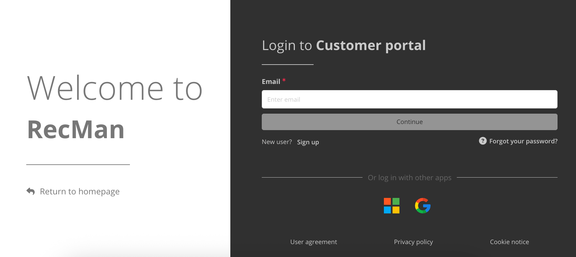

Here you input the email and password given to you by the company. Click “Log in” in order to log into your customer profile. When logging in for the first time, you are likely doing so using a temporary password, or a one-time login link. Therefore, it is recommended that you set a new and strong password for later use.

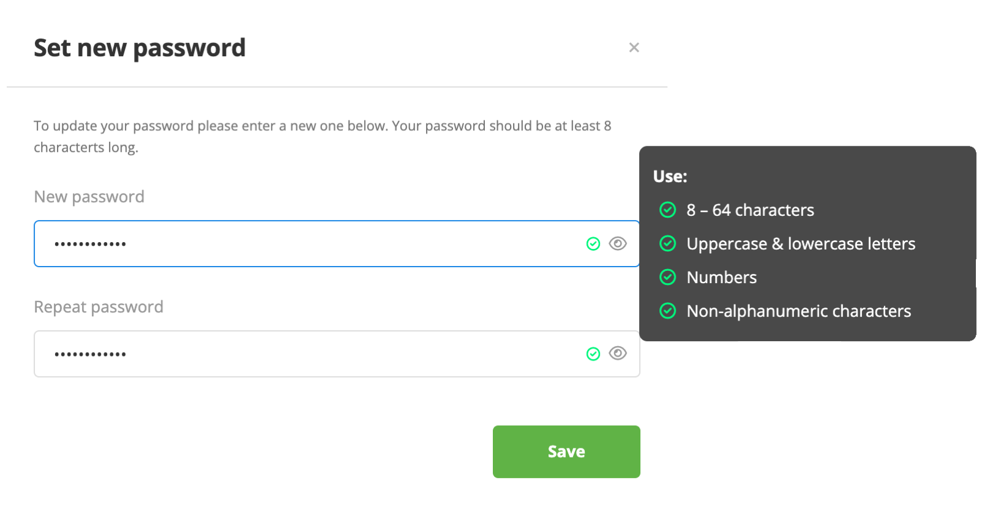

Clicking save, you should now be in the customer portal’s home dashboard:

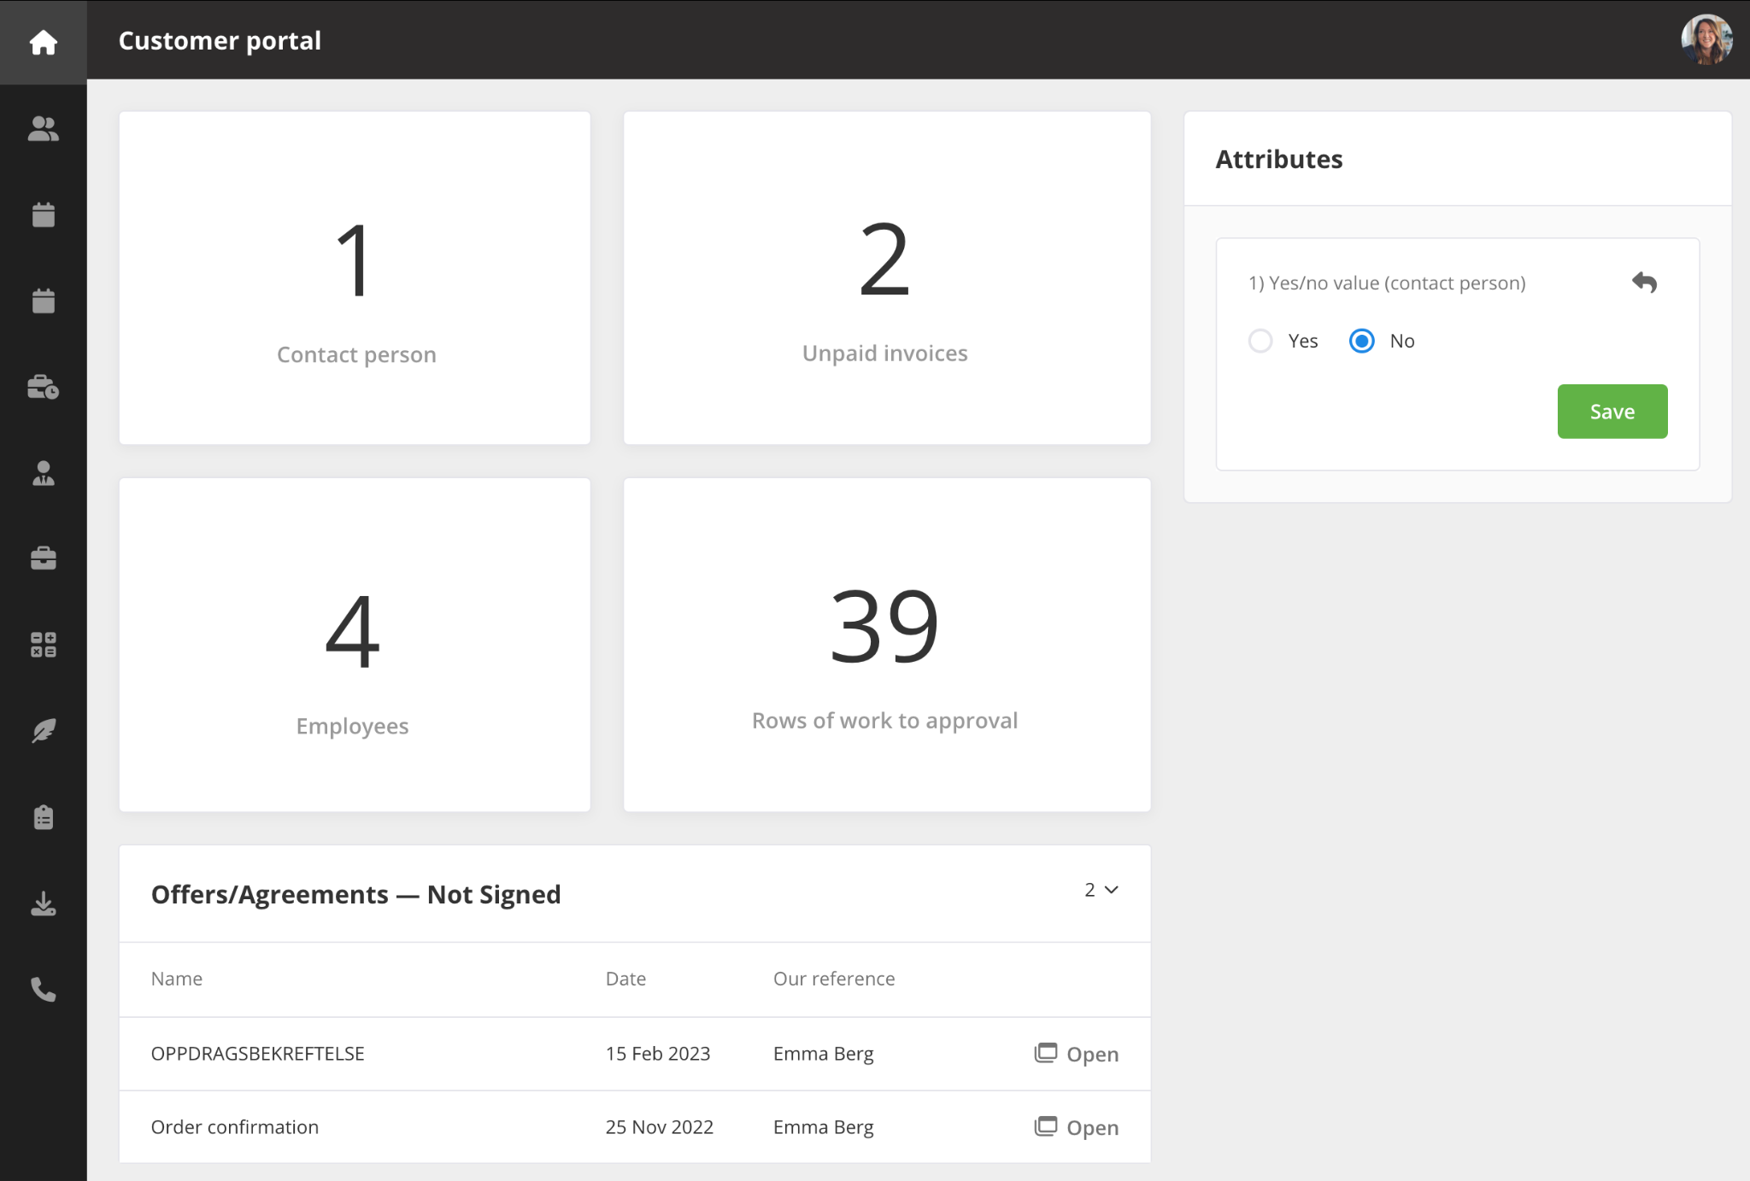

Here you should be able to view some basic information regarding the work “to approval”, unpaid invoices and offers awaiting signatures. You can also enable SSO authentication to make your profile more secure using a Google or Microsoft account.

## 2.1 Login issues and forgotten password

Should you have issues with your login, we recommend double checking that your email and password is written correctly. Should you be positive that both are correct, you can use the «Forgot your password?” button.

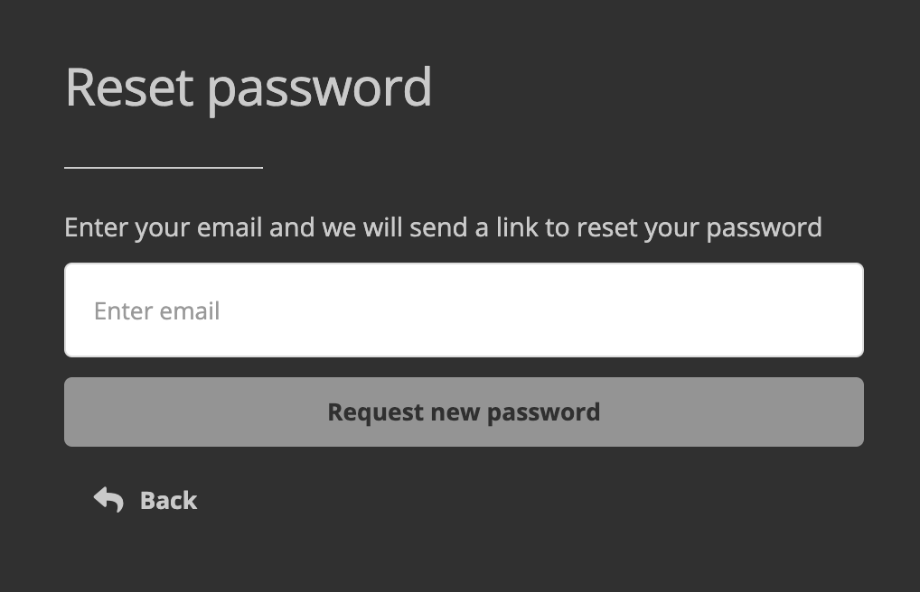

Once pressed, you will see a small box where you will be able to input your email once more, and press the «Request new password» button. Should your email have been input correctly, you will receive an email where you can click a link to be automatically logged in. You may also copy the link and paste it in the address field in your web browser if you are unable to click it.

When clicking the link, you will be logged into your profile, and you will see the same “Set new password” box as shown earlier.

Should you still have issues logging in, contact the company who has your profile in their system. On the same screen where you log in, you can click the “Return to homepage”. Here you should be able to find contact information, where the company should be able to provide you with a new password.

## 2.2 Change password

After you have logged into your profile, you can change your password, directly from your profile. As previously mentioned, you will be asked to define a new password the first time you log in / when you use the «Forgotten password» function, but should you wish to change it at a different time, you first click «Settings» as shown in the picture below.

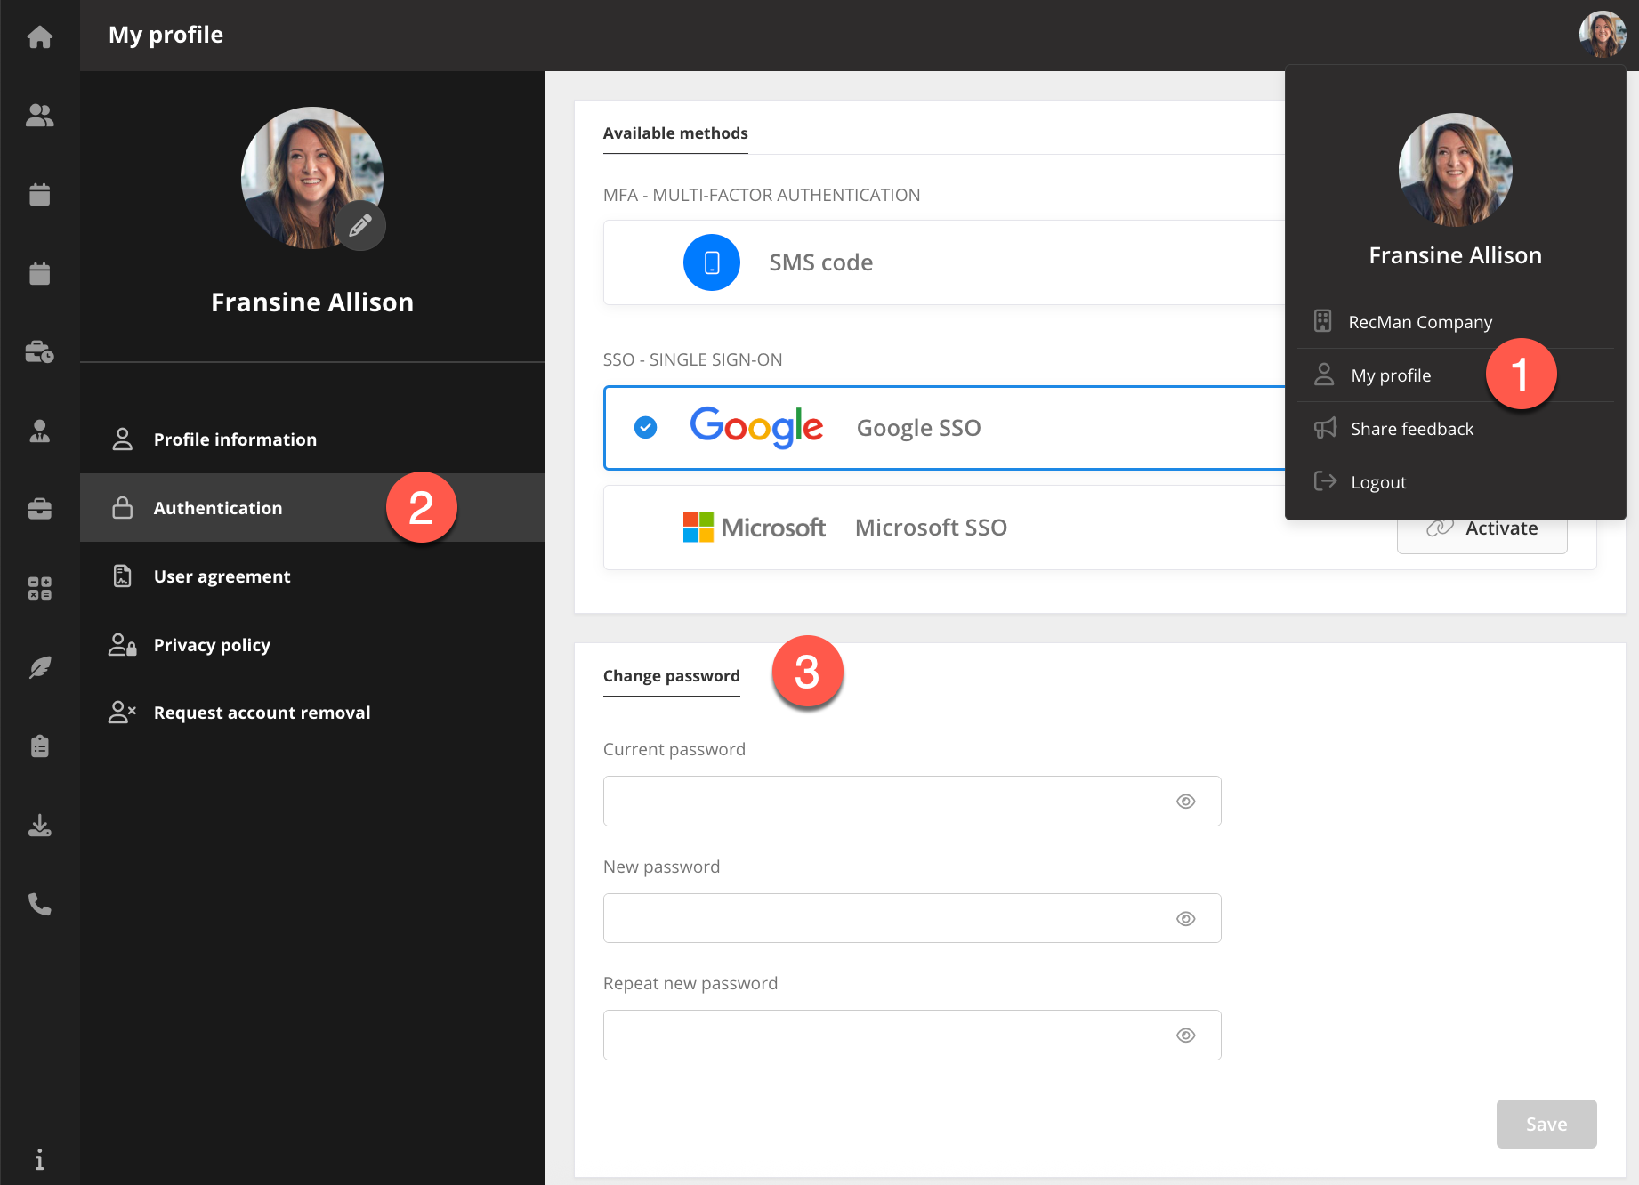

Here you have to enter your current password before inputting a new one twice to make sure it is entered correctly. Once done, click save to “change password”.

# 3 Menu

For the customer portal, you have the navigation menu to the left showing the modules you have access to. Hovering the icons will expand and reveal the module names, should you be in doubt.

As for the top right corner, you can find your own picture. Clicking on it lets you view or update the company information, “My profile”, share feedback or log out.

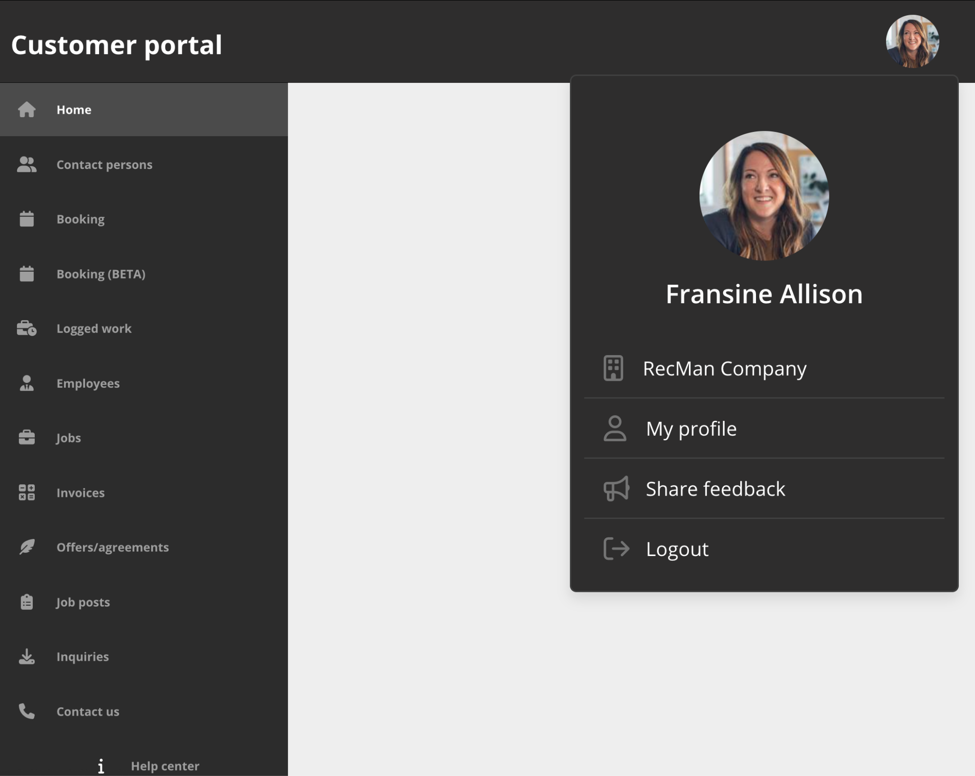

## 3.1 Contact persons

This module shows existing and lets you create new contact persons.

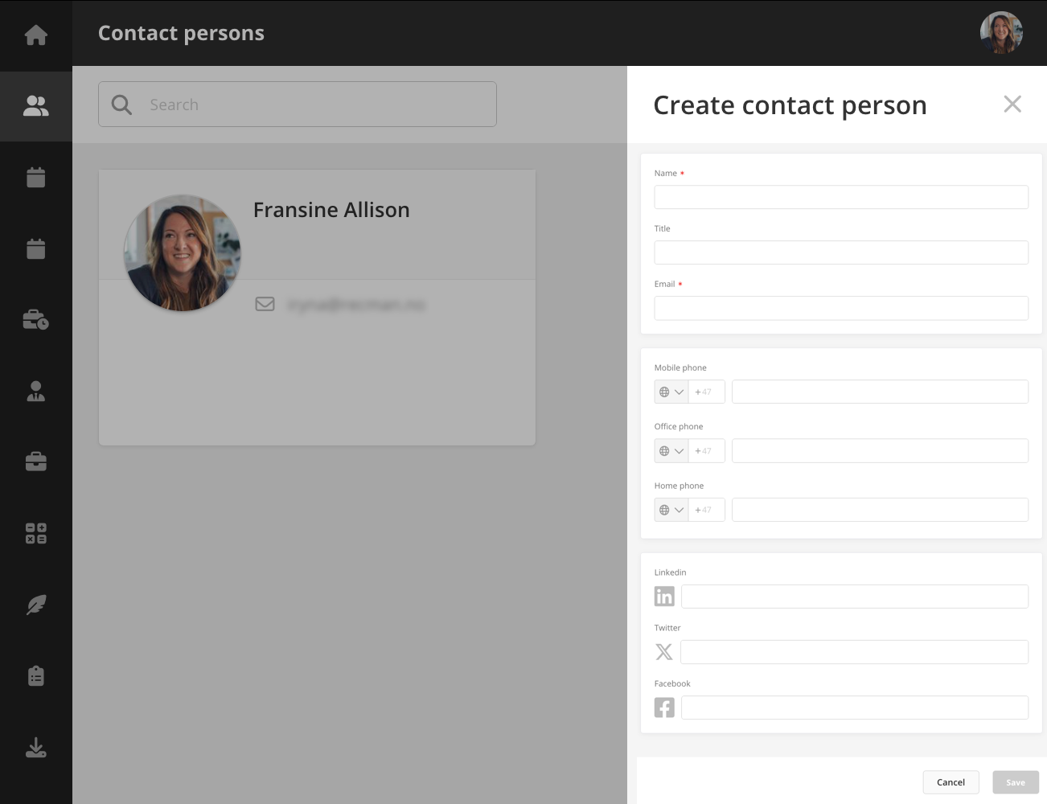

## 3.2 Booking

Here you can view existing bookings. You can filter them by status (Confirmed, Unconfirmed or Declined) and by project. In the upper bar, you can set the view (Request list, Schedule or Shifts) and select the period.

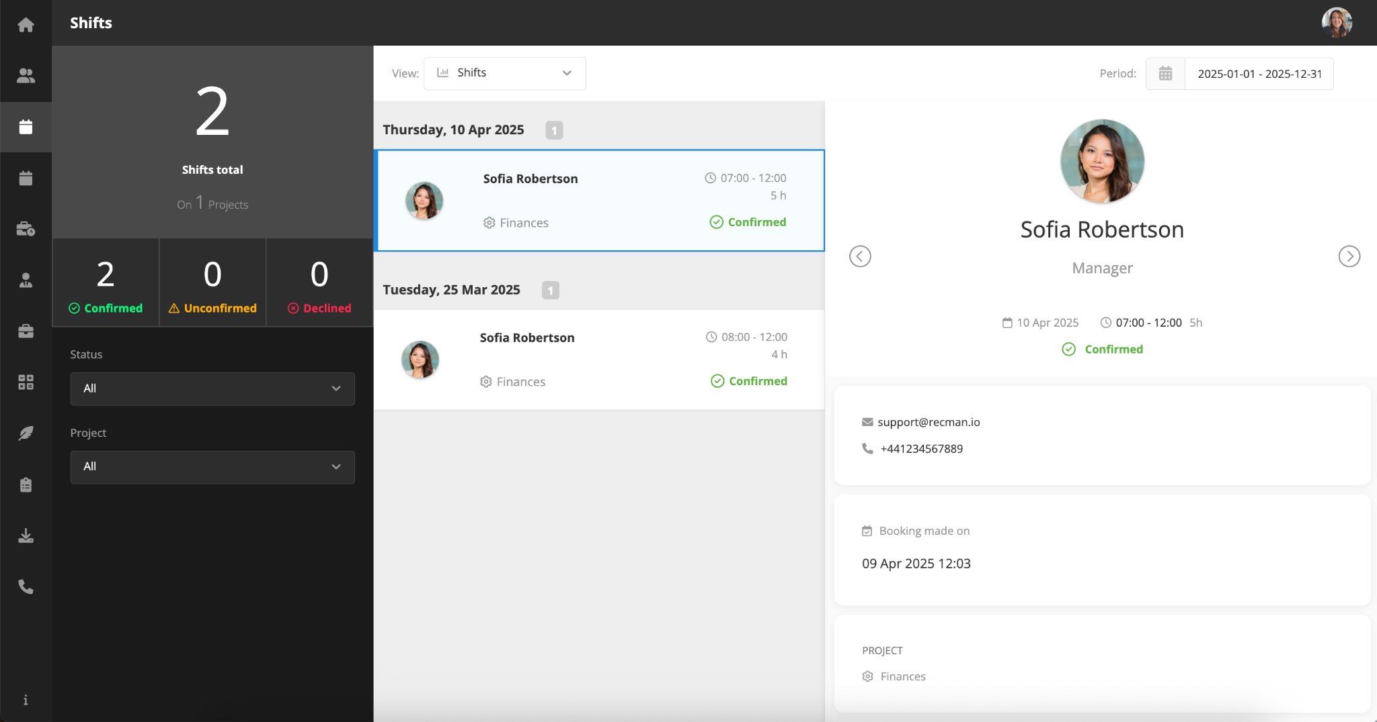

## 3.3 Booking (Beta)

The **booking module beta** is available in the customer portal and will eventually replace the old version. This updated module is fully connected with the core application, the employee portal, and the employee app, offering a more streamlined way to create and manage bookings.

Customers can create bookings, select projects, add collaborators, set dates, and attach files. Shifts can also be created within a booking, with employees assigned by co-workers. All bookings and shifts are visible across platforms, ensuring better coordination.

Access and editing rights depend on user roles and project associations.

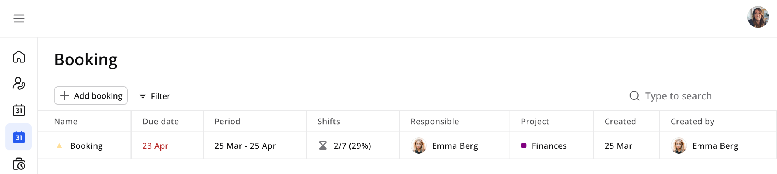

Read more about bookings in our dedicated help center article on the [Booking module](https://help.recman.io/hc/en-us/articles/25575033979922-Booking-module).

## 3.4 Logged work

In this module, you can view, edit and approve the logged work for the projects assigned to your profile.

Multiple filter options allow you to find the searched data quickly.

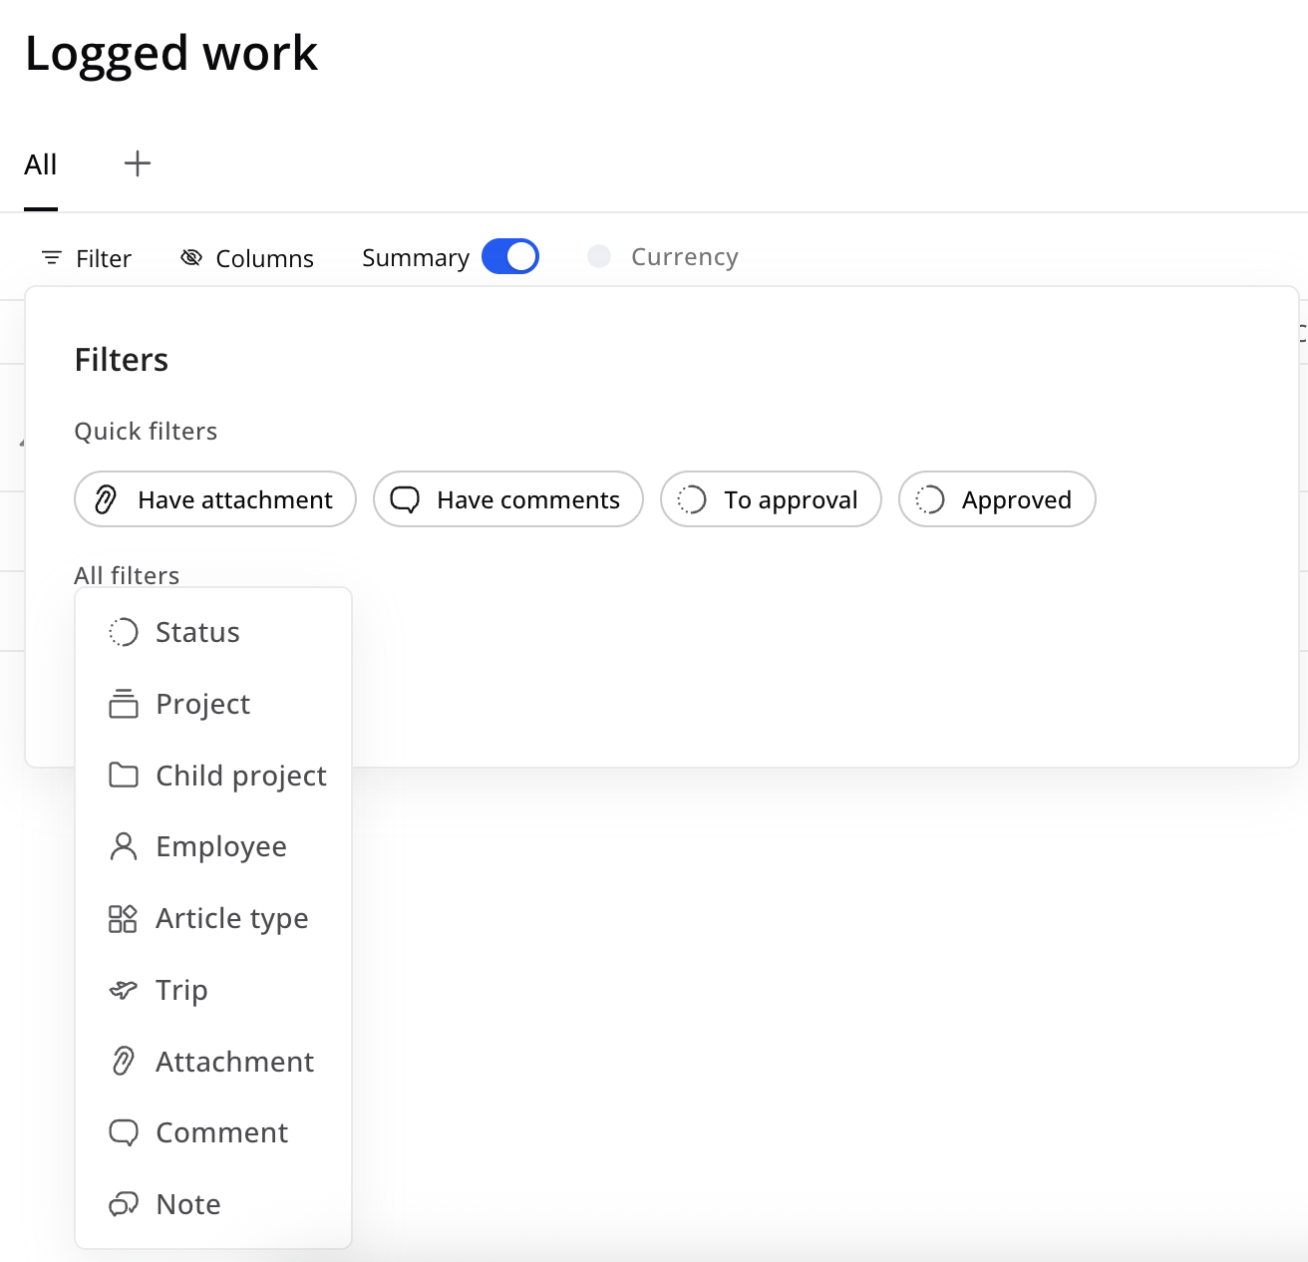

You can also navigate the period using the arrows and change between a monthly, weekly or custom view based on your preferences. For quicker navigation, you can create personalized tabs with specific filters by clicking the “+” button next to All.

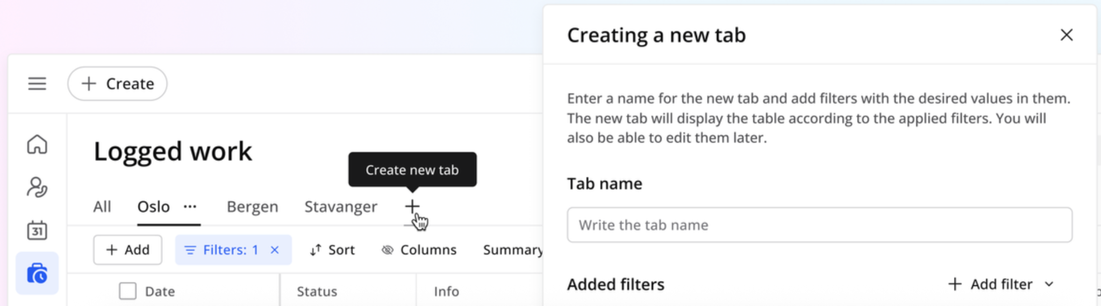

If everything looks in order, click “Approve” for all, check off one article at a time, or select multiple at a time. Using the select function, you can also download the list to an Excel spreadsheet, if you like.

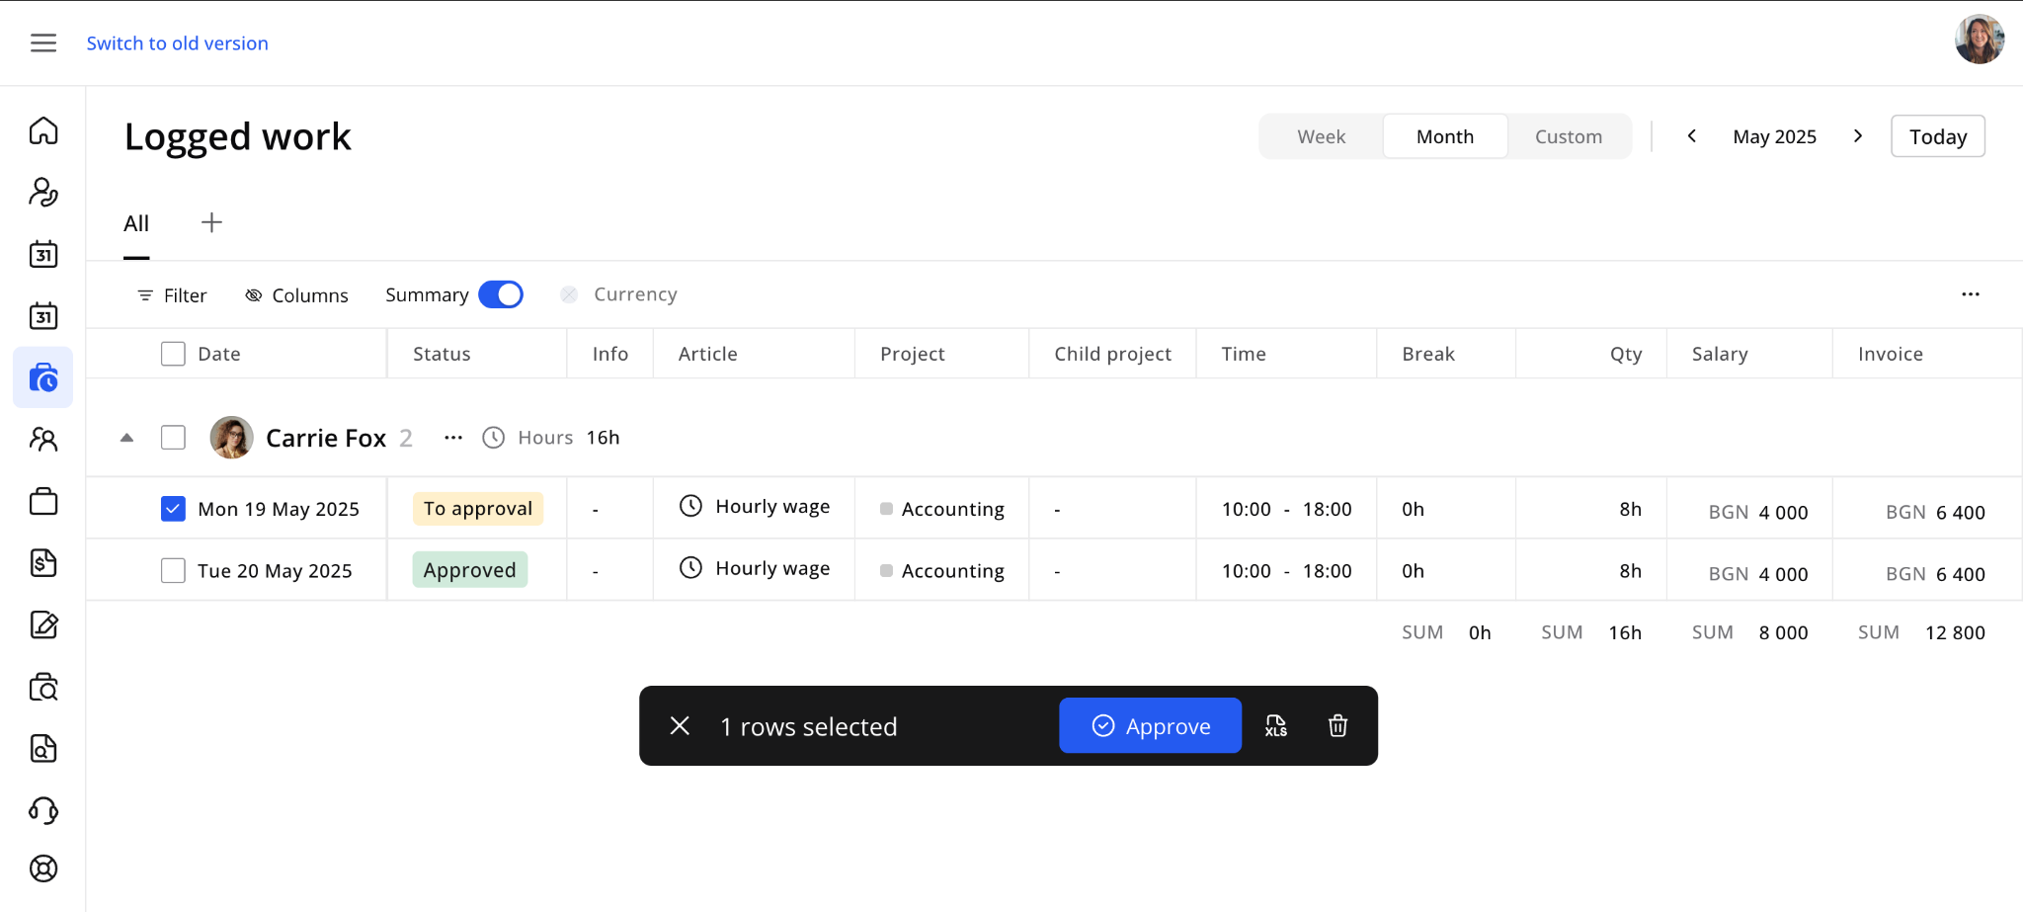

If you find an error, you can also click the article and write a comment in the drawer. This will become visible to users in the core application, who will review the logged work and take action to correct it.

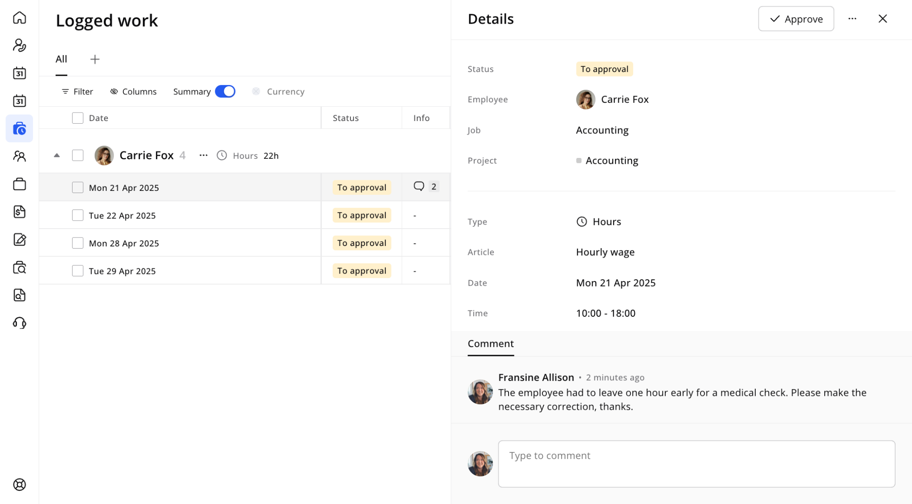

The customer portal allows users to edit and delete logged work entries. Users (contact persons) with the "Work - Edit" permission on the core site can easily modify details such as the date, hours worked, and break duration.

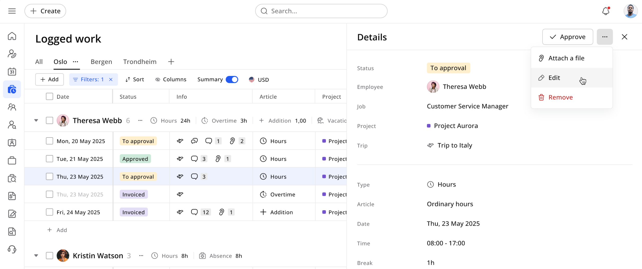

## 3.5 Employees

Here you will find the list of employees in your company with the possibility to create new ones.

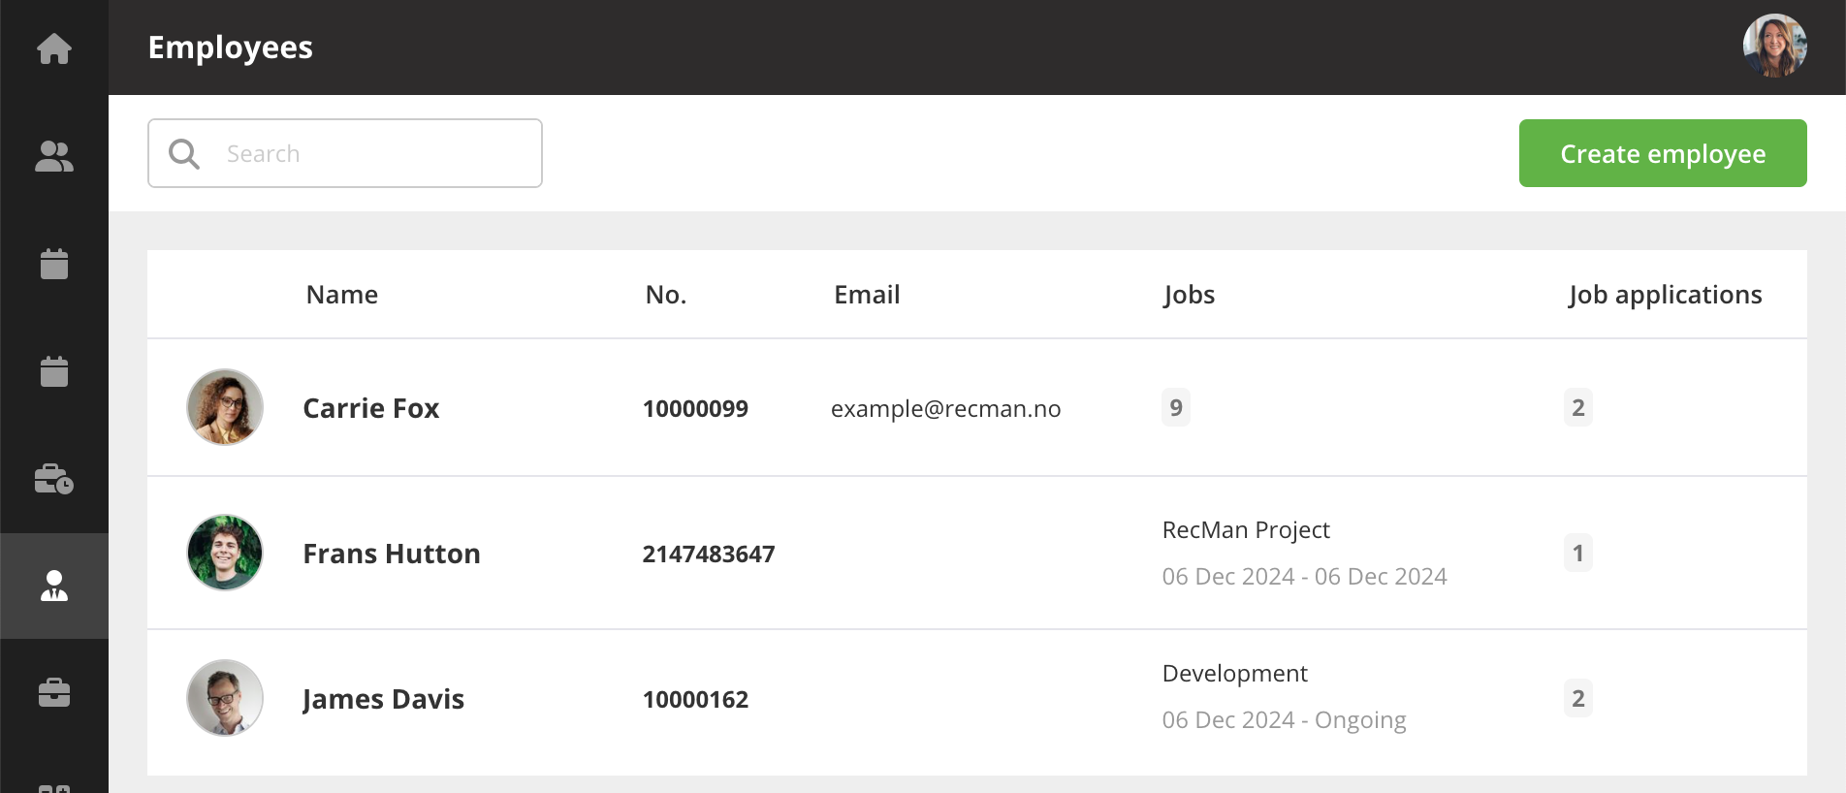

## 3.6 Jobs

Here you can view the active jobs for your ongoing projects. Using the filters at the top lets you navigate the months for active jobs, but you can also switch between a monthly and weekly view. Click the “this month” shortcut to be taken back to the current month.

The filters available here let you search for employees, filter the status of their logged work and projects.

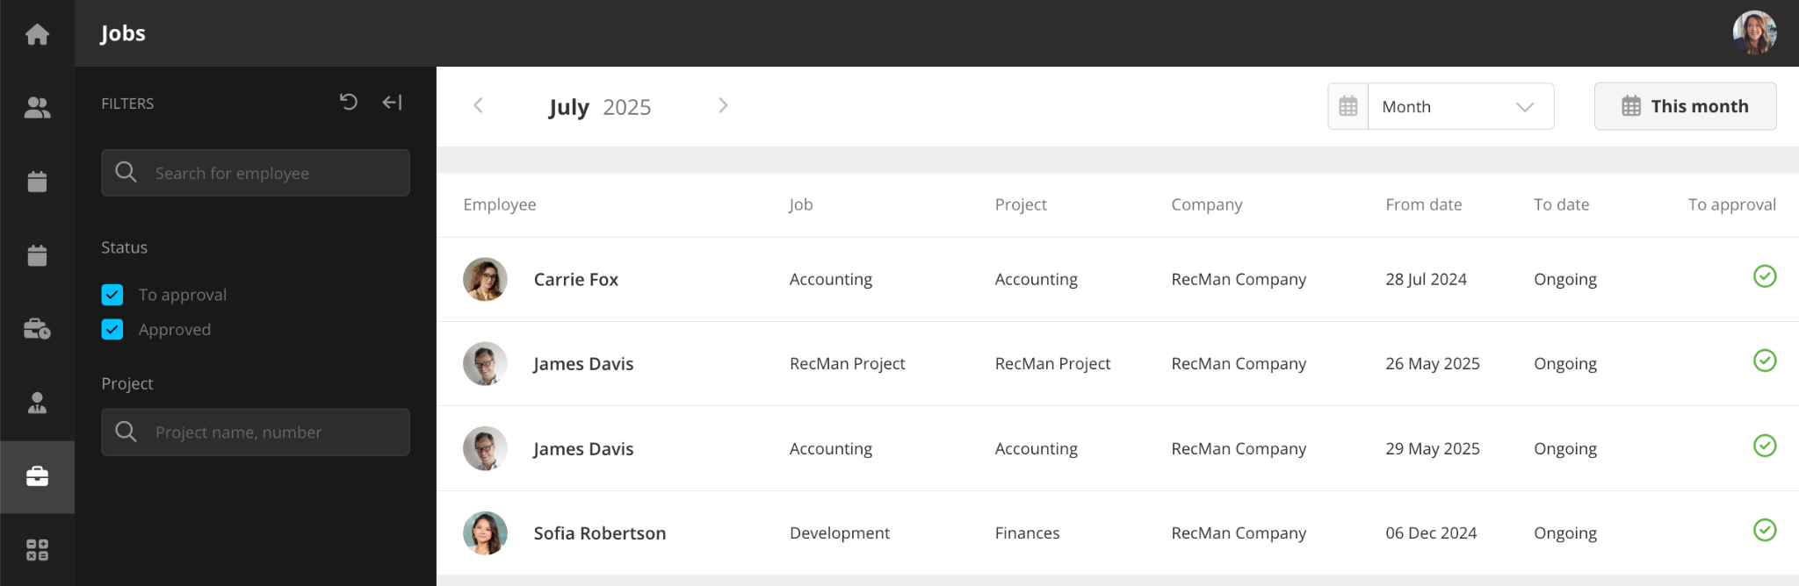

## 3.7 Invoices

In the invoice module, you can view all the invoices sent to you, your assigned projects or for the whole company.

Using the menu at the top, you can click the arrows to navigate the various months, change between a monthly, quarterly or yearly view, and use the “This month” shortcut to take you to the current month.

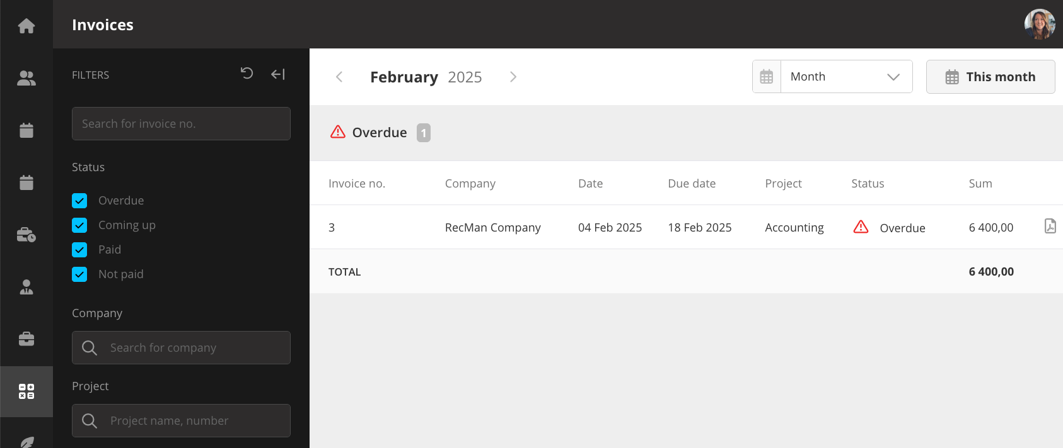

You can filter for invoices that are coming up, overdue, paid and not paid, as well as by invoice number, company and project.

## 3.8 Offers/agreements

In the offers module, here you can view all the offers sent to you, the project or the entire company. This is typically order confirmations and other general offers. By clicking open, you can view the agreement and sign it electronically.

Expanding the filters lets you search the agreements, filter for “awaiting signature” and “signed,” and search offers connected to specific projects.

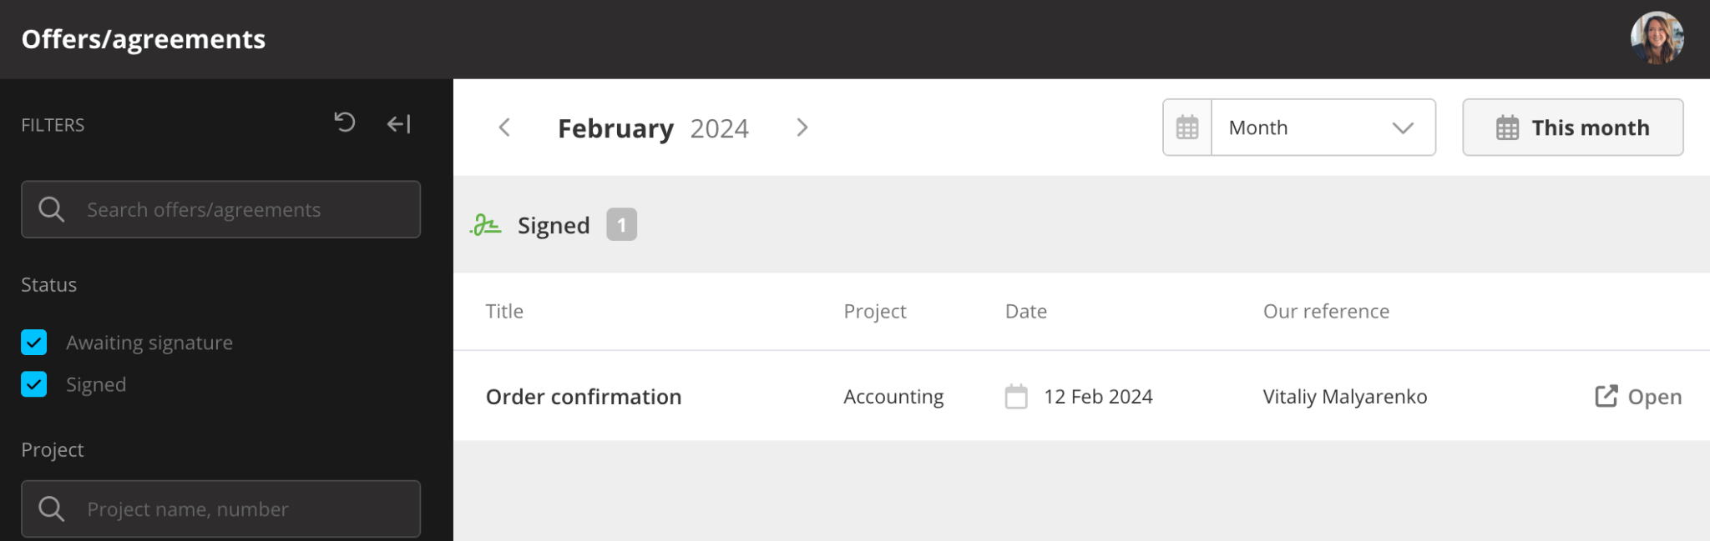

## 3.9 Job posts

Here you can view job posts.

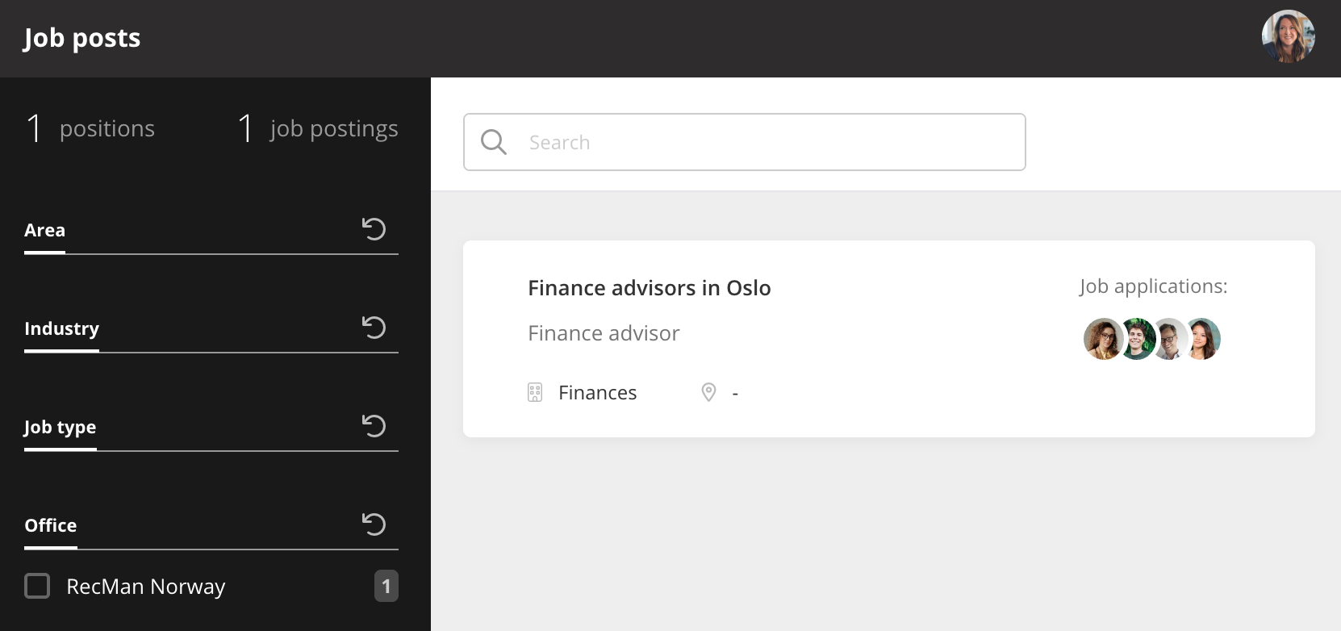

## 3.10 Partner’s recruitment module

The recruitment module in the customer portal is designed specifically for recruitment partners.

For this module to appear and work, the contact person's profile must have the “Partner portal” permission activated, and the job posts must be published on the Intranet (this job post portal must first be activated in System settings → Job postings).

Partners have access to a centralized dashboard displaying all job posts they're actively supporting with candidate sourcing.

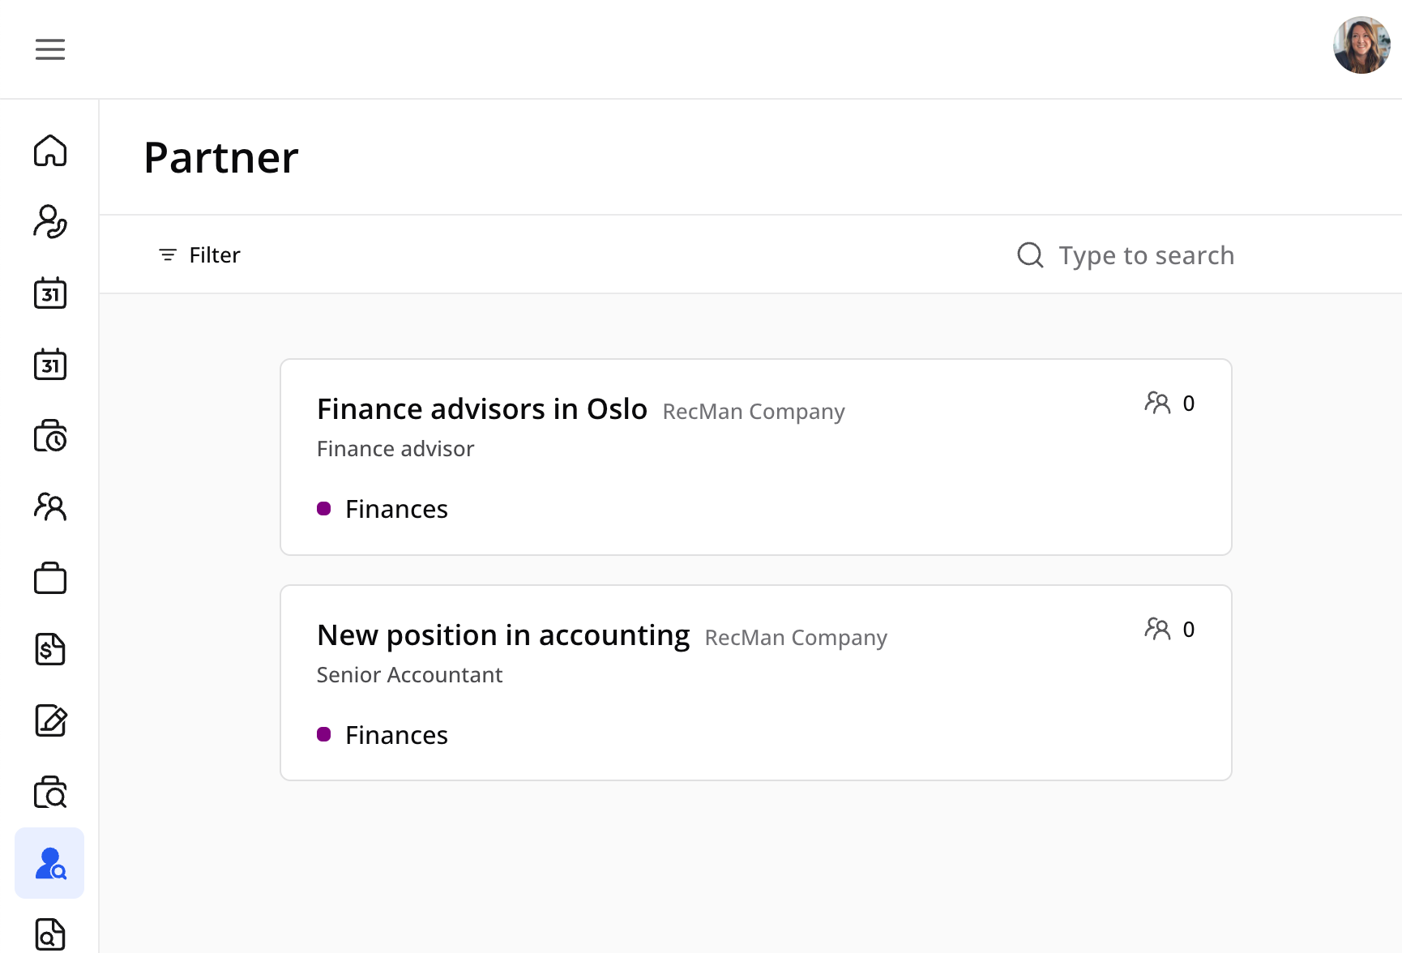

The interface includes robust filtering options by application status, company, and project, along with quick search functionality for efficient navigation through available positions.

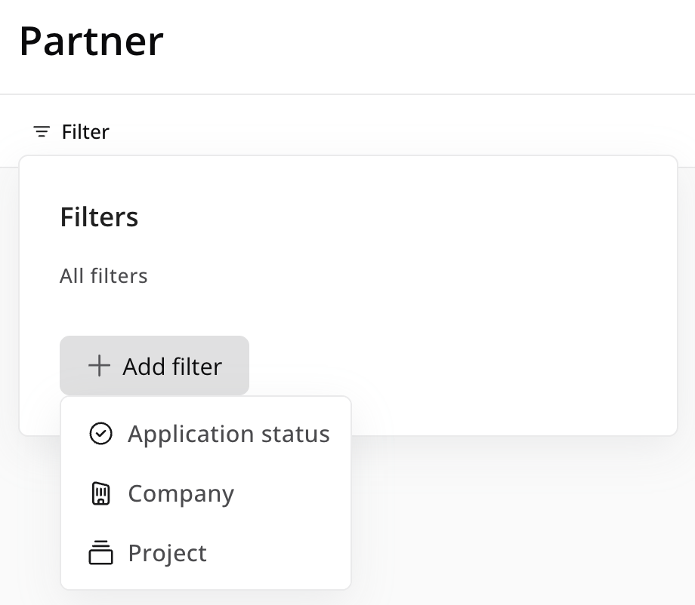

Each job post provides partners with a detailed project overview, including candidate metrics and essential project information.

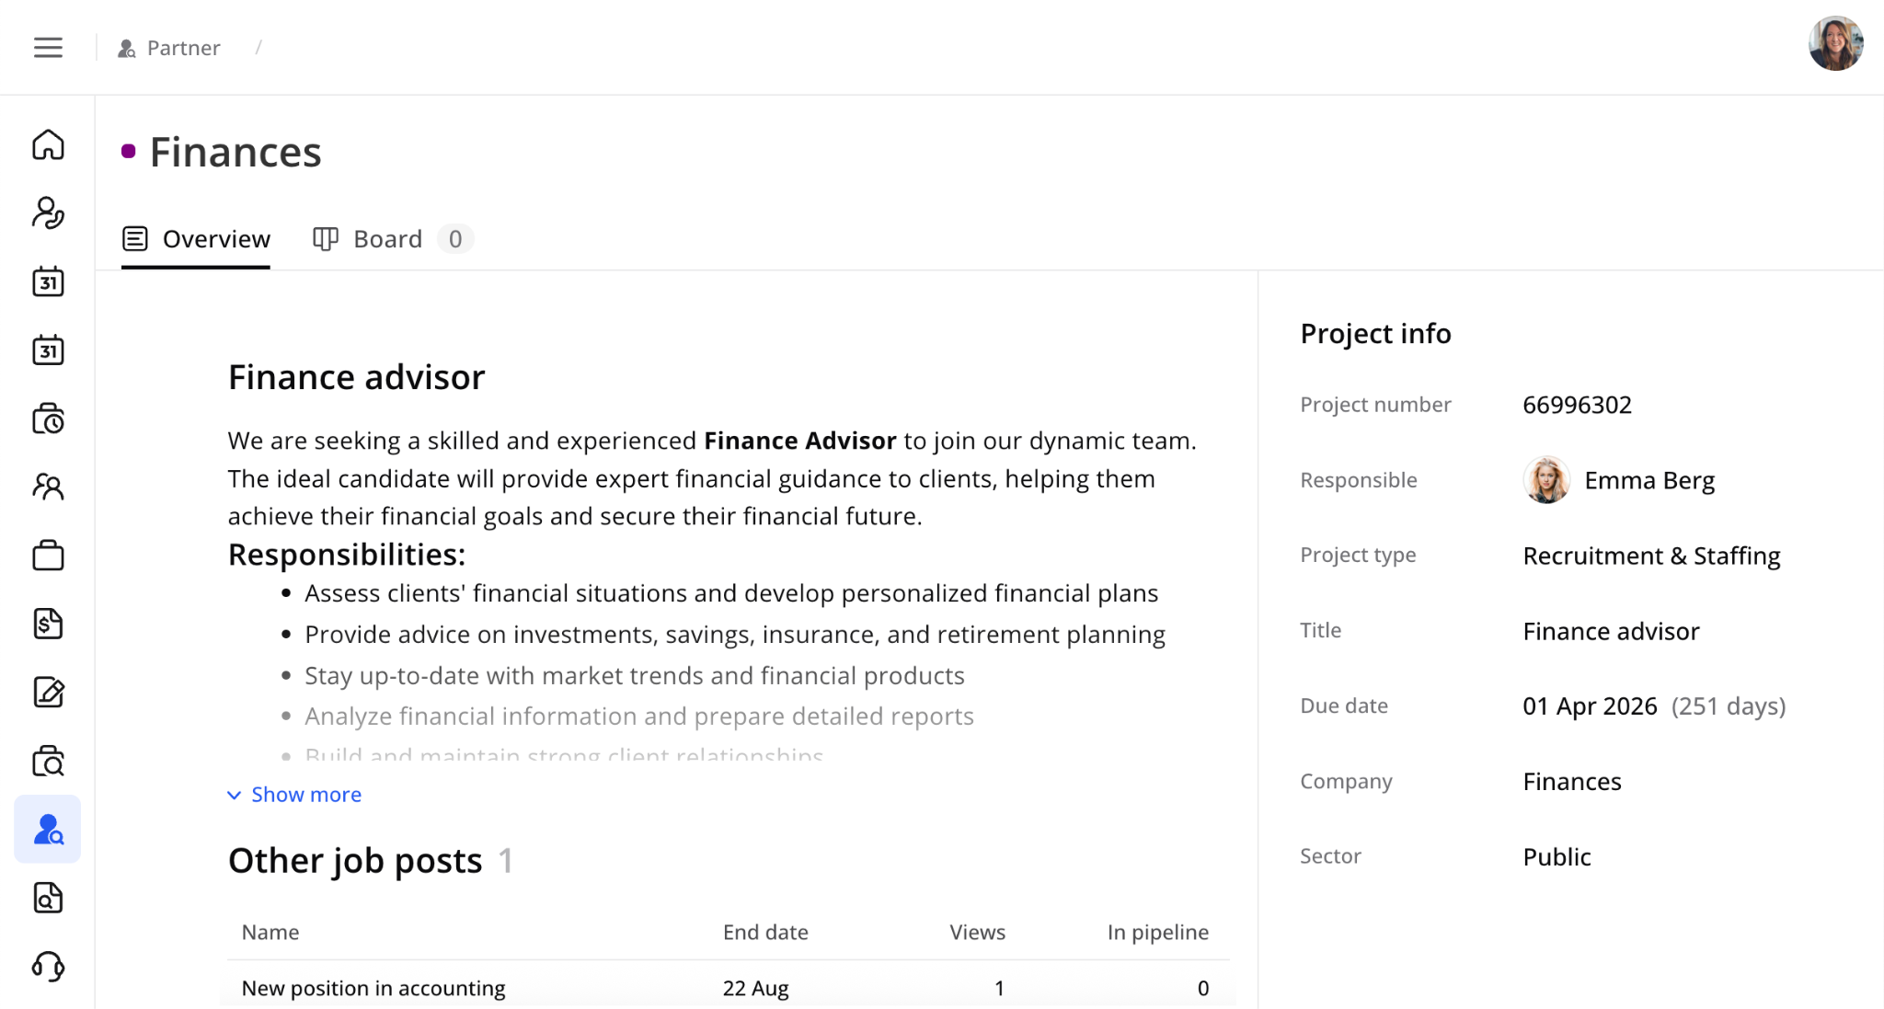

The core feature is an integrated recruitment board that displays the complete pipeline steps from the core recruitment process. Here, partners can attach files to candidates directly in the candidate drawer using a simple drag-and-drop, along with the Plus button.

Partners can filter candidates by status and have full capability to add new candidates either from their existing database or by creating entirely new candidate profiles.

Once candidates are added to the system, partners can comprehensively review candidate information and maintain ongoing communication with core team members through an integrated commenting system. The module supports project-specific custom fields, allowing partners to provide tailored information relevant to each recruitment project.

## 3.11 Inquiries

Using the inquiries module, you can send requests to the staffing agency for new business or if something is wrong with the newest invoice or offer.

