

User guide for candidates and employees

*User manual for the Career Page and Employee Portal*

| **Version** | *2* | |
| --- | --- | --- |
| **Latest update** | *2025-08-06* | |
| **Created by** | *Gøran Sæland* | |
| **Contributors** | *Marius Gravem, Iryna Volynets* | |
| **Confidentiality level** | *PUBLIC* | |

Content

**1 Introduction 2**

**2 Login 2**

2.1 Login issues and forgotten password 3

2.2 Change password 3

**3 Career Page 4**

3.1 All job posts 4

3.2 Applications 4

3.3 Agreements 4

3.4 Profile 5

3.5 Settings 5

3.6 Submit feedback 6

3.7 Logout 6

**4 Employee Portal 7**

4.1 Log work 7

Hours 9

Hour registration with child projects 9

Manually 9

Units (Piecework) 9

Additions, deductions, and attachments 10

Dashboard tab 10

4.2 Absence 11

4.3 Logged work 12

4.4 Requests 13

4.5 Calendar 14

# 1 Introduction

This document describes the Career Page and Employee Portal and their features, both for candidates and employees. We will also discuss various functions, like mandatory CV fields, resetting your password, and work registration.

Note: This guide is made with every possible permission and function turned on. Should your profile look different, it could mean that your permissions and functionality are limited or adjusted by your employer.

# 2 Login

First, we will walk you through logging in to access your profile and showing you how to reset your password if you have forgotten it. Note: The login may behave differently depending on whether you are a candidate or an employee.

When you register a profile with the company using RecMan, you can log in as you please. You may have a profile in several RecMan accounts at different companies, where your profiles are not shared between the accounts. Because of this, you must use the correct site when logging in. A typical site for logging in should look like this:

https://*company.*recman.page/login

Here, we have written *“company,”* which you will use as the name of the company you are registered with. When visiting this link, you will see the following screen.

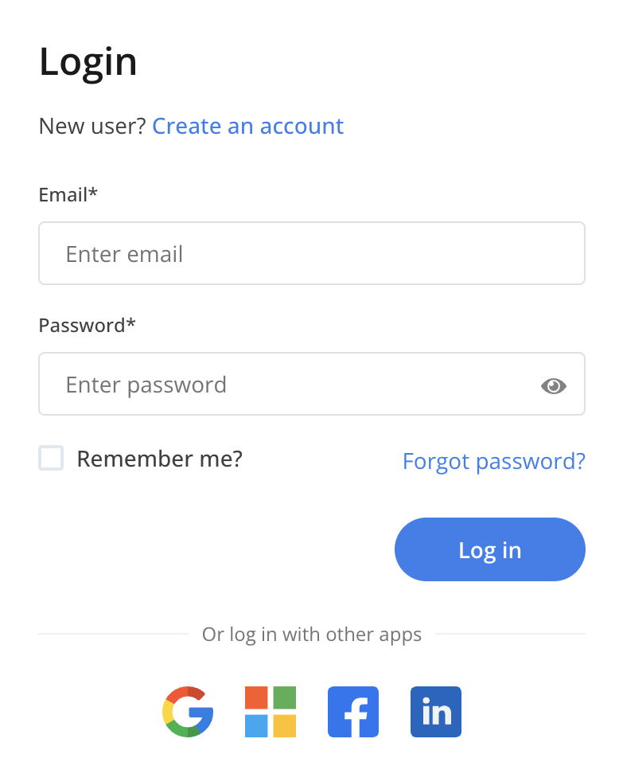

## 2.1 Login issues and forgotten password

If you have issues with your login, we recommend double-checking that your email and password are written correctly. If you are positive that both are correct, you can use the “Forgot password?” button.

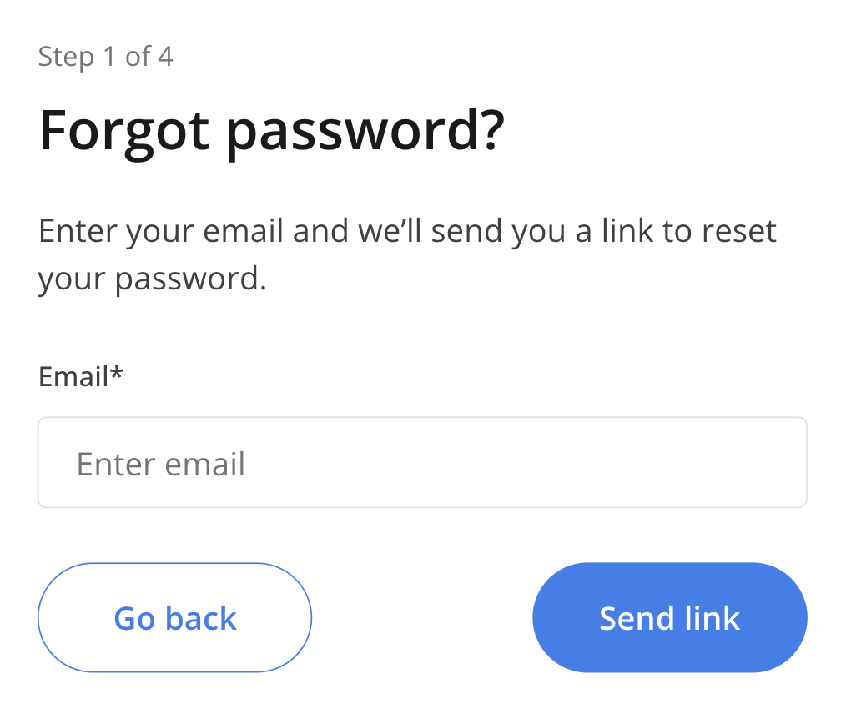

If you still have trouble logging in, contact the company you are trying to log into. On the same screen where you log in, you can see a link to their website.

## 2.2 Change password

After you have logged in to your profile, you can change your password directly from your profile. You will be asked to define a new password the first time you log in or use the «Forgotten password?» function, but should you wish to change it later, you first click «Settings,» as shown in the picture below.

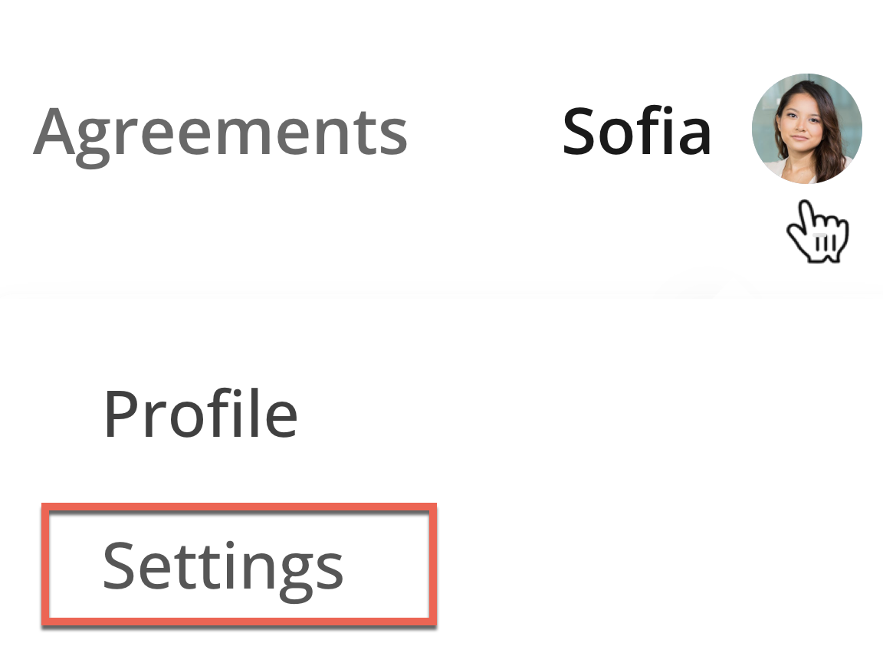

# 3 Career Page

When logging in to your profile, you will have a selection of tabs to visit. These can vary depending on the company’s RecMan account settings and whether you are a candidate or an employee.

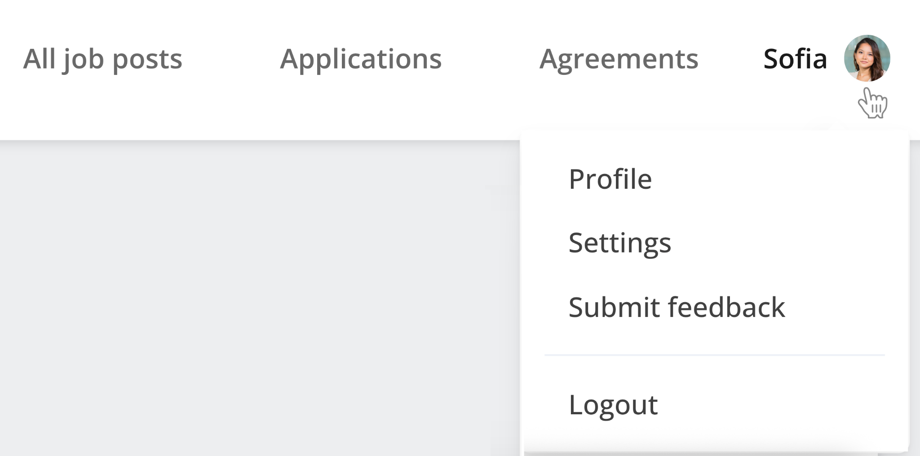

## 3.1 All job posts

Here you may see all available positions for which you can apply. As you have already created a profile, you will not be required to fill out information as you did when first registering.

## 3.2 Applications

You may see your active and prior applications for positions and their status here.

## 3.3 Agreements

Your employer can send you electronic agreements to sign. Usually, these agreements are offers, confidentiality agreements, employment contracts, and order confirmations. Note that this button is only visible once an agreement has been created for you.

You get these agreements sent to your email. However, you can also see all agreements sent to you directly in your candidate profile. Additionally, you can sign any unsigned document after opening it. This button is displayed in red if you have unsigned documents.

## 3.4 Profile

Your candidate profile page contains your personal information, files, and CV data.

CV information, such as education, work experience, skills, references, etc., can be inserted and edited, and files and profile pictures can be uploaded. You may verify your diploma by getting information from the diploma registry. You may also add or update your contact information. You may also insert additional details if you are employed.

Sometimes, the company you have registered with may define some fields as mandatory. This means that they demand that you fill them in. If you don’t, your profile could potentially not be assessed. You will be notified which fields you are missing, as shown in the picture below.

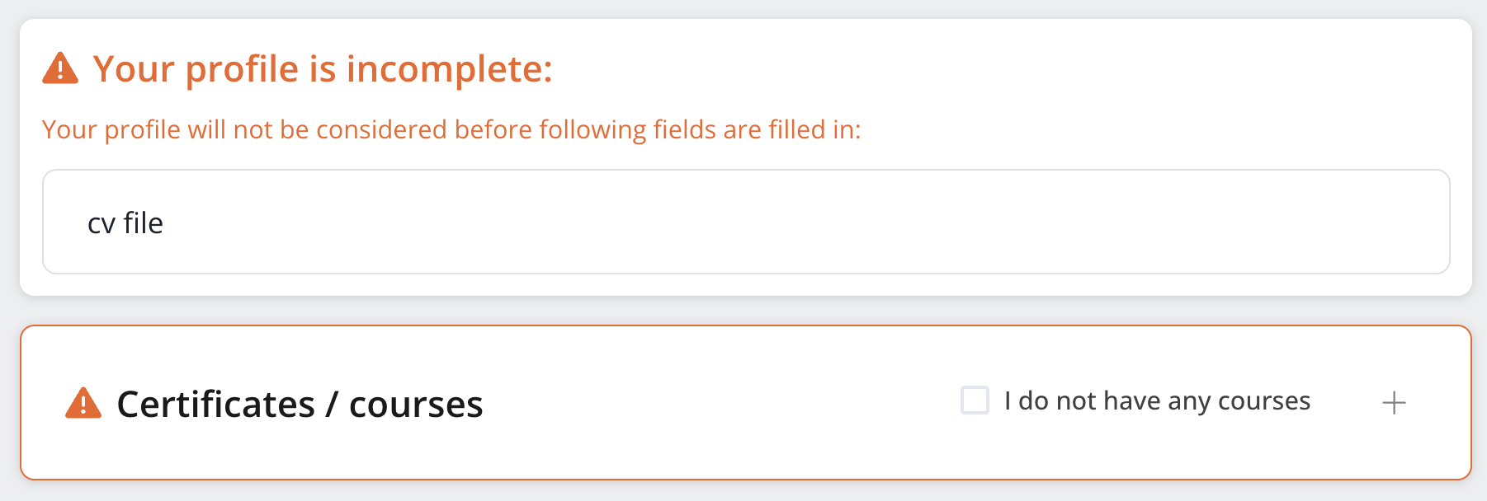

Note: Even though the company does not use mandatory fields, we highly recommend you fill out as many fields as possible in your CV. This will increase your chances of getting considered for a position. Incomplete profiles are often ignored or deleted outright.

## 3.5 Settings

Here, you may set a variety of settings for your profile. You can access and view the terms you accepted when registering and change the default period set for automatic deletion (if activated by the company). Depending on the permission set by the company, you may either delete or request deletion. If you are employed, you cannot delete your profile. Automatic deletion will also be put on hold if you are an employee. Note: The company will not be able to restore your profile should you regret your decision to delete it.

## 3.6 Submit feedback

If you have any feedback, submit it using this button, and it will be forwarded to the product managers and developers at RecMan.

## 3.7 Logout

Click this button to log out. If you don’t log out, you will be logged in when you return to the page later, provided you allow cookie storage in your web browser.

# 

# 4 Employee Portal

# 

## 4.1 Log work

Once you have logged into your employee profile, you have several options. We will now go through the logging work process. To find the screen for work registration, click «Log work».

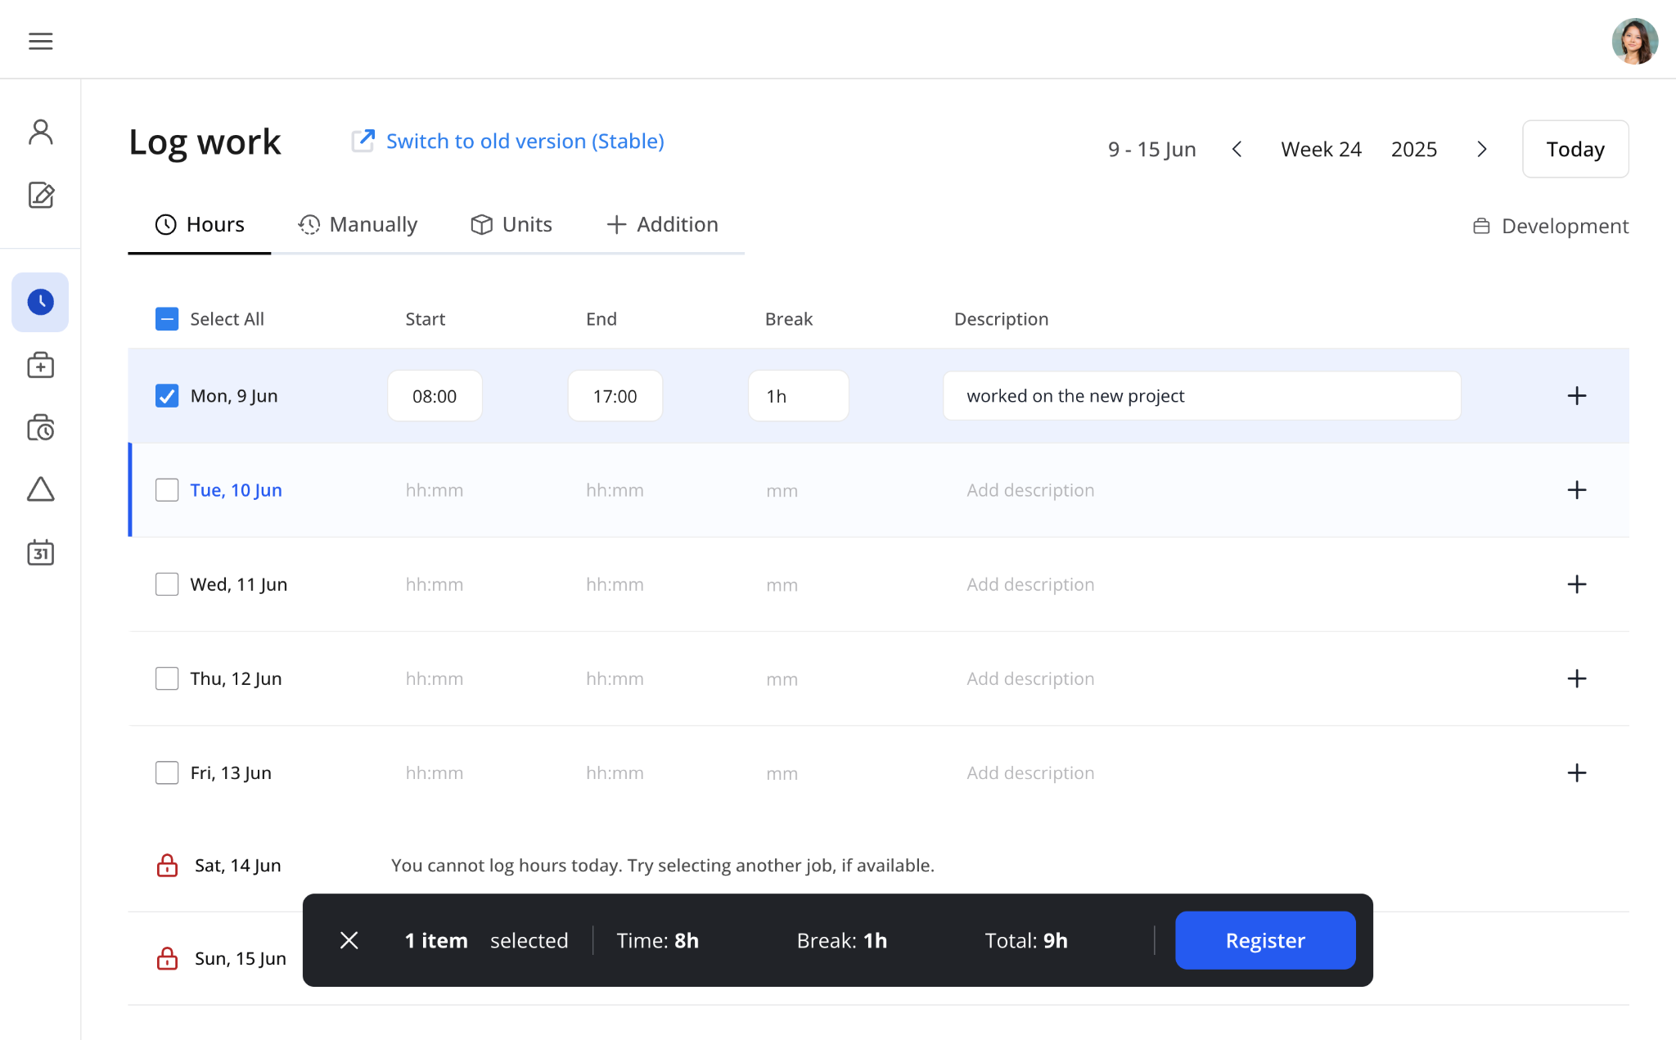

Once clicked, you will see a screen where you can log your work. In most cases, this screen will display the days of the current week, with the ability to register hours for various times on these days. Note that this screen may differ depending on your employer’s preferences and policies.

You can select one or more days before clicking «Register». Note that the «Register» button only appears when valid work is ready to be registered. The work will be recorded, and your employer or an external approver can approve it.

You can also change which week you want to log your work on by clicking the week and year buttons in the top right corner. Note that depending on policies set by your employer, the ability to log work on certain days, i.e., in the future, can be closed, and you will have to wait until tomorrow.

If your manager leaves a comment, you can answer it in the Comments section at the bottom of the right-side Details drawer.

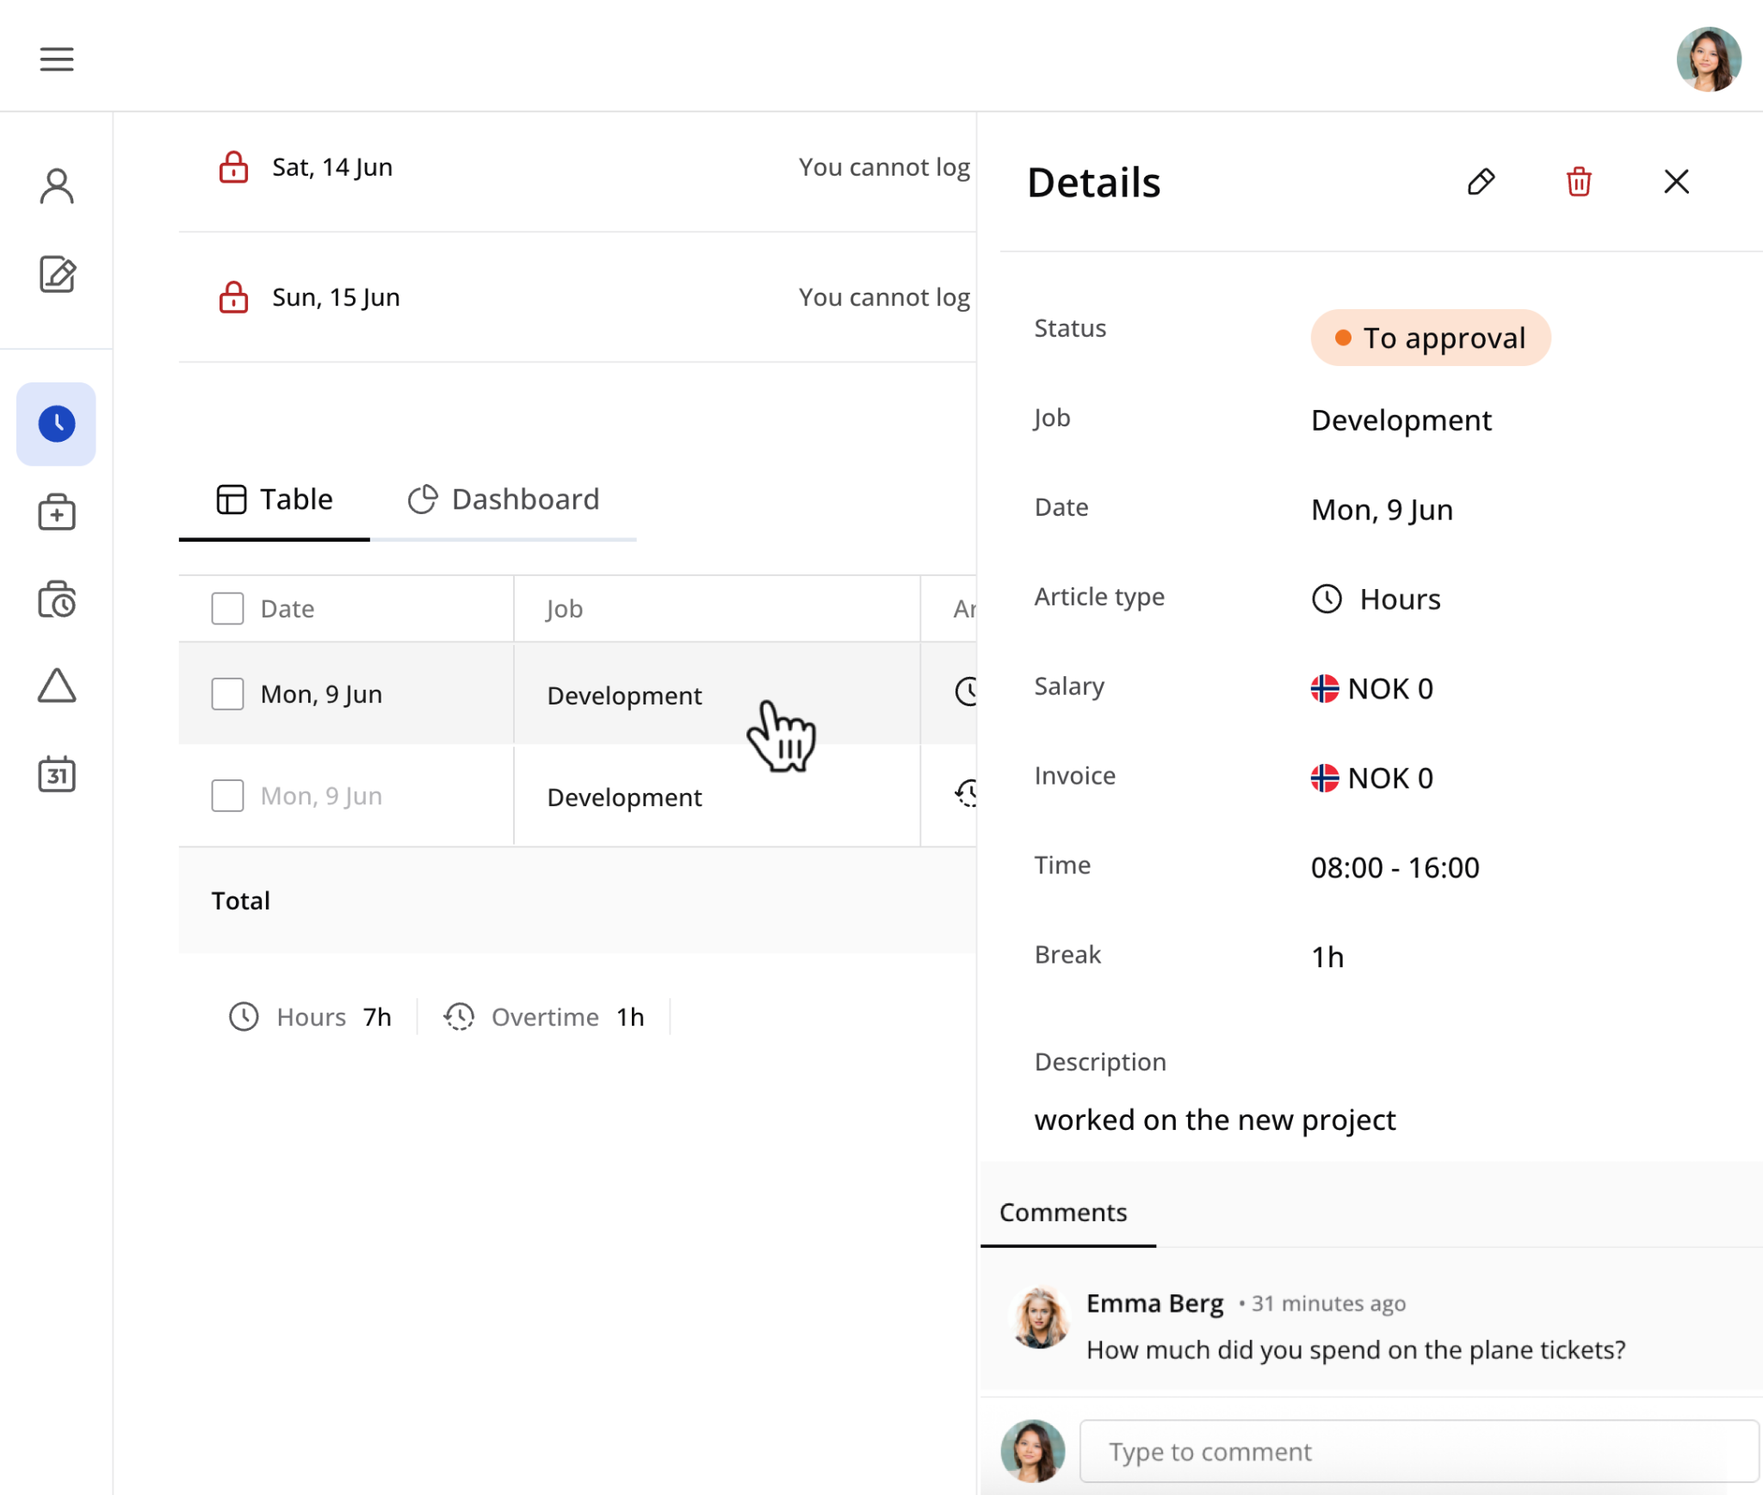

If you are to log piecework, addition/deduction, absence or for some reason two or more sets of hours on a given day, click the tabs for “Units”, “Addition” or “Hours”. In the “Addition” tab, the date is preselected. Here you can upload attachments or add more rows by hovering over the date.

### Hours

In some cases, you are required to log work at different times on the same day. By clicking the “Hours” button, another row for logging work on the same day is added. This could also be used in combination with absence, where you, for instance, were at work for two hours, two hours at the doctor's, and then four hours at work again.

### Hour registration with child projects

When you are to record regular work, but your work is to be separated during the day, your employer may use child projects. You can define this when you register your hours for your employer so that they can see where you worked and at what times. This is typically used in construction.

### Manually

In rare cases, a function for logging work manually will be available. This means you define the salary article, work type (salary, addition, overtime), time and dates you have worked.

### Units (Piecework)

Unit logging, or piecework, is common in sales, consulting, and construction positions. Piecework is often registered in addition to regular hours. Note that it could be in quantity or hours, so be aware if it should be 1 hour and 30 minutes or 1.5.

Piecework with period logging is very similar to regular piecework logging, with some changes. You record your work for the whole month, and once they have been sent to the employer, it may not be changed. Additionally, you must record work for the previous period before recording for the current month.

You can find specific jobs quickly by typing in articles. All job-related articles appear in a single dropdown under the article column. Grouped articles are marked, but any article can be selected with one click. The system manages group associations automatically.

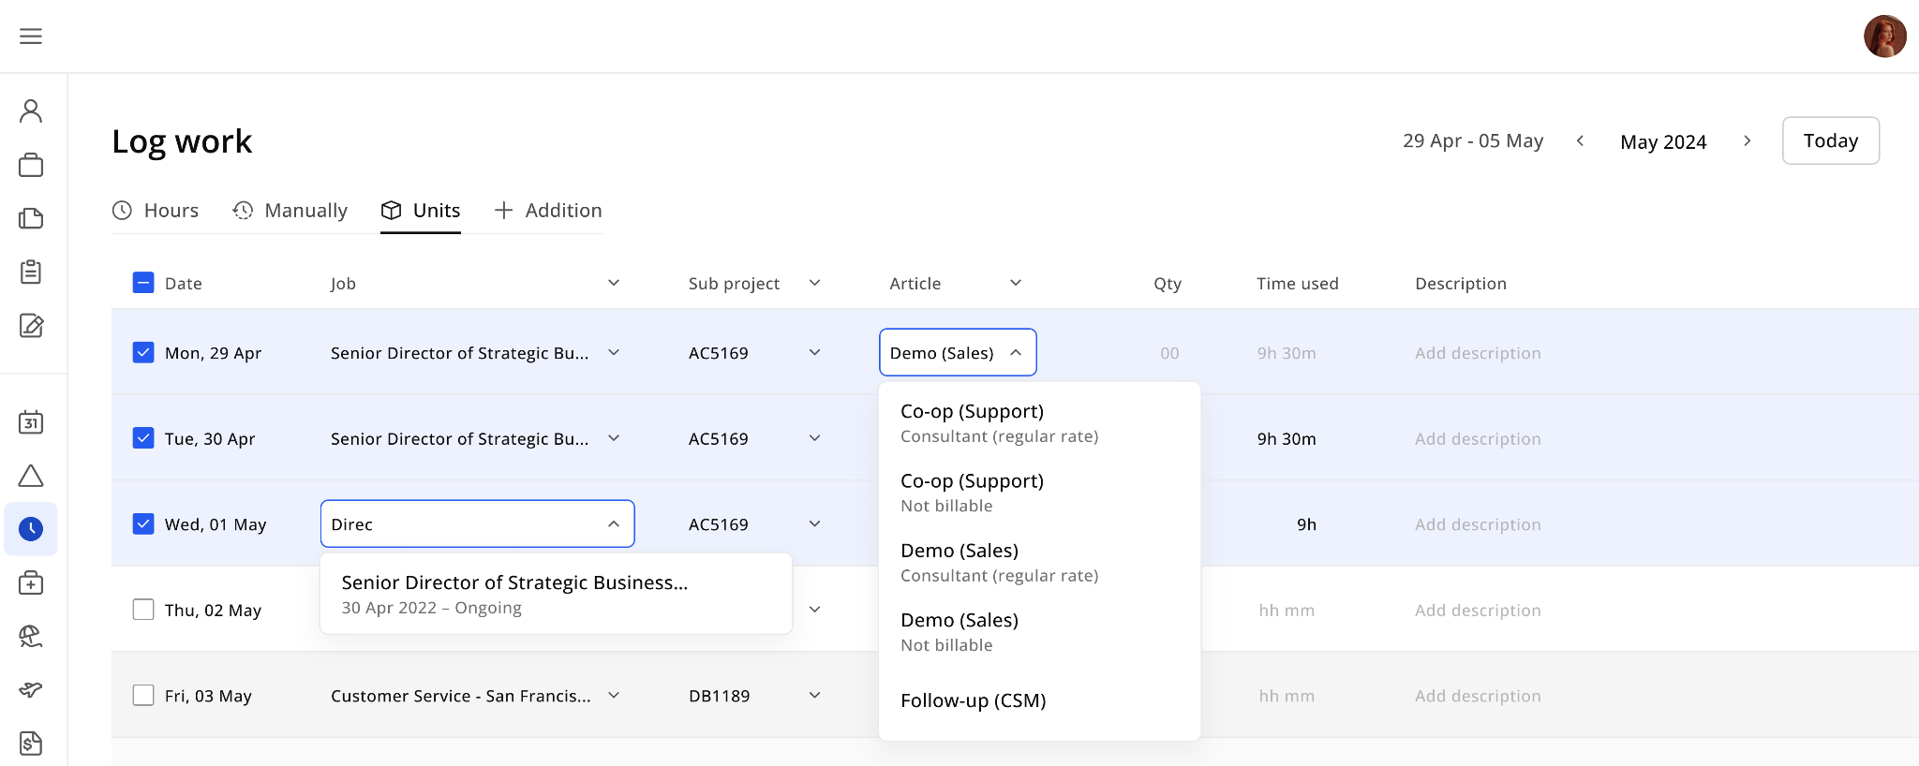

### Additions, deductions, and attachments

Additions and deductions are logging that you can do to adjust your salary. For instance, if you are to receive compensation for parking, driving to work, using your tools, etc., this can be logged as additions. You can upload attachments in this tab, and if you are using a phone, you may upload a picture directly from your mobile camera. Non-included lunch and rent are examples of deductions. You get additions in addition to your regular salary, while deductions are deducted from your salary.

### Dashboard tab

A Dashboard tab will show a visual interface that displays key information in an easy-to-read format. It includes widgets like Total salary, Hours, Work week, etc.

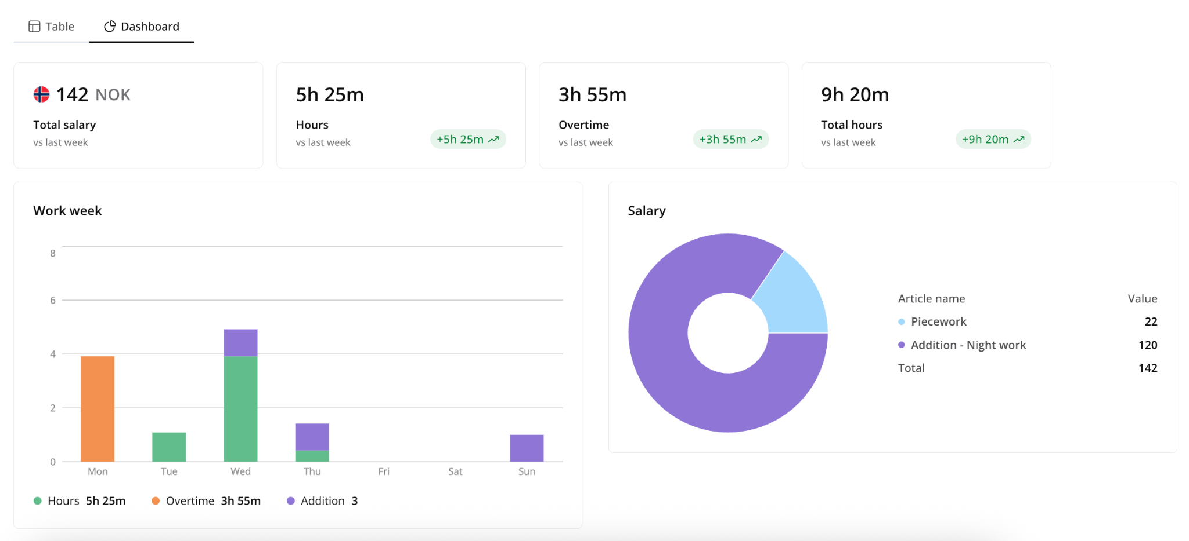

## 4.2 Absence

Absence is registered like regular work, but with the option to change the article. Absence is registered on days you haven’t worked, such as when you're sick.

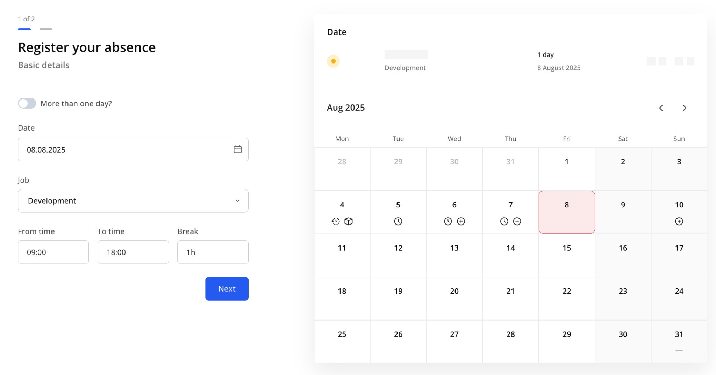

## 

## 4.3 Logged work

“Logged work” allows you to review and manage all logged work items.

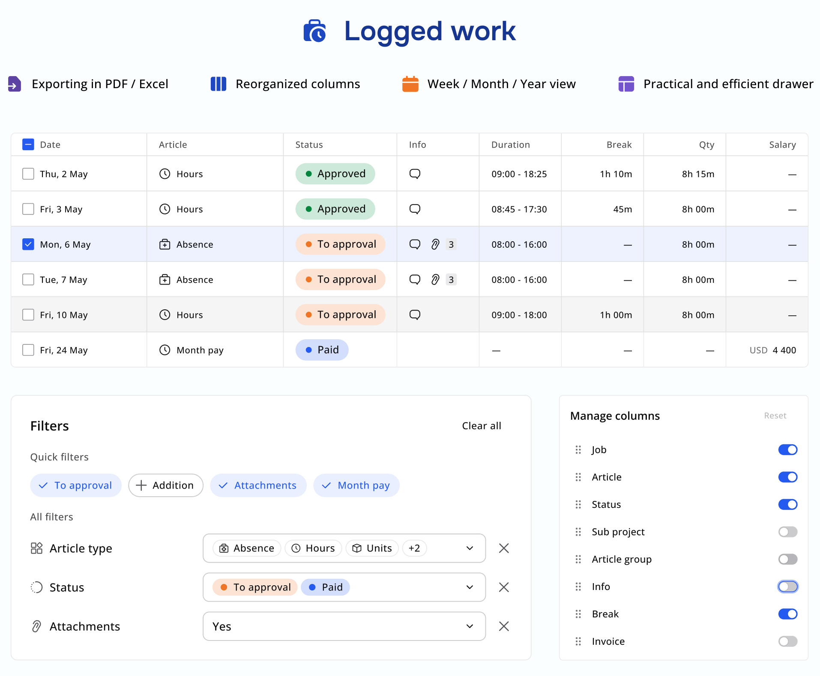

## 4.4 Requests

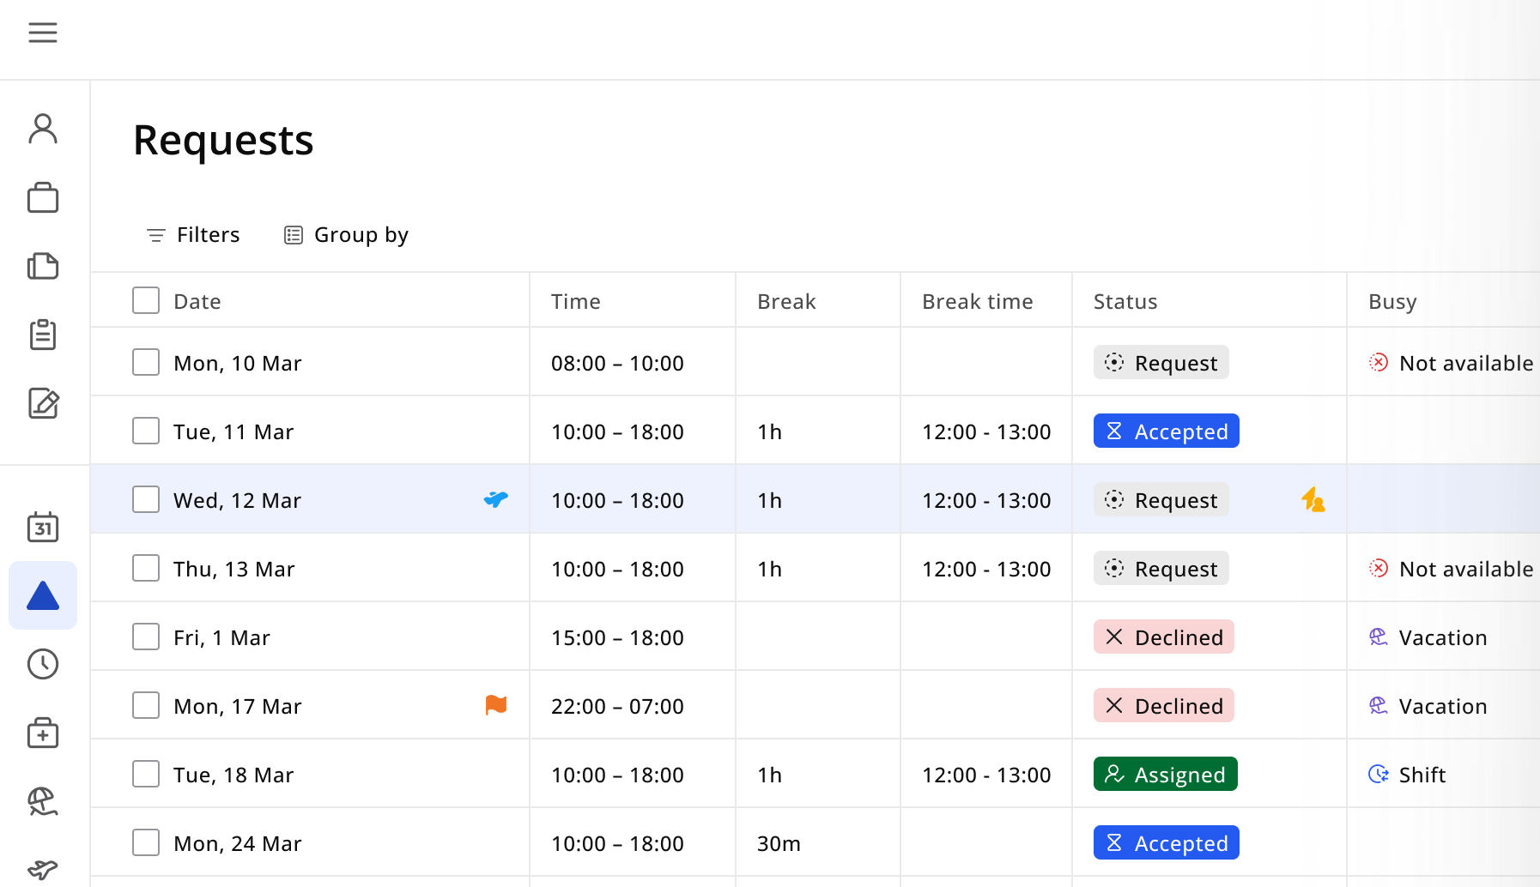

The Requests module in the Employee Portal allows employees to receive and respond to booking requests.

When a booking is created in the RecMan or Customer Portal, and you have been added, you will receive a request in the Requests module. You can view project details, check availability, and decide whether to accept or decline the request. If accepted, the request is automatically converted into a shift.

## 4.5 Calendar

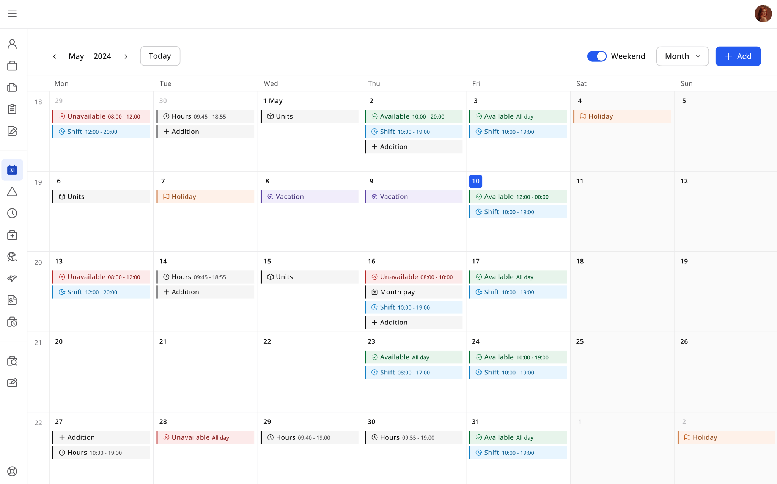

The work calendar module has a monthly view and includes flexible viewing options. Based on your preferences, you can display the calendar with or without weekends. By clicking the button of the current month, you can easily navigate through two dropdowns with months and years.

The calendar displays various events, including availability and unavailability events, logged work items, shifts, and holiday events. Depending on permissions, you can create, edit, and delete shifts directly from the calendar interface. A view-only modal displays detailed information about events for users without editing permissions.

You can view detailed information for availability, unavailability, and shift events. When creating new events, you can schedule single-day or multi-day events, with options to set them as all-day events or specify exact start and end times. The calendar supports complete event lifecycle management, allowing authorised users to view, edit, and delete events as needed.